***A Linha Curva Revision Mat***

**Aural setting (*An audible accompaniment to the dance such as music, words, song and natural sound or silence).***

* The musicians have to strike, shout, slap, clap, use body percussion, chant.
* There are around 50 instruments used including shakers, congas, bongos, drums
* Music all has a heavy Brazilian Samba feel

The accompaniment at the start is cleverly used to immediately grab the audiences’ attention. The female dancers shout ‘Tum Tarakka Tum’ and the rest of the cast respond with ‘HEE HEE HEE’ at the beginning of the piece.

The accompaniment is key in structuring the dance and reflects the structure of a curved line which is also the title and choreographic intention of piece. The music starts on a high with intense chanting and a driving samba rhythm, drops to a gentler pace in Section 2 ( Adage) with a mysterious echoing sound, taps on the drums and a scraping sound, before climbing to a full blown samba until the end with bongos, congos, bass drum, whistles and shakers. This is effective in grabbing the audiences’ attention immediately and then following the calmer middle section, it helps to create a climax to finish the dance.

**Background/choreographer**

Choreographer- Itzik Galili

Performed by Rambert Dance Company

Performed at Sadler’s Wells Theatre London 2009

Dance Style: Samba, Contemporary and Capoeira

**Stimulus, choreographic intention and choreographic approach**

A Linha Curva means The Curved Line in Portuguese

Stimulus- Brazilian Culture

Choreographic intention- The main intention is to simply have fun

However, the large ensemble sections of vibrant Brazilian inspired movement are performed in regimental **straight lines, creating a sense of samba parade**.

There are also a number of **narrative sections** that through the choreography present observations of how Brazilian men communicate with women, for example men in tribes hunting the girls as well as showing off and competing with each other.

Choreographic approach- Galili worked collaboratively with the dancers and asked them to come up with their own motifs for example four counts of eight each, almost all of them were based on improvisation. The dancer’s motifs were then taught to other dancers to form the ensemble sections and they were named after themselves e.g. Liris, Robson, Adage, and Galili said each of the dancers personalities could be seen in each motif

Structure ( the way in which the dance is organised)- The structure of the piece follows ‘The Curved Line’ ( see diagram below)- Ensemble sections being very energetic full of samba and loud bongo music, then a dip in the Adage septet, which sees a change in music, change in dance style and some narrative sections. It then goes back up to the fast paced ensemble sections.

**Lighting-**

Designed by Itzik Galili.

The different coloured and timed lighting creates a **chequer-board effect** on stage and **defines the lines and spacing** for the dancers in large ensemble sections of the piece.

The timing and cues for the lighting is **pre-programmed** and so in a way **dictates the speed and pace** of the dancing and music

There is a 7x7 grid of light that covers the stage; single squares, rows or lines of different coloured light can be illuminated instantly. The dancers can be immediately illuminated and hidden when the lights go on or off.

The lighting also compliments the costumes and supports the stimulus of the piece; ‘celebration of Brazilian culture’. The lit squares on the floor are made up of different bright colours. These colours are the same colours as the dancers’ hot pants and are reminiscent of the vivid colours one might see in the costumes worn due a Rio Carnival which creates a sense of fun.

The lighting also directs the audience where to look. Rows and lines of light appear, with dancers inside them, which the audience immediately look at as their attention is directed to these illuminated areas. This means the audience keep up to date with the quick formation changes and entrances/exit as they are less likely to miss parts of the choreography as they are immediately directed to them.

**Costume-** Male and female dancers both wear **black vests** with **different coloured Lycra shorts**.

The colours are **carnival inspired** and **enhance the impact of the lighting**.

The shorts are made out of wet look Lycra and come in ten different colours.

This uniform look adds to the **feeling of equality** in the ensemble sections. This clearly identifies them as being part of the same group and is particularly effective in the ensemble sections as the unison movement appears even more unified as they wear the same outfits.

The men wear metallic disc-shaped collars that reflect the light for the opening of the dance; this instantly catches the audience’s attention and adds a vibrant feel to the piece.

One of the main uses of the costume is that it allows the dancers to appear and disappear in the light. The hot pants and black chiffon vest are invisible when out of the stage lights. This allows the dancers to enter the stage without being seen then surprise the audience by appearing when they stage lights come on them in a particular formation; it makes entrances and exits incredibly slick almost like an illusion.

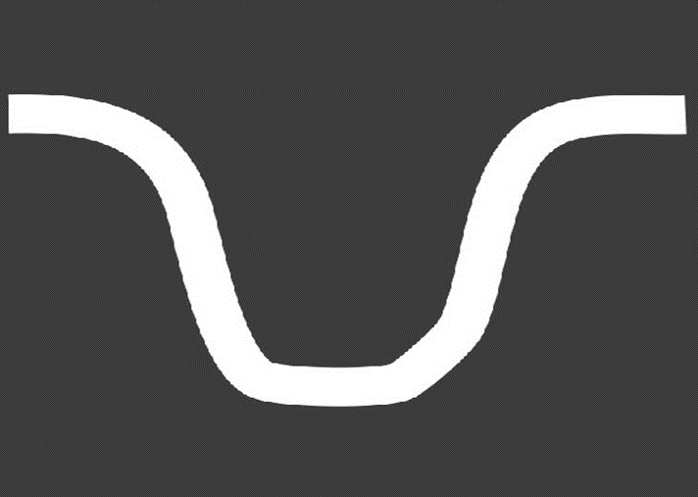

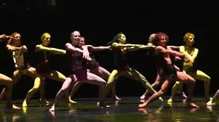

**Staging/set: “The presentation of dance in the performing space”**

There is no set apart from a raised platform at the back of the stage upon which 4 percussionists perform.

Props: “A portable object that is used in a dance, for example a suitcase.”

In one section skateboards are used to propel 5 dancers across the stage*.*

**Performance environment – Different Settings for Dance**

End Stage- A performance space with the audience on one side; also known as “end-on”.