A  L  I  N  H  A  C  U  R  V  A | CHOREOGRAPHER: Itzik Galili
PERFORMANCE ENVIRONEMNT:
End stage – a stage where the audience is positioned at one side
STRUCTURE:
- Distinct parts of the piece that are made up of big ensemble dance sections. The big ensemble dance sections involve the dancers performing a series of repeated motifs/phrases in a number of different formations that are dictated by the grid-like, multi-coloured lighting.
- Large ensemble (group) sections are interlinked with scenes that have more of a sense of narrative (story) and character. The more narrative scenes do not feature the grid lighting effect. During these sections, the competitive nature of the males and how they relate to the women is evident.
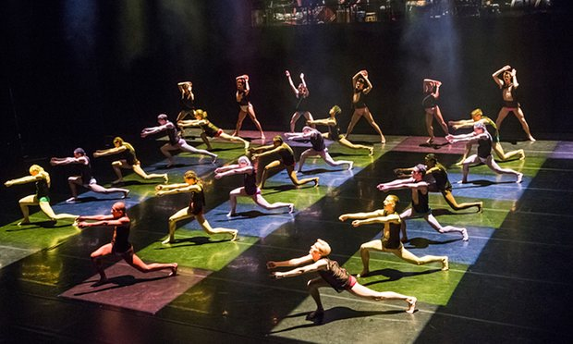
STIMULUS:
Brazilian culture: celebration of the Brazilian way of life and the ability to live in the moment.
CHOREOGRAPHIC APPROACH:
Improvisation + Task setting: Itzik Galili asked his dancers to improvise + choreograph a very short solo, which included their favourite movements. The solo had to stay withinthe boundaries of a small square.
CHOREOGRAPHIC INTENTION:
- To have fun:
- To show the contradiction between straight lines and curves:
- Showing off + male competitiveness:
- Brazilian men pursuing women:
 | DANCE STYLES:  Samba  Capoeira,  Contemporary | Key Features/Characteristics: | Samba:  - Brazilian dance style  - Fast dynamic footwork  - Swaying motion of the hips and body  - Upbeat rhythmic movement |  | Capoeira:  - Brazilian dance style  - Influenced by martial art movements (kicks, leg swipes)  - Loose, relaxed, continuous movement quality  - Duet work  - Action – reaction  - Break dance type movements |  | 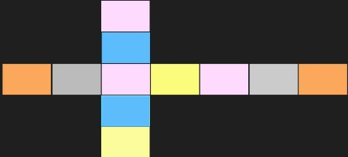  Contemporary:  - Floor work  - Movements of the upper body include contractions, release, and spirals  - Grounded movement  - Internalising the feeling of the movement (feeling it from within).
 | EVIDENCE OF DANCE STYLES IN A LINHA CURVA: | Examples: | Liris motif:  - Swinging motion of the hips within the motif  - Positioning in a straight line representative of the samba parades  - Fast, dynamic movement similar to that of samba. |  | Contact Duets:  - The contact duets link back to the capoeira dance style – mimicking the movements of Capoeira including kicks, leg swipes, and the use of action-reaction.  Male Battle:  - Towards the end of the dance the men showcase the strength by doing a range of capoeira influenced movements e.g. spins, drops, and kicks, and balances. |  | Adage Septet Motif:  - Includes the high release and arching of the back  - Movement remains grounded throughout  - Moments of floor work have been choreographed into the dance e.g. at the beginning of the dance one the Liris motif and Robson motif have been performed for the first time. Floor work is also incorporated into the duet work.
M  O  T  I  F  +  D  E  V  E  L  O  P  M  E  N  T  C  O  N  S  T  I  T  U  E  N  T  F  E  A  T  U  R  E  S | KEY MOTIFS:  Liris  Robson  Adage Septet | Description of Motif: | Liris Motif:  - A fast unison septet facing upstage.  ACTIONS: Shoulder roll, clap, gesture, plie, hip swing, arm wrap, reach, drop, throw  DYNAMICS  Fast, precise, rhythmic, grounded, weighted, release, strong  SPACE  Downstage, facing upstage, horizontal line, performing inside one square on the grid.  RELATIONSHIP  Unison |  | Robson Motif:  - A fast motif, swinging the arms over the head over a wide base in 2nd.  ACTION  swing, drop, roll, throw, catch  DYNAMICS: strong, lively, fast  SPACE  Facing stage left, then the front on the 2nd repetition, performing inside one square on the grid.  RELATIONSHIP  Unison. |  | Adage Septet:  - A slow, fluid, rippling phrase for 7 girls  ACTION  Lunge, reach, ripple, contract, gesture, arch, rise, turn, drop, bounce  DYNAMICS  Slow, languid, gentle, careful, soft, sudden [bounce], suspend  SPACE  Dancers are spaced and positioned on a yellow square of the grid. They work on the diagonals and verticals of the grid.  RELATIONSHIP  Accumulation. Unison.
 | MOTIF DEVELOPMENT | Examples of Developments: | Liris motif developed by:  SPACE:  - DIRECTION – facing upstage downstage  RELATIONSHIP:  - FORMATION -horizontal line diagonal line.  - Originally performed in Unison the Liris motif if then developed using ACCUMULATION
Robson motif develop by:
ACTIONS:
- FRAGMENTATION – the original motif if broken up and performed in a different order using other motifs.
SPACE:
- DIRECTIONS – Facing Stage left Downstage
RELATIONSHISP:
- FORMATION - Performed in various different formations throughout e.g. horizontal line vertical line
- ACCUMULATION – Used to transition from Adage Septet Robson motif.

Adage Septet motif developed by:
SPACE:
- DIRECTION: facing upstage left downstage right
RELATIONSHIPS:
- SIMULTENIOUS CANON: The 7 dancers fall into different points of the motif creating contrast.
- COUNTERPOINT: Performed alongside the ‘Robson’ motif.
- FORMATION: Originally performed on singular squares across the grid being performed in clear linear/grouped formation.
 | Costume: Description (say what you see) |  |  | Costume Contributions: |  |  |  | Interpretation:
 | Dancers:  - Male dancers wear mirrored neckpiece at the very beginning of the dance. This is removed.  - Men and women wear the same costumes  - Tight Lycra metallic shorts  - Black mesh top with coloured zip  - Slight variations in the style of the top (zips arranged in a variety of lines – diagonal, horizontal, vertical)  - Top is backless (men turn their top round when they get to battle scene)  - Shorts and zip are brightly coloured (blue, yellow, pink, green, red)  - Bare feet  Musicians:  - Black T.shirts  - Capoeira style trousers |  |  | - Shows geographical context,  - Supports mood/atmosphere,  - Sculpt body,  - Enhances the flow of the action,  - Enhances the line of the body,  - Complements the lighting,  - Supports genre,  - Links to stimulus,  - Links to the choreographic intention  - Serve a more practical purpose - costumes were chosen so that the dancers could disappear when out of the light. They had to be able to go black in the dark. |  |  |  | Once you have described an aspect of the costume and stated it contribution – always remember to give an interpretive comment e.g.  - … this enhance…  - … this suggests…  - … this could represent…
 | Lighting: Description (say what you see) |  |  | Lighting Contributions: |  |  |  | Interpretation:
 | - 49 overhead lights, which create a grid – shining directly downwards.  - Colour of lighting includes green, blue, pink, and yellow).  - Large ensemble sections: the overhead lights are programmed in a variety of patterns e.g. single strips/lines and single squares highlighting solos.  - Showing off section: two large white wash lights positioned high up stage left, shining diagonally down.  - Different intensities of lighting within the different sections. |  |  | - Supports mood/atmosphere,  - Supports choreographic intention,  - Links to stimulus  - Highlights dancer/groups of dancers,  - Accentuates actions/gestures/body parts,  - Aids theme,  - Complements the costume and accompaniment  - Highlights key areas of the performing space,  - Adds to dance style/genre,  - Highlights climax,  - Highlights structure of the dance, |  |  |  | Once you have described an aspect of the costume and stated it contribution – always remember to give an interpretive comment e.g.  • … this enhance…  • … this suggests…  • … this could represent…
 | Set Design: Description (say what you see) |  |  | Set Design Contributions: |  |  |  | Interpretation:
 | - No set apart from a black floor and a raised platform for the musicians upstage.  - Skateboards used during Adage Septet section. Dancers propel themselves across the stage in a straight line. |  |  | - Wings at side of stage create entrance/exits for the dancers,  - Creates levels - The musicians are integral to the piece as a whole and Galili wanted them to be visible - music and dance working together within the Brazilian culture of the stimulus. The raised platform allows this without reducing the performance space.  - Creates contrast - The emptiness and blackness of the stage creates the perfect environment for the vibrant lighting design that is so important for the dance. |  |  |  | Once you have described an aspect of the costume and stated it contribution – always remember to give an interpretive comment e.g.  • … this enhance…  • … this suggests…  - … this could represent…
 | Accompaniment: (say what you hear)  First 15 seconds of the A Linha Curva – chanting from the men, shouting from the women  - As soon as the dancing starts - a rapid, intense, animated rhythm on conga and bongo is used, which sets the pace for the whole dance.  - Adage Septet: A dramatic change. The rapid rhythms have gone and now we have a mysterious, echoing sound with just taps on the drums, a rattling scraping sound, and the tinny berimbaum string (Brazilian instrument)  - Brazilian influences  - A full blown carnival samba! It begins by calling with a whistle before falling into a lively, exciting samba rhythm on bongo, conga, bass drum, shaker and whistle. |  |  | Accompaniment Contributions:  - Suggests geographical location,  - Enhances theme,  - Enhances the structure of the dance,  - Enhances climax,  - Enhances mood/atmosphere,  - Complements the lighting and costumes  - Enhances the audible aspects of the dancer,  - Adds humour,  - Links to stimulus/starting point,  - Enhances the action content,  - Has a close relationship with the movement,  - Links to dance style,
USEFUL IMAGES:
Once you have described an aspect of the costume and stated it contribution – always remember to give an interpretive comment.

