Year 11 Exam Paper Content – PPE November 2019
Section A:
- Hypothetical Choreography questions - poems, pictures, quotations, sculptures e.t.c.
- Technical Skills
- Expressive Skills
- Mental Skills
- Physical skills
- How a dancer can improve Technical, Physical, expressive and mental skills
- Dance technique application, safe application of movement
Section B:
- Analysis of your own performances – set study - FLUX and Performance in a duo/Trio
- Application of technical, physical, expressive and mental skills in these two pieces
Section C:
- Professional works : Emancipation of Expressionism, Shadows, A Linha Curva and Artificial Things
- Intention and understanding using costume, set design, lighting, props, music and movement
- Your opinion of the works success
- The similarities and differences

Fact File:

Shadows
GCSE Dance (8236)

Anthology fact file

Choreographer | Christopher Bruce trained at the Ballet Rambert School, joining Ballet Rambert in 1963. He is the last major choreographer to have been nurtured by Marie Rambert. Bruce was Associate Director of Ballet Rambert from 1975-1979, Associate Choreographer in 1980, then Artistic Director from 1994-2002. His best-known works include Cruel Garden (1977), Ghost Dances (1981), Berlin Requiem (1982), Swansong (1987) and Rooster (1991).  Christopher Bruce was awarded a CBE in 1998; other awards include: the  Evening Standard Award, Prix Italia, International Theatre Institute Award for Excellence in International Dance, De Valois Award for Outstanding Contribution to Dance at Critic’s Circle National Dance Awards, and an Honorary Life Membership of Amnesty International in recognition of his achievements in the field of dance and human rights.
Company | From Leeds, Phoenix Dance Theatre is one of the UK’s leading contemporary dance companies. Founded in 1981 Phoenix Dance Theatre began by performing work created within the company. Under the direction of Sharon Watson, who was appointed Artistic Director in May 2009 , Phoenix has re-introduced diverse mixed programmes of work by both established and up and coming choreographers, including classic pieces from the company’s repertoire.
Date of first performance | Premiered 26th November 2014.
Dance style | Stemming from his own training, Christopher Bruce’s signature movement style is grounded in modern dance techniques with a combination of classical and contemporary dance language termed “neo-classical”.
Choreographic approach | Bruce does not prepare movement before entering the studio, preferring to wait and work with the dancers so that he can be influenced by them. For Bruce, as well as being appropriate to the piece, the movement must also sit well on the dancers.  He started Shadows with the idea of a family unit sitting around the hearth  or around a dinner table and knew that the furniture would become an intrinsic part of the choreography as opposed to being a static set. The “anxiety of the music” greatly influenced the movement content, with the form of the piece allowing each member of the family to have a voice and tell their story.
Stimulus | Arvo Part’s Fratres for violin and piano was the starting point for the work. For Bruce, the music “evokes images of a European history and tradition steeped in over a thousand years of suffering and human experience.”  In Shadows, Bruce translates this vision into an exploration of a family dynamic, examining the relationships between each member (son, daughter, mother and father) as they deal with an unseen but ever-present outside force.

Choreographic intention | Christopher Bruce’s works are often ‘politically aware’, in reference to past or current political events happening across the world, exploring their effect on human life. In this piece, Bruce invites the audience into the world of a small family, possibly set in Eastern Europe (though this is left up to individual interpretation) coming to terms with deprivation, poverty, and the realities of what lies outside their intimate family home. Bruce describes  this piece as “a darker work, with a sort-of narrative”, allowing the audience  to apply their own context to the material danced on stage.
Dancers | 4 dancers (2 male / 2 female).
Duration | 12 minutes.
Structure | Semi-narrative.  Solo, duet, trio, quartet.
Aural setting | The accompaniment is Arvo Part’s Fratres (composed in 1977), the version for violin and piano pre-recorded for use in performance. The music has no break in tempo, following Part’s signature style of composition – using broken chords and diatonic scales. The music is in a minor key and is integral to the dark, solemn atmosphere of the piece. There is a clear correlation between the movement vocabulary and accompaniment in  terms of speed and dynamics, often used to introduce each character and their emotional response to their environment.
Costume | Designed by Christopher Bruce. The costumes are clearly gendered, depicting the era of the 1930s -1940s: simple shirts, skirts, trousers and dresses as well as large overcoats worn at the very end of the piece. Colours are muted and worn down - again symbolising deprivation and poverty. There are no costume changes in the piece.  Towards the end of the piece the dancers/family prepare to leave the  house by putting on shoes and coats. It is clear that these jackets are oversized for the son/daughter, again referencing to the fact that the family are living in poverty.
Lighting | The lighting was designed by John B Read, who uses the lighting to create an intimate space on stage depicting the feeling of ‘a room’, as well as to indicate what is waiting for the family outside that they are so reluctant to step into.
Performance environment | End stage.
Staging/set | Designed by Christopher Bruce. Shadows uses a minimal set within a black-box (a simple set with bare walls and floor) theatre space. The piece includes a table, a bench, two stools, a coat stand and suitcases – all  worn-looking, and somewhat drab: confirming the notion of hardship within  the family. The space created allows the audience to enter the heart of the home, the kitchen. This is where the narrative of the choreography and the relationships between the family members unfolds.

A Linha Curva
Choreographer
Itzik Galili has built a body of more than 70 works showing a pioneering diversity. Lighting plays an integral role, and his interest in the medium led him to design the lighting for most of his works. In 1994 Itzik Galili was honoured with the Final Selection Culture Award (Phillip Morris), for exceptional talent and contribution to dance and culture in the Netherlands. In 2006 he was knighted in the royal order of The House of Oranje Nassau.
Company
Rambert is Britain’s national company for contemporary dance. Founded by Marie Rambert in 1926, the company has sustained her pioneering commitment to choreography and developing dancers as artists, leading the way for nearly 90 years. The company thrives on its unique ability to share the widest range of repertoire: works from our rich heritage as the UK’s oldest dance company; new works and re-stagings by choreographers from all over the world, including those who may be less well-known in the UK, and landmark dance from the 20th century. Bold, risk-taking, agile and beautiful, the dancers combine rigorous technique and artistry with an extraordinary ability to challenge and entertain. The company is also renowned for its use of live music and is the only UKbased contemporary dance company always to tour with an orchestra.
Date of first performance
Originally performed by Balé da Cidade de São Paulo (Brasil), 2005. Rambert premiere Tuesday 12 May 2009 at Sadler’s Wells, London.
Dance style
The work is filled with rhythmic pulses and blends samba, capoeira, and contemporary dance technique
Choreographic approach
When originally creating A Linha Curva, Itzik Galili worked collaboratively with the dancers and nearly all of the motifs were composed from improvisation. One of the tasks set by Galili was quite simple, he asked the dancers to choreograph a very short solo (2 – 3 counts of eight) of some of their favourite moves which stayed within the boundaries of their allocated square within a chequer-board grid (see lighting) that takes up the floor space of the stage. Galili believes that you can see essences of the dancers’ personalities in these sequences. Each of these sequences was named after the dancer who made it and the dancers then learnt each other’s sequences to form the basis of this large ensemble work.
Stimulus
A Linha Curva means The Curved Line in Portuguese. The stimulus for the work is Brazilian culture. Galili wanted to create a celebration the Brazilian way of life and the ability to live in the moment.
Choreographic intention
The intention behind the choreography is simply to have fun - but there are also a few contradictions, as touched upon in the title. Large ensemble sections of vibrant Brazilian inspired movement are performed in regimental straight lines, creating a sense of samba parade. There are also a number of narrative sections that through the choreography present observations of how Brazilian men communicate with women, for example men in tribes hunting the girls as well as showing off and competing with each other.
Dancers 28 dancers (15 male / 13 female) Duration 23 minutes
Structure
Distinct parts to the piece that are made up of big ensemble dance sections interspersed with scenes that have more of a sense of narrative and character. The big ensemble dance sections involve the dancers performing a series of repeated phrases in a number of different formations that are dictated by the grid-like, multi-coloured lighting. The more narrative scenes do not feature the grid lighting effect and it is during these sections that Galili explores the competitive nature of the males and how they relate to the women.
Aural setting
The music is written by Percossa, a percussion group based in Holland. The music, which includes vocal sounds, is played live by four percussionists and is influenced by Brazilian samba music. The dancers also contribute to the vocal sounds.
Costume
Designed by Itzik Galili. Male and female dancers both wear black vests with different coloured Lycra shorts. The colours are carnival inspired and enhance the impact of the lighting. The shorts are made out of wet look Lycra and come in ten different colours. This uniform look adds to the feeling of equality in the ensemble sections. The men wear metallic disc-shaped collars that reflect the light for the opening of the dance.
Lighting
Designed by Itzik Galili. The different coloured and timed lighting creates a chequer-board effect on stage and defines the lines and spacing for the dancers in large ensemble sections of the piece. The timing and cues for the lighting is pre-programmed and so in a way dictates the speed and pace of the dancing and music.
Performance environment
End stage.

Staging/set
There is no set apart from a raised platform at the back of the stage upon which 4 percussionists perform. In one section skateboards are used to propel 5 dancers across the stage.

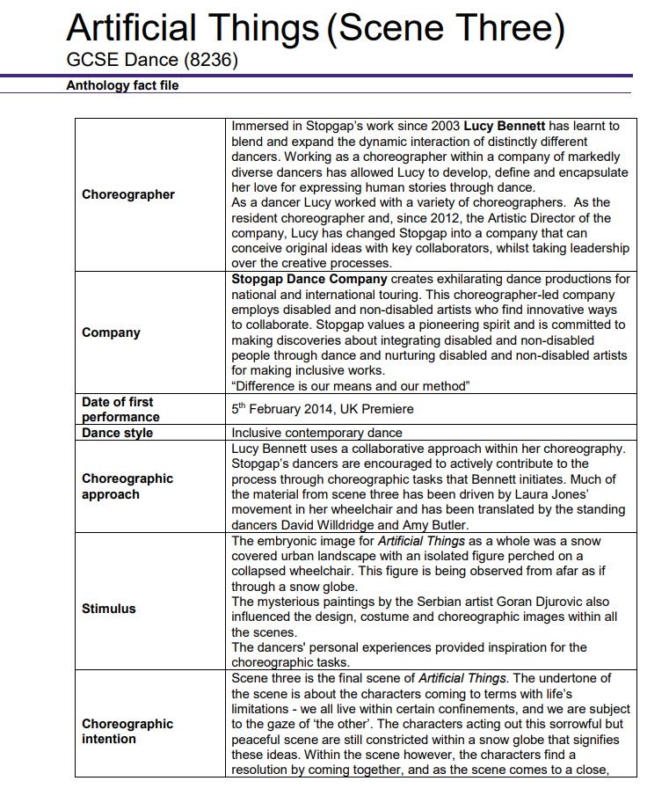

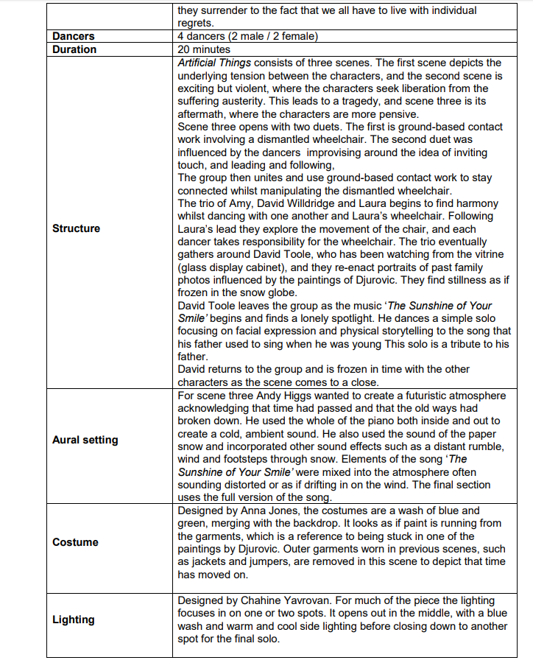

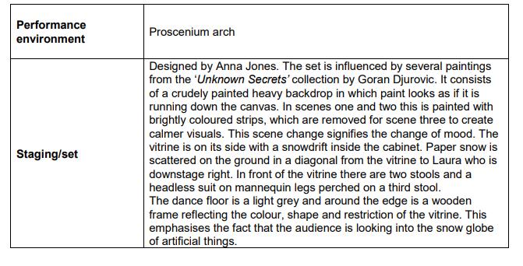

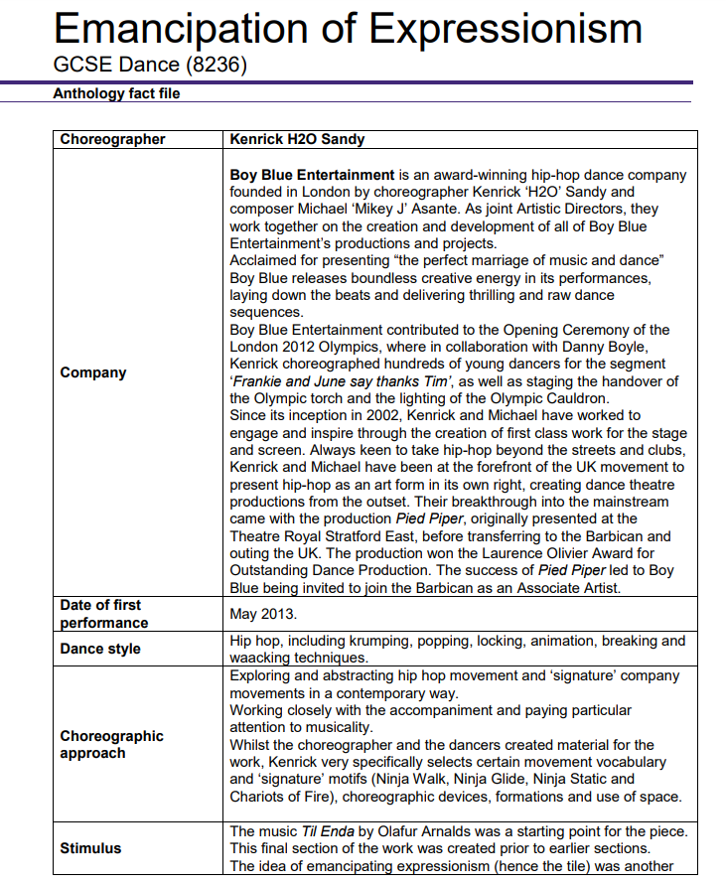

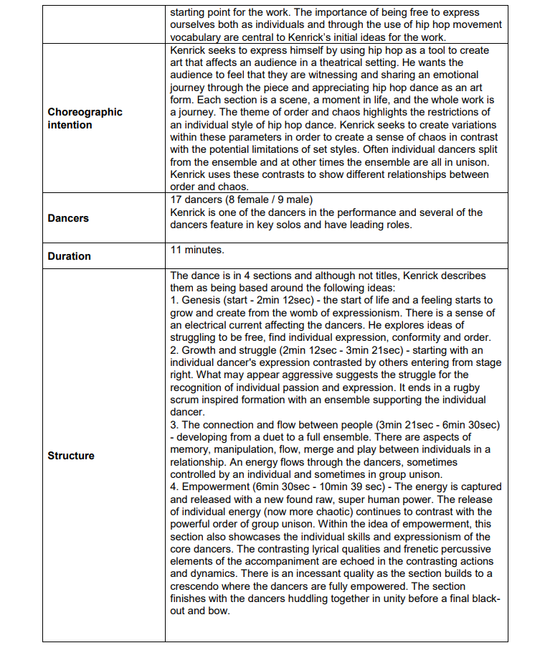

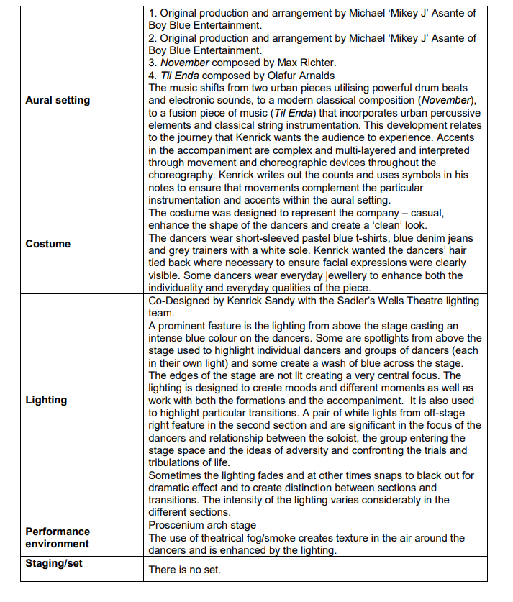

AQA Education (AQA) is a registered charity (number 1073334) and a company limited by guarantee registered in
England and Wales (number 3644723). Our registered address is AQA, Devas Street, Manchester M15 6EX.
2 of 2
V2

