Religious Studies

Theme D
Peace and Conflict

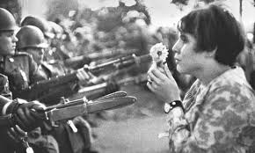

Name: _______________________
Keywords

Conflict | Dispute between sides, can be between individuals, groups or nations.
Forgiveness | Letting go of blame against a person for wrongs they have done; moving on.
Holy War | War that is believed to be sanctioned by God.
Justice | Bringing fairness back to a situation.
Just War | Set of rules for fighting a war in a way believed to be justified and acceptable to God.
Nuclear deterrence | Having nuclear weapons with the aim of deterring/preventing other states attacking for fear of retaliation and nuclear war (possibly leading to Mutually Assured Destruction).
Nuclear weapons/war | A weapon of mass destruction which causes widespread damage and loss of life. Nuclear war would be a war fought using these weapons.
Pacifism | Belief that all violence is wrong, which then affects all behaviours.
Peace | The opposite of war; harmony between all in society.
Peace-making | Working to bring about peace and reconciliation.
Protest | A statement or action to express disagreement; can be an organised event to demonstrate disagreement with a policy or political action
Reconciliation | Making up and rebuilding relationships between two groups/sides after disagreement.
Retaliation | To pay someone back for their harmful actions.
Terrorism | Use of violence and threats to intimidate others; used for political purposes to build fear in the ordinary population and to secure demands from Government.
Victims of war | Those who are harmed during a war, for example those killed, injured or left homeless.
Violence | Behaviour involving physical force which intends to hurt, kill or cause damage.
War | Armed conflict between two or more sides.
Weapons of Mass Destruction | Weapons which cause widespread, indiscriminate damage (eg nuclear, chemical, biological).

TASK : Choose 8 key words from our course so far and write them into the circles. Then, draw lines from each word to a different word, writing a sentence that joins them. Complete the rest of your ‘Concept Map’. Try to be as creative as possible, matching up each key concept word with its neighbours and with concepts from the other side of the circle!
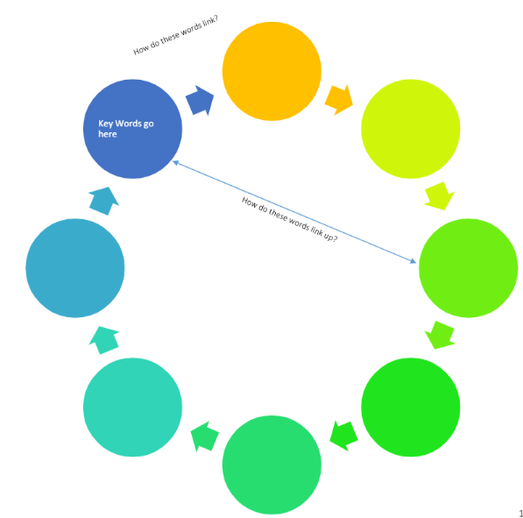
____________________________________________________________________________________________________________________________________________________________________________________________________________________________________________________________________________________________________________
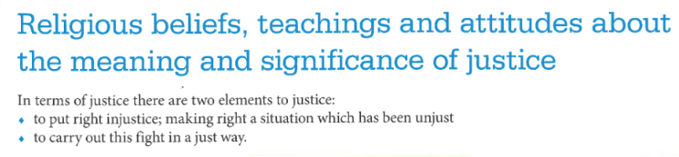

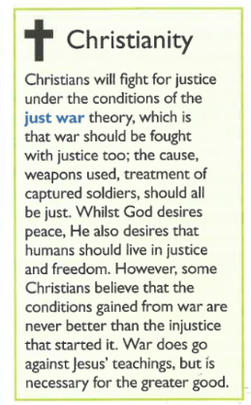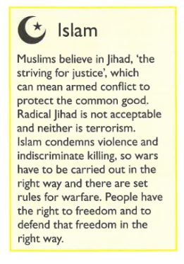

Justice can be defined as bringing fairness back to a situation. There are two elements of Justice that are looked at in this Peace and Conflict module. To put right an injustice, and to do so in a just way. If it was not done in a fair way, then others would feel a sense of injustice and the cycle of violence would be perpetuated.

Christianity teaches against violence. However we live in a world where sometimes war is the only option that is left. It is important to note that there are very stringent conditions for a Christian to be able to go to war; this is known as the just war theory. It focuses on every aspect of War: the cause or justification; to the weapons that are used; and the treatment of soldiers once they have been captured.

Christians believe that God desires peace, some Christians therefore that would argue that going to war is never justifiable. Believing that which is gained from war never outweigh the injustice of starting a war, and the consequences of war. They would argue that even if there was a dictator that was coming to invade your land and enslave your nation that war is not an option this is due to the pain and suffering that people will go through due to the fact of War itself. Other would argue that War goes against the teachings of Jesus, however believe it necessary for the greater good

Islam is also a religion of peace; the word Islam means peace. Every Muslim faces the Jihad (struggle). There are two elements of this: the greater and, the lesser Jihad; correspond to the internal struggle to be a good Muslim and can mean the armed conflict to protect the common good respectively. This does not mean to say the radical Islam and terrorism is allowed. The terrorist act are a misappropriation of the word Jihad, and would not stand up to the very strict conditions for war in Islam. There is a similar just war theory within Islam. War is to be carried out in the right way, there are prescriptive rules for Warfare. Muslims believe people have the right to freedom and to defend that right in the correct way.

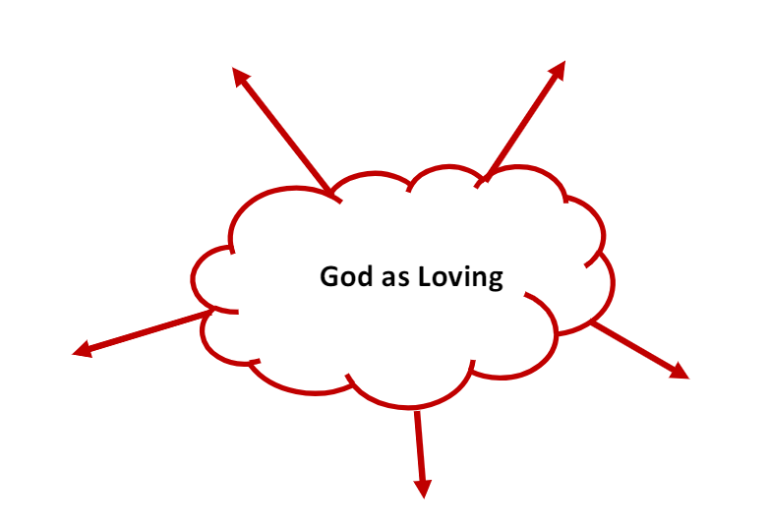
Justice

Using the mind map and the example above, give your own definition of Justice. Include religious attitudes.
________________________________________________________________________________________________________________________________________________________________________________________________________________________________________________________________________________________________________________________________________________________________________________________________________________________________________________________________________________________________________________________________________________________________________________________________________________________
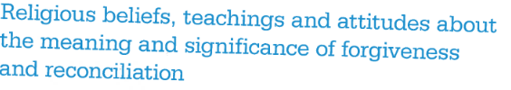
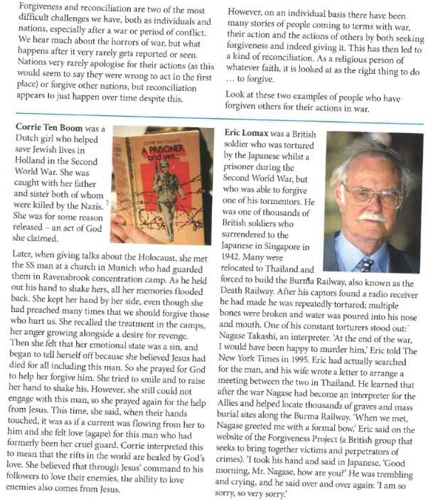

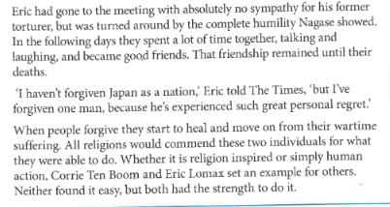

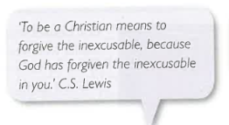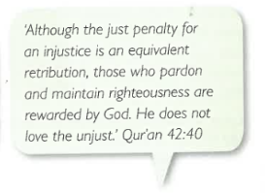

Task: Create a Newspaper article on the examples of forgiveness. Give it a catchy headline and change the style of writing to be more like a news report. Try to include the religious attitudes to forgiveness. Maybe include an editorial opinion on your opinion on Forgiveness,

THE Droylsden Daily
Headline

…………………………………………………….

…………………………………………………….

…………………………………………………….

…………………………………………………….

…………………………………………………….

…………………………………………………….

…………………………………………………….

…………………………………………………….

…………………………………………………….

…………………………………………………….

…………………………………………………….

…………………………………………………….

…………………………………………………….

…………………………………………………….

…………………………………………………….

…………………………………………………….

…………………………………………………….

…………………………………………………….

…………………………………………………….

…………………………………………………….

…………………………………………………….

Picture

………………………………………………

………………………………………………

………………………………………………

………………………………………………

………………………………………………

………………………………………………

………………………………………………

………………………………………………

………………………………………………

………………………………………………

………………………………………………

………………………………………………

…………………………………………………….

…………………………………………………….

…………………………………………………….

…………………………………………………….

…………………………………………………….

…………………………………………………….

…………………………………………………….

…………………………………………………….

…………………………………………………….

…………………………………………………….

…………………………………………………….

…………………………………………………….

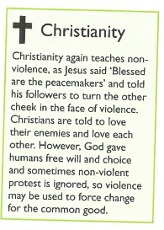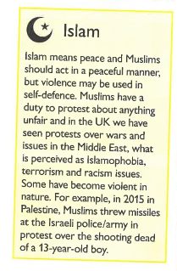
Choose a Religious story, that has a moral message about violence

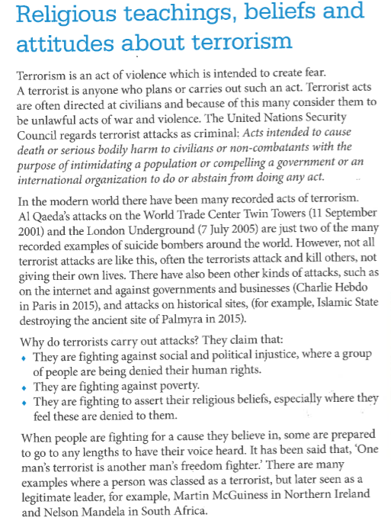

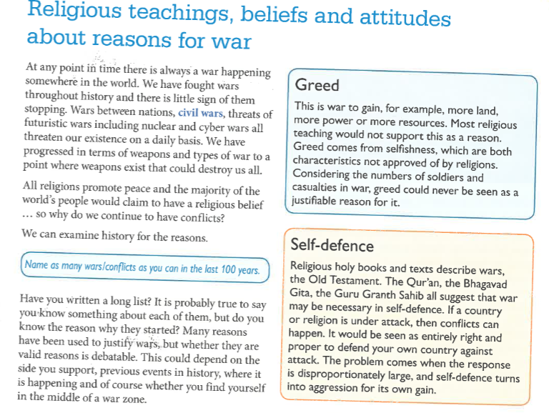
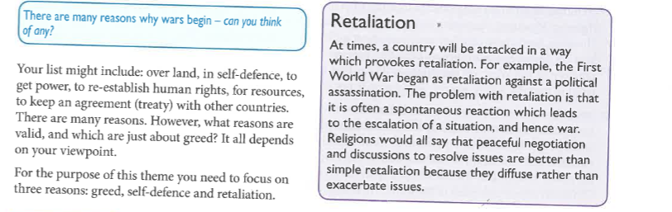

Write out the different teaching and attitudes to the reasons for war below

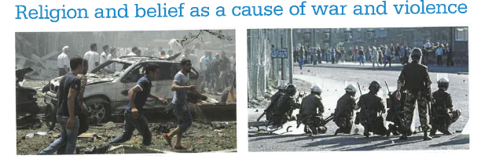
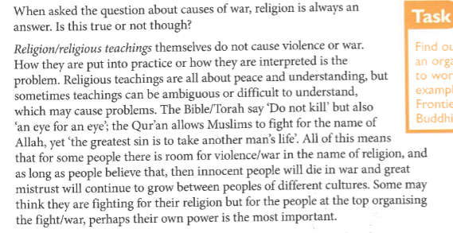
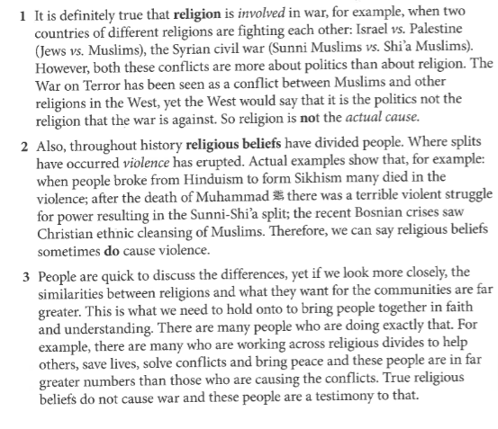

Task
Use the table to help plan an essay on “Religion only creates more violence in the world”
- Use the information above to help you put points in each section
- Include a specific example for each side
- Include a religious quote for each side

Causes violence | Creates peace

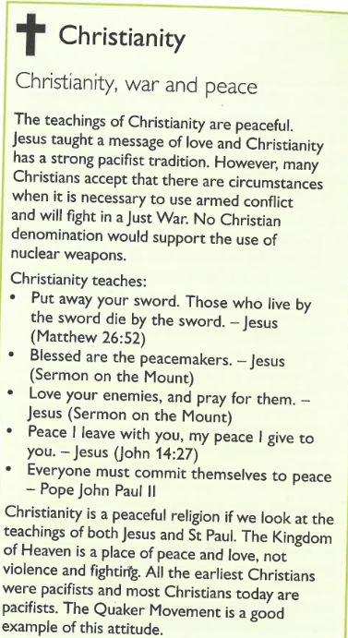
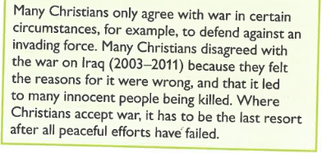
Quote | Explain what you think it means in your own words, then explain what it says about war and peace.
Put your sword away. Those who live by the swords die by the sword

(Matthew 26:52)
Blessed are the peacemakers

(sermon on the mount)
Love your enemies, pray for them

(sermon on the mount)
Peace I leave you, my peace I give you

(John 14:27)
Everyone must commit themselves to peace

(Pope John-Paul II)

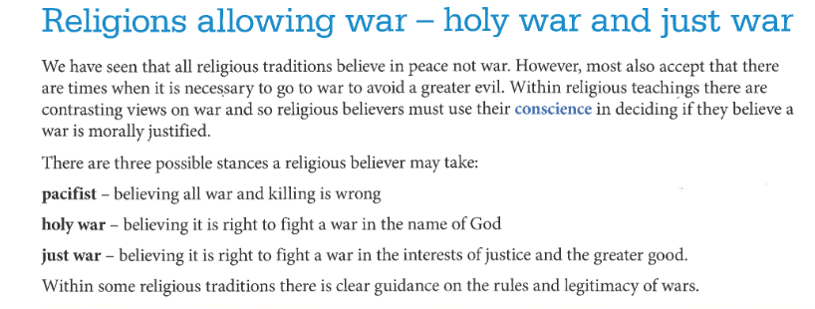
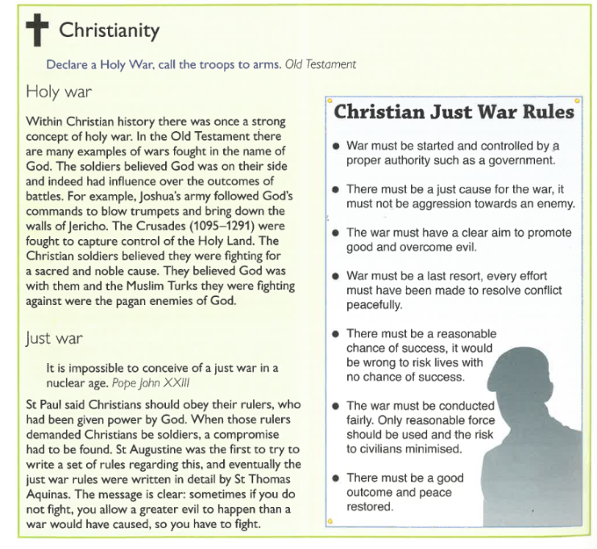

Create a Check list for a Just war

- _____________________________
- _____________________________
- _____________________________
- _____________________________
- _____________________________
- _____________________________
- _____________________________

Choose any war that has happened in history. Go through the Check list. Do they meet the conditions for a Just war?

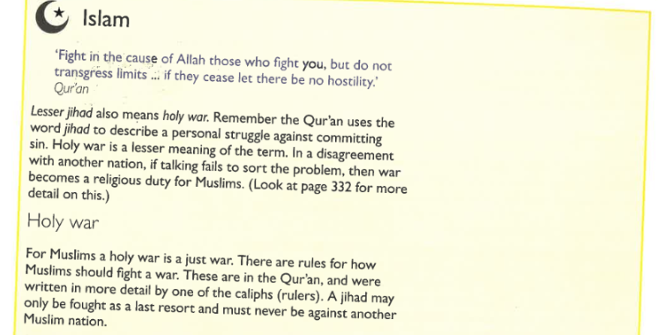
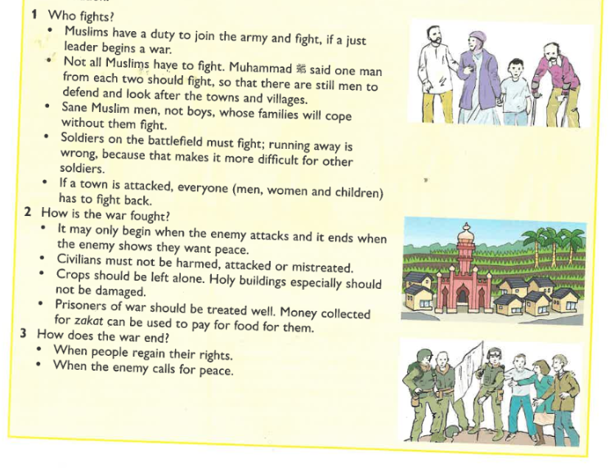
On the next page make a ‘comparison between the Christian Just war theory and the conditions required for an Islamic Holy war. Are there any similarities that they share? Is there anything that is unique to Christianity or Islam?

Just Christian | Both | Just Islam

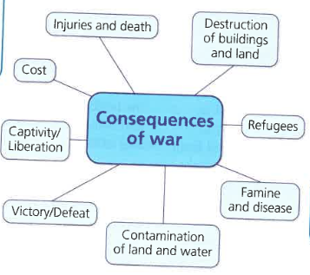
- Add to the Spider diagram
- Write a short explanation of these consequences of war.
  - How are they caused?
  - What might the short term effect be?
  - What might the long-term effect of these be?
  - What is the impact on an individual?
  - What might be overall impact?
Destruction of buildings and land
______________________________________________________________________________________________________________________________________________________________________________________________________________________________________________________
Refugees
______________________________________________________________________________________________________________________________________________________________________________________________________________________________________________________

Famine and disease
______________________________________________________________________________________________________________________________________________________________________________________________________________________________________________________
Contamination of land and water
______________________________________________________________________________________________________________________________________________________________________________________________________________________________________________________
Victory/defeat
______________________________________________________________________________________________________________________________________________________________________________________________________________________________________________________
Captivity
______________________________________________________________________________________________________________________________________________________________________________________________________________________________________________________
Liberation
______________________________________________________________________________________________________________________________________________________________________________________________________________________________________________________
Cost
______________________________________________________________________________________________________________________________________________________________________________________________________________________________________________________
Injuries
______________________________________________________________________________________________________________________________________________________________________________________________________________________________________________________

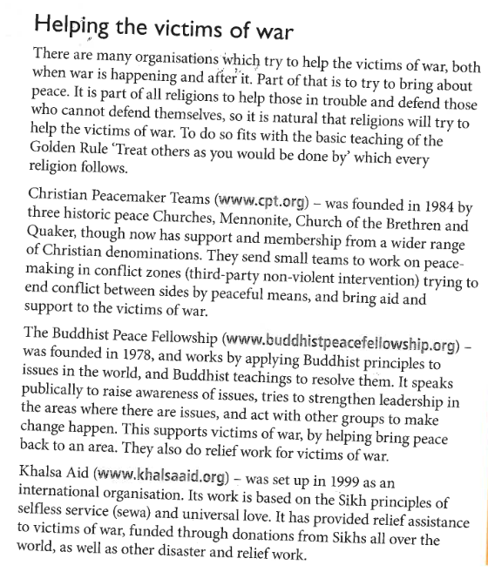

Write a speech trying to get young people to help the victims of War
Use DAFOREST to help you
Direct address, Alliteration, Facts, Opinions, Rhetorical Language, Statistics, Three (rule of)
________________________________________________________________________________________________________________________________________________________________________________________________________________________________________________________________________________________________________________________________________________________________________________________________________________________________________________________________________________________________________________________________________________________________________________________________________________________________________________________________________________________________________________________________________________________________________________________________________________________________________________________________________________________________________________________________________________________________________________________________________________________________________________________________________________________________________________________________________________________________________________________________________________________________________________________________________________________________________________________________________________________________________________________________
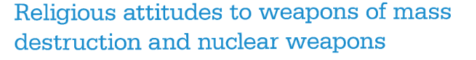
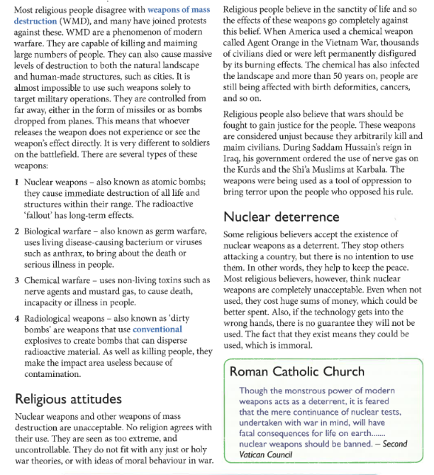

Task
Write the different WMD on the post-it note
Write religious perspectives on WMD on the post-it notes
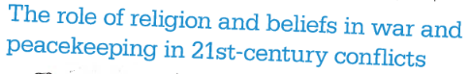

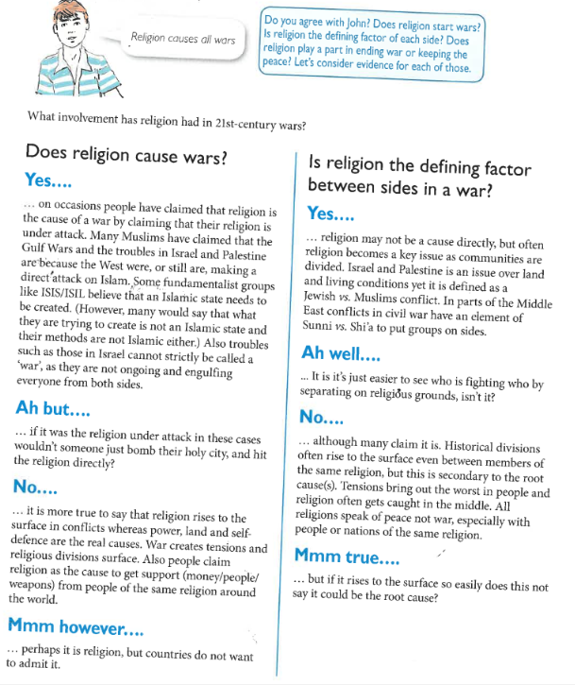
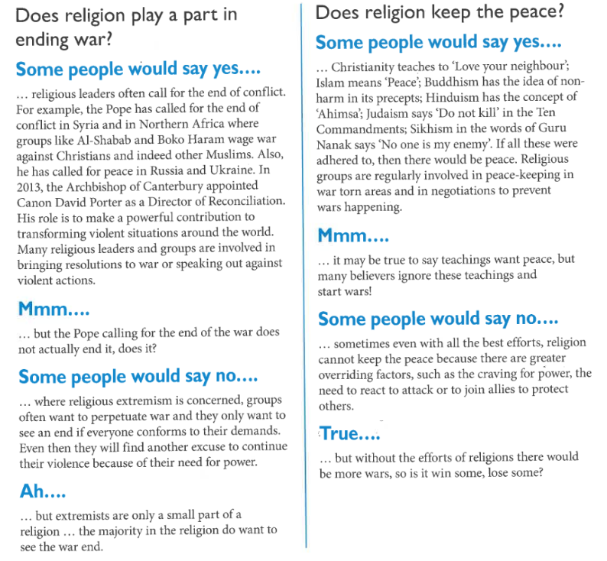

Task

Practice writing a conclusion based on the arguments that are made above.

- Analyse the arguments.
- Give your opinion on which one you find most convincing.
- Give opinion in why you are not convinced by the other side of the argument
- Explain why you think this.
- In your conclusion you must make reference to the arguments that have been made.

Question | Conclusion
Does religion cause wars? | _________________________________________________  _________________________________________________  _________________________________________________  _________________________________________________  _________________________________________________  _________________________________________________  _________________________________________________  _________________________________________________  _________________________________________________  _________________________________________________
Is Religion the defining factor between sides in war? | _________________________________________________  _________________________________________________  _________________________________________________  _________________________________________________  _________________________________________________  _________________________________________________  _________________________________________________  _________________________________________________  _________________________________________________  _________________________________________________
Does Religion play a part in ending war | _________________________________________________  _________________________________________________  _________________________________________________  _________________________________________________  _________________________________________________  _________________________________________________  _________________________________________________  _________________________________________________  _________________________________________________  _________________________________________________  _________________________________________________
Does religion keep the peace? | _________________________________________________  _________________________________________________  _________________________________________________  _________________________________________________  _________________________________________________  _________________________________________________  _________________________________________________  _________________________________________________  _________________________________________________  _________________________________________________
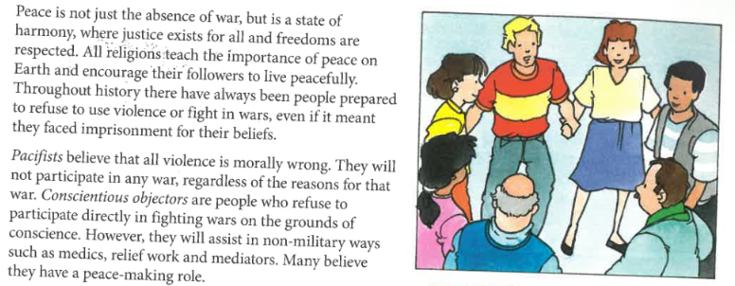
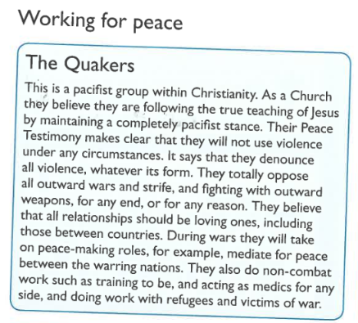
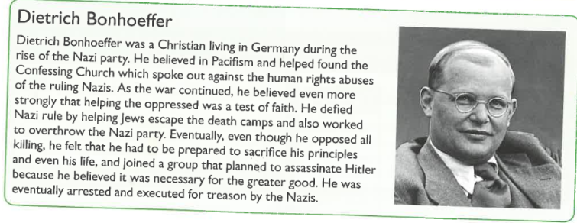
Task
Fill in the spaces below what religious attitudes to Pacifism
Find two religious quote to support this point of view
