GCSE Religious Studies
Relationships & Families
Workbook

Name:

Sex and Sexuality
People have sex for many reasons: love, lust, fun, money, to create life, etc. Society’s views to sex have changed over time – as it has done with most things, however you will need to know both secular (what society says/does) and religious attitudes.
Age of Consent
This is when you are old enough by law to choose to have sex. It is sixteen for anyone. Of course you could have sex before then – but you aren’t considered mature enough to be responsible enough and it is against the law.
Celibacy
This is when a person chooses to have no sexual partner. Either they decide to wait until marriage to have sex (chastity) or they will never marry and never have sex (celibacy).
Heterosexuality
People of opposite genders in a relationship
Homosexuality
People of the same gender in a relationship

Adultery
Having an affair (a sexual relationship) with someone who is not your marriage partner.
Sex Before Marriage
Having a sexual relationship before marriage. Some people feel that marriage is no longer relevant in today’s modern world, choosing to cohabit instead.

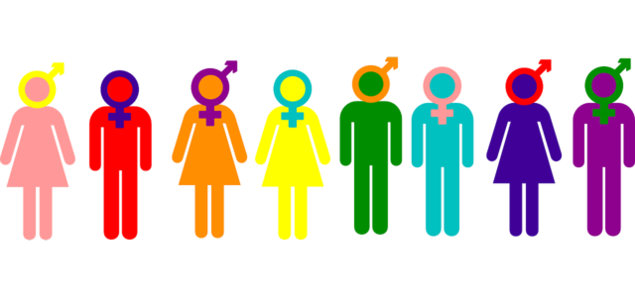

Tasks:
- Why might a person have sex?
…………………………………………………………………………………………………………
…………………………………………………………………………………………………………

- What is the age of consent?
…………………………………………………………………………………………………………
…………………………………………………………………………………………………………

- Why shouldn’t you have sex before the age of consent?
…………………………………………………………………………………………………………
…………………………………………………………………………………………………………

- What is celibacy?
…………………………………………………………………………………………………………
…………………………………………………………………………………………………………

- What is chastity?
…………………………………………………………………………………………………………
…………………………………………………………………………………………………………

- What is heterosexuality?
…………………………………………………………………………………………………………
…………………………………………………………………………………………………………

- What is homosexuality?
……………………………………………………………………………………………………………………………………………………………………………………………………………………

- What is adultery?
……………………………………………………………………………………………………………………………………………………………………………………………………………………

- What is ‘sex before marriage’?
……………………………………………………………………………………………………………………………………………………………………………………………………………………

- Why might someone choose to have sex before marriage nowadays?
……………………………………………………………………………………………………………………………………………………………………………………………………………………

Contraception and Family Planning
Contraception: Methods used to prevent a woman from becoming pregnant during or following sexual intercourse

There are two types of contraception:
- Natural contraception: This can include Natural Family Planning. This is when a person doesn’t have sex during the time of the month when they are most likely to become pregnant. Natural contraception also includes the Withdrawal Method, where the man ‘pulls-out’ before he ejaculates. However this is an extremely unreliable method of contraception.
- Artificial contraception: These methods include the pill, injection or condom to prevent contraception.

Christian Attitudes to Contraception
Most Christians believe that only married couples should have sex and only with each other. Chastity (not having sex until marriage) is a virtue. Attitudes to the use of contraception vary. In addition to views on contraception, there is a celibate tradition in Christianity for those who follow the monastic life, and the priesthood.
Roman Catholic:
The Roman Catholic Church believe that every sexual act must be within the framework of marriage; only married couples should have sex and the most important reason for sex is to have children. There should be a chance of pregnancy within every sex act. The Roman Catholic Church opposes artificial contraception. However, population growth is currently a debate throughout the planet, so some Catholics will consult their consciences when making a decision about using contraception.
Sex before marriage is called fornication, and is a sin. The same goes for masturbation, because it cannot lead to pregnancy.
For some Christians, homosexual sex is thought to be unnatural, and again cannot lead to pregnancy, so it is a sin. In places, the Bible also says it is wrong for a man to sleep with another man, which has also been used to show homosexuality to be wrong.
Many Catholics also want to enjoy sex without the worry of having more children that they can’t look after or afford.
St. Thomas Aquinas developed a theory on Natural Law, which many Catholics consult when making moral decisions. Aquinas said there are some fundamental laws laid down by God and are the basis of how human should live and carry out their lives. There are five primary precepts:
- Self-preservation/preservation of the innocent
- Continuation of the species through reproduction
- Education of children
- To live in society
- To worship God
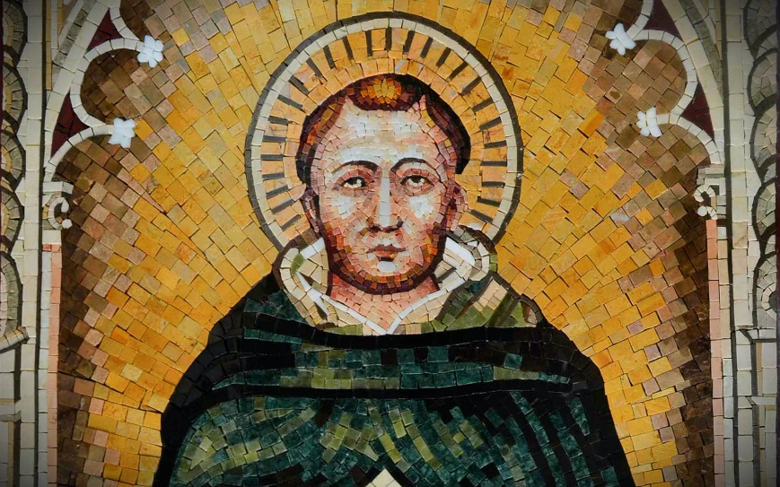
From these primary precepts, Aquinas set out secondary precepts that fulfil and maintain the primary precepts. For example, the second precept says that we should reproduce, therefore contraception is wrong as it would prevent reproduction.
Natural Law should always be followed. If Natural Law states that we should continue the species, then contraception is going against that! - Aquinas
The Catholic Church takes an absolutist view of Aquinas’s Natural Law, meaning that the rules Aquinas laid down should always be followed. Therefore, contraception should not be used as it goes against Natural Law.
Church of England
Natural Law is not an absolute set of laws, but a relative set of laws. God gave humans intelligence and creativity so that they can use their consciences to decide what is right in any given situation. There might be some situations where using contraception is the moral and responsible thing to do, e.g. where the parents already have children and cannot afford any more, or when considering global over-population.
In addition, contraception doesn’t just prevent pregnancy, but the spread of STIs/STDs, so it is a good thing for this reason.
For some Christians, the use of contraception is to be encouraged as it leads to responsible parenthood.
Humanism
Contraception is allowed so that people can enjoy their lives and limit the size of families. Sex is regarded as an expression of human affection and love between two people and it has no religious or sacred aspect.
Science should be used to improve the quality of life for human beings, therefore is the use of contraception limits the size of families and leads to an improvement in the quality of life it should be used.
Tasks:
- What is natural contraception?
…………………………………………………………………………………………………………
…………………………………………………………………………………………………………

- What is artificial contraception?
…………………………………………………………………………………………………………
…………………………………………………………………………………………………………

- What do most Christians believe about contraception?
…………………………………………………………………………………………………………
…………………………………………………………………………………………………………

- Explain in detail the Roman Catholic views about contraception.
…………………………………………………………………………………………………………
…………………………………………………………………………………………………………
……………………………………………………………………………………………………………………………………………………………………………………………………………………
……………………………………………………………………………………………………………………………………………………………………………………………………………………

- Explain St. Thomas Aquinas’ Natural Law.
…………………………………………………………………………………………………………
…………………………………………………………………………………………………………
……………………………………………………………………………………………………………………………………………………………………………………………………………………
……………………………………………………………………………………………………………………………………………………………………………………………………………………

- What do Church of England Christians believe about contraception?
…………………………………………………………………………………………………………
…………………………………………………………………………………………………………
……………………………………………………………………………………………………………………………………………………………………………………………………………………
……………………………………………………………………………………………………………………………………………………………………………………………………………………

- What do humanists believe about the use of contraception?
……………………………………………………………………………………………………………………………………………………………………………………………………………………
……………………………………………………………………………………………………………………………………………………………………………………………………………………

Muslim Attitudes to Sexual Matters
Islam does not agree with choosing never to marry or with monastic lifestyles. It is a religious duty to marry and have children. Every person should be a virgin before marriage, and observe chastity before and during marriage. Celibacy as a life choice is wrong.
If only those who are married have sex, then it is thought that society is protected, because all the issues linked to sex outside of marriage are gone. The message is very clear in Islam: only married couples may have sex, and then only with each other. Prophet Muhammad (PBUH) spoke of sex as being special within marriage. He said it was a source of pleasure and provided the blessing of children from God, if the couple so wished. This means that Muslims can and should use contraception. Muhammad (PBUH) also said that couples should only have as many children as they could properly look after – responsible parenthood.
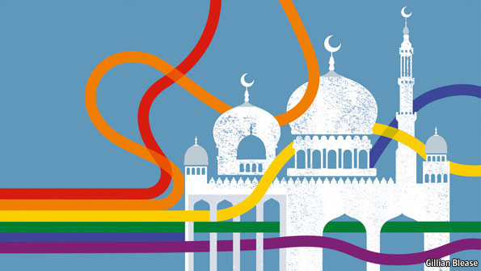
The Qur’an sets out specific punishments for those who have sex before marriage, or who commit adultery, or have homosexual relationships. It calls these people ‘fornicators’ and punishment is severe (flogging if single, execution if married). This is till part of Shari’ah law, and a punishment used in some Muslim countries. In several places, the Qur’an specifically mentions adultery, always saying it is wrong: “Do not commit adultery. It is shameful and an evil way to act.” (Surah 17:32)
Tasks:
- Why do Muslims disagree with celibacy or monastic lifestyles?
…………………………………………………………………………………………………………
…………………………………………………………………………………………………………

- How is society protected in Islam?
…………………………………………………………………………………………………………
…………………………………………………………………………………………………………

- What did Prophet Muhammad (PBUH) say about sex?
…………………………………………………………………………………………………………
…………………………………………………………………………………………………………

- What do Muslims believe about contraception?
…………………………………………………………………………………………………………
…………………………………………………………………………………………………………

- For which crimes does the Qur’an set out punishments for?
…………………………………………………………………………………………………………
…………………………………………………………………………………………………………

- What are the punishments for sexual misconduct?
…………………………………………………………………………………………………………
…………………………………………………………………………………………………………

- What does the Qur’an say about adultery in Surah 17:32?
……………………………………………………………………………………………………………………………………………………………………………………………………………………
……………………………………………………………………………………………………………………………………………………………………………………………………………………

Contrasting Beliefs: Contraception

Roman Catholics  - All sexual acts must be open to procreation – this is natural law  - Anything done to prevent natural law is wrong  - The Pope said, “any act which deliberately prevents procreation is an intrinsic evil.”  - Use of artificial contraception is a deliberate act, and that is a sin. Catholics should not use contraception | Anglican  - The church of England does not see contraception as a sin, nor is it against God’s teaching  - Sexual love is good in itself  - There can be good reasons for limiting or delaying parenthood
Islam  - Muslims should practise responsible parenthood  - Muslims should only have the children they can care properly for | Judaism  - Orthodox Judaism accepts the use of contraception for medical/health reasons  - The ‘wasting of seed’ is forbidden in the Torah, so the Pill is an acceptable form to use

- Explain the contrasting beliefs about the use of contraception in religious traditions.
……………………………………………………………………………………………………………………………………………………………………………………………………………………
……………………………………………………………………………………………………………………………………………………………………………………………………………………
……………………………………………………………………………………………………………………………………………………………………………………………………………………
……………………………………………………………………………………………………………………………………………………………………………………………………………………
……………………………………………………………………………………………………………………………………………………………………………………………………………………
Marriage and the Family
Marriage is the joining of two people as a legal couple. When done religiously, it is done before God for God’s blessing on the covenant.
Why do people marry?
People marry for many reasons, for example: love, money, family expectations, religious duty, to legitimise a relationship, to legitimise a child, for sex, for companionship, etc.
Some families expect a person to marry someone who their family approves of or someone who shares the same religion. This is not always the case, however.
Roles in Marriage
The marriage vows can help us understand the different roles within marriage. In marriage, a couple promise to each other, either through vows/promises or through a contract, to be good to each other through good and bad, until the marriage is ended by death. If you were setting up an agreement with someone about how you would live the rest of your life together as a couple, you would probably come up with the same or similar set of values.
Additionally, roles might include who keeps house (cooking, cleaning, etc.) who leads the upbringing of the children, or their discipline, who earns money for the family. Traditionally, the man went out to work and the woman stayed at home looking after the home and family. In our society, it is becoming more common for all these tasks to be shared by the man and the woman and even for them to be reversed from what is seen as traditional, e.g. a man who stays at home and a woman who goes out to work.
What is a family?
- Foundation for all human activity
- Where human relationships begin and develop
- Procreation, which develops new purposed and responsibilities
- Where children have stability and ensuring they have a good education
- Where children have a duty to obey their parents, which is a part of showing respect to them
- Where the norms and values of society are lived out and practiced
- Where new generations are brought up into adulthood
- Educating children in faith
- Same-sex couples who have a faith may also choose to raise their children within their religious faith
Types of Family
Nuclear
Two parents and one or more

Single Parent Family
One parent raising one or more children alone. Increased rates of divorce has led to more single-parent families.

Nuclear
Two parents and one or more

Extended Family
Number of adults and children who are related living in the same home, e.g. aunts, cousins etc.

Nuclear
Two parents and one or more

Reconstituted Family
Divorced adults remarried or cohabiting and may include children from the new relationship.

Nuclear
Two parents and one or more

Nuclear
Two parents and one or more children living in the same house

Nuclear
Two parents and one or more

Childless Family
Married or cohabiting couple without children due to choice or inability to conceive.

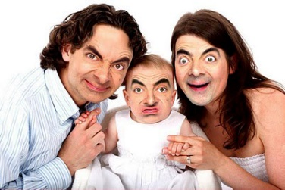

Contrasting Beliefs: Sex Before Marriage

Christianity  - Sex should only be experienced within marriage  - Sex is a gift from God for the purpose of procreation, but is also a sign of a couple’s loving bond  - Sex before marriage is seen as fornication, which is a sin  - St Paul said, “Now to the unmarried and the widows I say: It is good for them to stay unmarried, as I am. But if they cannot control themselves, they should marry, for it is better to marry then to burn with passion.” (1 Corinthians 7:9) | Islam  - Muslims consider marriage to be the foundation for family life.  - Islam teaches that a man completes half his religious responsibilities when he marries.  - Marriage is the best way for Muslims to have a stable relationships and true sexual fulfilment.  - Many Muslims believe a Muslim woman must marry as Muslim man.  - “There is no institution in Islam more beloved and dearer [to God] that marriage.” Hadith.
Anglicans  - The General Synod of the Church of England recognises the variety of family forms today. It stresses that whilst marriage is the ideal context, sexual relationships must be within permanent, loving relationships (which allows sex before marriage) | Quakers  - The Quaker Society sees marriage as the ideal context, but accepts changing society norms  - It accepts that a couple can be faithful to each other in a loving, non-exploitative relationship outside of marriage.

Tasks:
- What is marriage?
…………………………………………………………………………………………………………
…………………………………………………………………………………………………………

- Why do people marry?
…………………………………………………………………………………………………………
…………………………………………………………………………………………………………

- What are the different roles within marriage?
…………………………………………………………………………………………………………
…………………………………………………………………………………………………………

- What are the traditional versus the modern views of family roles?
…………………………………………………………………………………………………………
…………………………………………………………………………………………………………

- What is a family and the purpose of the family? Explain in detail.
…………………………………………………………………………………………………………
…………………………………………………………………………………………………………
…………………………………………………………………………………………………………
…………………………………………………………………………………………………………
…………………………………………………………………………………………………………
…………………………………………………………………………………………………………
…………………………………………………………………………………………………………
…………………………………………………………………………………………………………

- What are the five different types of family? What do they include?
…………………………………………………………………………………………………………
…………………………………………………………………………………………………………
- Explain the contrasting beliefs about sex before marriage in religious traditions.
……………………………………………………………………………………………………………………………………………………………………………………………………………………
……………………………………………………………………………………………………………………………………………………………………………………………………………………
……………………………………………………………………………………………………………………………………………………………………………………………………………………
……………………………………………………………………………………………………………………………………………………………………………………………………………………
……………………………………………………………………………………………………………………………………………………………………………………………………………………
……………………………………………………………………………………………………………………………………………………………………………………………………………………
Marriage Ceremonies
Christian Marriage Ceremonies
In some branches of Christianity, marriage is a sacrament; it brings a blessing from God. In the Roman Catholic ceremony, marriage takes place as part of the Mass.
- The couple will come to church to be united in marriage by the priest.
- The priest greets them before the whole congregation.
- The priest then ready a homily (a moralising lecture) about marriage and what Christian marriage is.
- He asks three set questions to the bride and groom to make sure they understand the responsibilities of the marriage.
- The couple make vows to each other, e.g. “to love and to cherish.”
- The priest declares they have agreed before God and accepts their decision. It is at this point he says, “What God has joined together, let no man put asunder”.
- The rings are blessed and exchanged.
- The priest blesses the marriage
- The couple sign the marriage register. This is the civil bit of the ceremony

Tasks:
- What is a sacrament?
…………………………………………………………………………………………………………
…………………………………………………………………………………………………………

- In Christianity, who are the couple united in marriage by?
…………………………………………………………………………………………………………
…………………………………………………………………………………………………………

- What is a homily?
…………………………………………………………………………………………………………
…………………………………………………………………………………………………………

- Why does the priest ask three set questions to the bride and groom?
…………………………………………………………………………………………………………
…………………………………………………………………………………………………………

- What is an example of the vows that couples say to each other?
…………………………………………………………………………………………………………
…………………………………………………………………………………………………………

- What does the priest say about the permanence of marriage?
…………………………………………………………………………………………………………
…………………………………………………………………………………………………………

- What part of the marriage is the ‘civil’ bit?
……………………………………………………………………………………………………………………………………………………………………………………………………………………

Muslim Marriage Ceremonies
- Traditionally, Muslim weddings last up to five days, because of the many cultural traditions depending upon which Muslim country or area is involved.
- The ceremony, which would take place on day four of a five-day celebration, is called nikkah. It is always a simple ceremony and is performed by an imam. Most nikkah are performed at the home of the bride or groom, and not the mosque
- The groom has to declare a mahr (a dowry), showing his respect for the bride. It can include anything she has asked for (for example, money, clothes or even a house). The groom can pay this over time, and is not allowed to take it away; it is hers.
- An imam usually leads the ceremony, but it could be any respected males. The bride does not have to be there, she will have given her consent beforehand
- Some couples take vows. They will have signed marriage contract beforehand about what they expect from the marriage and what the rights of their partner will be
- The imam announces their intention to marry and asks if anyone has any objections. He also recites some verses from the Qur’an, and the Nikkah Khutba, which is about the purpose of marriage
- The consent of the bride is asked for three times by the imam. After it is given, the marriage is complete

Tasks:
- How many days do Muslim weddings traditionally last?
…………………………………………………………………………………………………………
…………………………………………………………………………………………………………

- What is ‘nikkah’?
…………………………………………………………………………………………………………
…………………………………………………………………………………………………………

- What is a ‘mahr’?
…………………………………………………………………………………………………………
…………………………………………………………………………………………………………

- Who usually leads the ceremony?
…………………………………………………………………………………………………………
…………………………………………………………………………………………………………

- What will have been signed beforehand?
…………………………………………………………………………………………………………
…………………………………………………………………………………………………………

- What is the Nikkah Khutba about?
…………………………………………………………………………………………………………
…………………………………………………………………………………………………………

- How many times must the bride give consent?
……………………………………………………………………………………………………………………………………………………………………………………………………………………

Cohabitation and Same-Sex Marriage
Cohabitation is living together as if married. The only different is the couple have no marriage license and legally they do not have the same rights as a marriage couple (for example, to each other’s pension). Not everyone feels the need to go through the marriage ceremony.
Civil marriage registration is about being married, but not through a religious ceremony. It is done at a registry office and may include promises, but it is not religious. Since March 2014, same-sex couples have been able to marry, meaning they have exactly the same rights as any other married couple.
Civil partnership is the legal registration of a same-sex couple. This means that in law they are treated as if married and they have many of the legal protections which a married couple are entitled to.
Different Attitudes to Marriage and Cohabitation
- Marriage is just a piece of paper
- Marriage gives the couple protection if the relationship fails, but also tax benefits whilst in the relationship
- Same-sex couples can become legal next-of-kins because of Civil Partnership
- If a couple love each other, then marriage is key. Marriage is the only appropriate setting for sexual relationships and having children
- Cohabitation is important to find out whether you are compatible with your partner, without making the commitment of marriage

Contrasting Beliefs: Homosexual Relationships

Quakers  - Accept homosexuals into their community and do not condemn those who have homosexual relationships  - Quakers were one of the first churches to talk openly about sexuality  - The quality and depth of feeling between two people is the most important part of a loving relationship, not their gender or sexual orientation  - There should be genuine, selfless love between the couple  - Genesis says that all are created in the image of God – including homosexuals | Roman Catholics  - Does not accept homosexual relationships  - Homosexuality is an ‘objective disorder’ (only leading towards sin)  - Homosexual relationships are a ‘moral disorder’ (committing a sin)
Islam
- Homosexuality is a crime against Allah
- Under Shari’ah Law, it is punishable by execution
- Prophet Muhammad (PBUH) said, ‘if you find anyone doing as Lot’s people did, kill the one who does it, and the one to whom it is done.’

Tasks:
- What is cohabitation?
…………………………………………………………………………………………………………
…………………………………………………………………………………………………………
- Civil marriage registration?
…………………………………………………………………………………………………………
…………………………………………………………………………………………………………

- What is civil partnership?
…………………………………………………………………………………………………………
…………………………………………………………………………………………………………

- State three different attitudes to marriage and cohabitation.
…………………………………………………………………………………………………………
…………………………………………………………………………………………………………
…………………………………………………………………………………………………………

- Explain in detail contrasting beliefs from different religious traditions about homosexual relationships.
…………………………………………………………………………………………………………
…………………………………………………………………………………………………………
…………………………………………………………………………………………………………
…………………………………………………………………………………………………………
…………………………………………………………………………………………………………
…………………………………………………………………………………………………………
…………………………………………………………………………………………………………
…………………………………………………………………………………………………………
…………………………………………………………………………………………………………
…………………………………………………………………………………………………………
…………………………………………………………………………………………………………
…………………………………………………………………………………………………………
…………………………………………………………………………………………………………
…………………………………………………………………………………………………………
…………………………………………………………………………………………………………
…………………………………………………………………………………………………………
Divorce
Many marriages fail and are legally dissolved. This is what is meant by the term ‘divorce’. In the UK, more than one in three first marriages ends in divorce. Marriages fail because of many difficulties, which may put a strain on the marriage. For example, money, arguments, different attitudes or beliefs, affairs, illness, job issues, abuse, etc. when those difficulties become too great for one or both to cope with, they might turn to divorce as a solution.
Should it be easy to get a divorce?
Many religious people believe that divorce is always wrong. Many of them do see a need for divorce, but feel that it should not be an easy option as this might encourage people to not even try at their marriage. In 1969 the Church of England was key in getting the divorce laws relaxed. The situation at the time meant that people were living in loveless marriages, or separating and being unable to move on. Jesus taught compassion, forgiveness and second chances – allowing divorce is compatible with that. Religions argue that people made a serious commitment, so they should work hard at their marriage and work even harder when it is in difficulty. Divorce should only be the last option.
Support for marriages in difficulty
Since divorce is not a welcome option, religions try to support couples in these times. Obviously, families will support them, for example, look after the children, listen and help them solve problems, and so on. Religious people will also do those things, but they might also encourage them through their religion, such as through prayer, reading holy books, and so on.
UK society also provides marriage counselling services, which allow couples to try to talk through problems or to come to amicable agreements ahead of divorce. This is important because many people feel angel and negative emotions when their relationship ends, which they need help to get through.

Christian Attitudes to Divorce
For Roman Catholics, divorce is always wrong. Marriage is a sacrament, which cannot be broken. Promises are made to God and each other to stay together ‘until death do us part’, and these promises are binding. It is possible to have an annulment, which is where the marriage is set aside, as if it was never real.
For most other Christians, divorce is discouraged, but accepted as a last resort. It is sometimes the lesser of two evils, and also a necessary evil so divorcees should not be made villains.
Christianity teaches:
- God hates divorce (Old Testament)
- ‘Whoever divorces…then marries another; it is as if he committed adultery’ – Jesus
- We should forgive those who wrong us, and show love to all – Jesus

Tasks:
- What do Roman Catholics believe about divorce?
…………………………………………………………………………………………………………
…………………………………………………………………………………………………………

- What promise is made to God that cannot be broken?
…………………………………………………………………………………………………………
…………………………………………………………………………………………………………

- What do other Christians believe about divorce?
…………………………………………………………………………………………………………
…………………………………………………………………………………………………………

- What does Christianity teach about divorce?
…………………………………………………………………………………………………………
…………………………………………………………………………………………………………
…………………………………………………………………………………………………………
…………………………………………………………………………………………………………
…………………………………………………………………………………………………………
…………………………………………………………………………………………………………

Muslim Attitudes to Divorce
Divorce is acceptable to both men and women. However, it is seen as the absolute last resort as it is deemed hateful to God. Islam teaches:
- Marry and do not divorce; the throne of Allah shakes due to divorce (Hadith)
- If you fear a breach between a man and his wife, appoint two arbiters (Qur’an)
A Muslim couple and their families are expected to work hard to fix any problems in a marriage to avoid divorce. There has to be mediation between them, and they have to give time for reflection and to solve problems. If divorce is still the solution, then the man states, “I divorce you” three times before witnesses. He must then wait three months (iddah) – to be sure his wife is not pregnant, and perhaps to resolve the problems. In these three months the couple are not to have sex but must remain living together. If the woman is pregnant, the couple must then remain together until after the baby is born. After that, he must pay the second part of the dowry to show the marriage has ended. The man must also support the woman until she remarries.

Tasks:
- What is divorce seen as in Islam?
…………………………………………………………………………………………………………
…………………………………………………………………………………………………………
- What is ‘iddah’ and why is this observed?
…………………………………………………………………………………………………………
…………………………………………………………………………………………………………

- Explain what Islam teaches about divorce.
…………………………………………………………………………………………………………
……………………………………………………………………………………………………………………………………………………………………………………………………………………
…………………………………………………………………………………………………………
…………………………………………………………………………………………………………
…………………………………………………………………………………………………………
…………………………………………………………………………………………………………
…………………………………………………………………………………………………………

Remarriage
This is when a person marries a different partner after a divorce from someone else; this is their second (or more) marriage. It is also sometimes the case that people who divorced later remarry each other. Some people talk about marriage after the death of a partner as being remarriage, others call this a second marriage.
Attitudes to remarriage
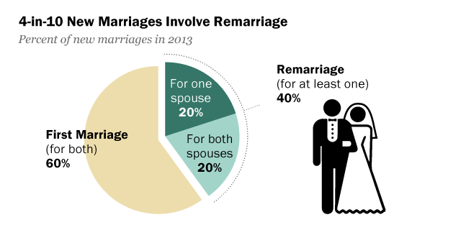
For most Christians, getting married again after the death of a first partner is not an issue. The vows state, “Till death us do part”. They believe the person deserves to be happy and remarriage might help them to be happy. Some, however, disagree with remarriage because a person has eternally vowed themselves to one person.

If it is marriage after divorce, Christians have a variety of opinions. For Roman Catholics, remarriage is wrong because the original marriage still exists. Divorce is not recognised by God, so remarriage is not allowed.
Other Christians might allow remarriage, but not allow a religious ceremony. Many Anglican vicars will not perform a marriage ceremony for divorced persons. They recognise that people might have found new happiness, and do believe that marriage forms the basis of a strong, good society. However, they also see the original ceremony as having a sanctity and vows made before God cannot just be laid aside to remake with someone else.
In the Roman Catholic tradition, it is possible to get an annulment of the marriage. This means that the marriage was never proper, usually because it was not consummated (there was no sexual relationship) or because one or both did not properly understand the responsibilities of marriage. Technically, any marriage after an annulment is not remarriage as there was no first marriage.
Tasks:
- What is remarriage?
…………………………………………………………………………………………………………
…………………………………………………………………………………………………………
- What do Christians generally believe about remarriage?
…………………………………………………………………………………………………………
…………………………………………………………………………………………………………

- What do Roman Catholics believe about remarriage?
…………………………………………………………………………………………………………
…………………………………………………………………………………………………………

- If a Christian remarries, what might they not be allowed? Why is this?
…………………………………………………………………………………………………………
…………………………………………………………………………………………………………
…………………………………………………………………………………………………………
…………………………………………………………………………………………………………
…………………………………………………………………………………………………………
…………………………………………………………………………………………………………

- What is an annulment?
…………………………………………………………………………………………………………
…………………………………………………………………………………………………………

- When might someone be granted an annulment?
…………………………………………………………………………………………………………
…………………………………………………………………………………………………………

Gender Equality –
Gender Prejudice
Gender prejudice is prejudice against someone because of their gender.
Why are some people prejudiced?
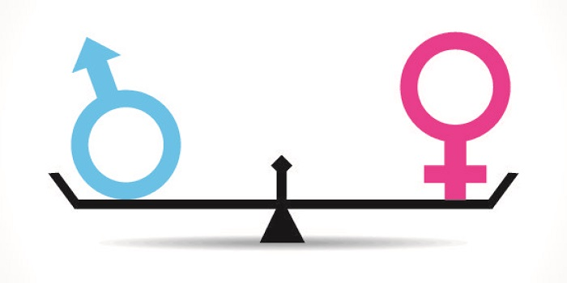
Prejudice is the pre-judgement of others based on a characteristic they have, rather than what they are really like. People are often prejudiced because of the way they were brough it; they were taught this kind of attitude and behaviour. There is often an element of tradition. In some societies, women don’t hold positions of power and do they are seen as less important. Attitudes are changing but in some cultures that change is very slow. It may also be because of an experience they have had, so their attitude to women was shaped by the women/men they met, or the situations they were in which made them think women/men should be treated in a certain way.
What is the effect of gender prejudice against women?
It can lead to different treatment (discrimination), so that women are given fewer opportunities, for example, by not getting the same chances or promotions at work. It may be that the culture within which they live sets stricter rules for women than for men, for example, where women are not allowed to leave the house, or can only leave when chaperoned, or where girls are not allowed education beyond a certain age; they seem not to have the same rights as men.
It may be that women are not allowed to contribute to decision-making or leadership roles, so a female perspective is never considered. Prejudice within power structures can mean that when women are treated negatively, there is no consequence for the perpetrator, and this further encourages that negative behaviour.
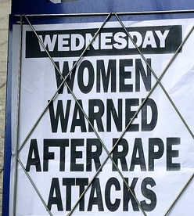
If you read the newspapers or watch TV shows, you get the impression that women are the usual victims of violent crime. 2014 saw a string of stories about the gang-rape of women in India with little justice served, which has become such an issue that it has led to campaigns and actions by women’s’ groups. When no punishments are given to men who commit these crimes, the message seems to be that violence against women is not so bad, which encourages more of it. Gender discrimination spans from unkind comments to murder; it definitely has an impact.
Ultimately, gender prejudice (when experienced through discrimination) makes women feel powerless, which affects their confidence and self-esteem. However, in society, it keeps women less powerful, and makes society work for men rather than for the balance of society. It is true that in the UK, laws exist to prevent gender discrimination, and that employment law is being changed to equalise pay and conditions, so things are
getting better for women.
The sexualisation of women even stretches to our Prime Minister and politicians – no station of female is beyond sexist judgements.
Tasks:
- What is gender prejudice?
…………………………………………………………………………………………………………
…………………………………………………………………………………………………………
- Explain why some people are prejudiced?
…………………………………………………………………………………………………………
…………………………………………………………………………………………………………
…………………………………………………………………………………………………………
…………………………………………………………………………………………………………

- What is the effect of gender prejudice against women? Name three effects.
…………………………………………………………………………………………………………
…………………………………………………………………………………………………………
…………………………………………………………………………………………………………
…………………………………………………………………………………………………………
…………………………………………………………………………………………………………
…………………………………………………………………………………………………………

- In the UK, what exists to prevent gender discrimination?
…………………………………………………………………………………………………………
…………………………………………………………………………………………………………

Christian Teachings about Gender Equality
- Some of the earliest converts, and leaders of the churches, were women, for example Priscilla and Ephesus
- “There is neither slave Jew nor Gentile, neither slave nor free, nor is there male and female, for you are all one in Christ Jesus.” (Galatians 3:28)
- “So God created mankind in His own image, in the image of God He created them; male and female he created them.” (Genesis 1:27)
Tasks:
- Who were Priscilla and Ephesus?
…………………………………………………………………………………………………………
…………………………………………………………………………………………………………
- What does Galatians 3:28 state about equality?
…………………………………………………………………………………………………………
…………………………………………………………………………………………………………
…………………………………………………………………………………………………………
…………………………………………………………………………………………………………

- What does Genesis 1:27 state about equality?
…………………………………………………………………………………………………………
…………………………………………………………………………………………………………
…………………………………………………………………………………………………………
…………………………………………………………………………………………………………

Muslim Teachings about Gender Equality
- Muslims believe that God created all people equal and men and women were created from a single soul. Men and women have the same spiritual nature, according to the Qur’an
- Prophet Muhammad (PBUH) said, ‘I command you to be kind to women.’
- I shall not lose sight of the labour of any of you who labours in My way, be it man or woman; each of you is equal to the other (Qur’an 3:195)
- “People, We created you from a single man and a single woman, and made you into races and tribes so that you could recognise one another.” (Qur’an 49:13).
Tasks:
- What do men and women share the same of?
…………………………………………………………………………………………………………
…………………………………………………………………………………………………………

- What did Prophet Muhammad (PBUH) say?
…………………………………………………………………………………………………………
…………………………………………………………………………………………………………

- What does the Qur’an 3:195 say?
…………………………………………………………………………………………………………
…………………………………………………………………………………………………………

- Put (Qur’an 49:13) in your own words.
…………………………………………………………………………………………………………
…………………………………………………………………………………………………………

Attitudes to the Role of Men and Women
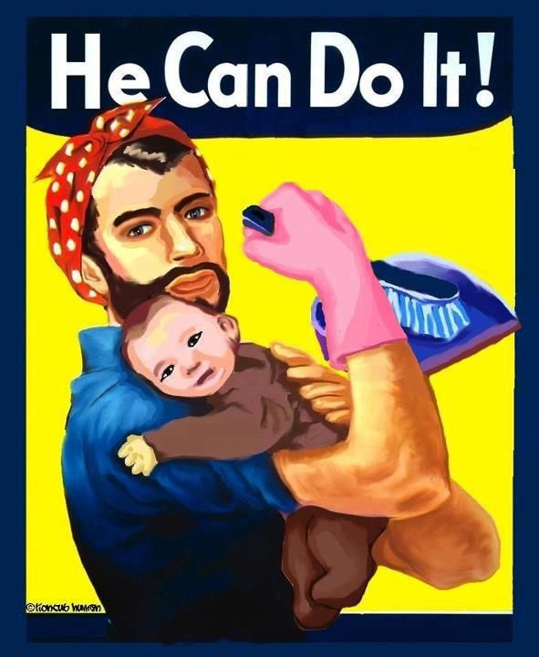
Traditionally, men have held positions of authority in most religions. They usually are the decision-makers, the leaders in the home, community and religion and generally have more power. This is true in society generally. Even looking at newspaper headlines can tell us that men often have greater responsibilities because of their leading roles.
Within religion, there is a debate about the role of women. They are treated differently to men and there is often the accusation that women are being discriminated against, despite the fact that all religions condemn any kind of discrimination. Here are some examples:
- In Christianity, women cannot be priests in the Roman Catholic Church and the first female bishops in the Anglican Church were appointed in 2015
- In Islam all religious leaders are men and women do not pray at the front of the mosque
- In Judaism, many women sit separately to men, often upstairs, and no not take part in synagogue services
- With the exception of ISKCON (the Hare Krishna movement) in Hinduism, all Brahmin priests are male
- In Theravada Buddhism, women will pray that their rebirth will be as a man
- In Sikhism, whilst either gender may read the Guru Granth Sahib at services, it is unusual to see women fulfilling this role
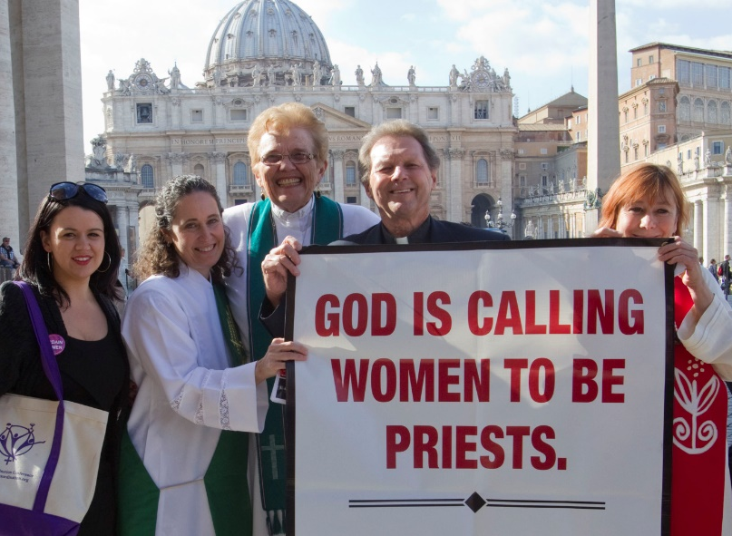
If women are denied access to certain roles then this could be said to be discriminatory. However, religion would just say that roles are different, but equal. If women are happy with their roles and what they are permitted to do and not to do then to them discrimination is not an issue. The issue arises when a woman wants to do something as part of her religion but is not allowed because rules or traditions say they cannot.
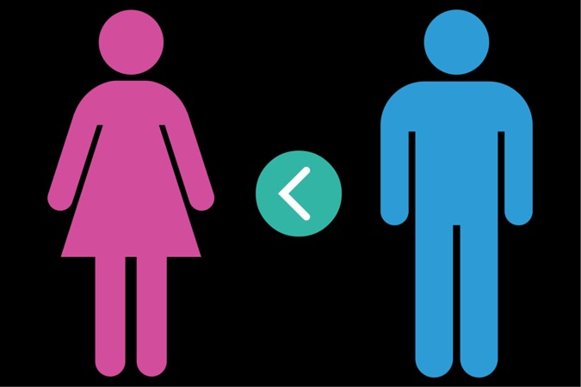
As time moves on, there are changes being made to traditions but women have to fight hard for those changes. They would argue that if we are all creations of God, then if, for example, a woman wants to devote herself to the service of God and serve the community of believers, would God not want her to simply because she is a woman? Perhaps a woman could deal with community issues and help people in a different way to a man? Compassion and understanding are key qualities and many women have these.
It all depends on how you view these issues. It is not the same as other forms of prejudice where people inflict hurt and pain on others. However, if you desperately want to do something or be part of something, being denied that because of being female is hurtful.
Tasks:
- What is the traditional role of men in society?
…………………………………………………………………………………………………………
…………………………………………………………………………………………………………
- What is an example from Christianity of women being discriminated against?
…………………………………………………………………………………………………………
…………………………………………………………………………………………………………

- What is an example from Islam of women being discriminated against?
…………………………………………………………………………………………………………
…………………………………………………………………………………………………………

- What is an example from Judaism of women being discriminated against?
…………………………………………………………………………………………………………
…………………………………………………………………………………………………………

- What is an example from Hinduism of women being discriminated against?
…………………………………………………………………………………………………………
…………………………………………………………………………………………………………

- What is an example from Sikhism of women being discriminated against?
…………………………………………………………………………………………………………
…………………………………………………………………………………………………………
Exam-style questions
- Which word describes the practice of having more than one wife? (1 mark)
………………………………………………………………………………………………………………………………………………………………………………………………………………………………………………
- Which word describes a sexual relationship between a man and a woman? (1 mark)
………………………………………………………………………………………………………………………………………………………………………………………………………………………………………………
- Which word describes a sexual relationship between two people of the same gender? (1 mark)
………………………………………………………………………………………………………………………………………………………………………………………………………………………………………………
- What is meant by the term divorce? (1 mark)
………………………………………………………………………………………………………………………………………………………………………………………………………………………………………………
- What is meant by the term adultery? (1 mark)
………………………………………………………………………………………………………………………………………………………………………………………………………………………………………………
- What is meant by the term celibacy?. (1 mark)
………………………………………………………………………………………………………………………………………………………………………………………………………………………………………………
- What is meant by the term chastity? (1 mark)
………………………………………………………………………………………………………………………………………………………………………………………………………………………………………………
- What is meant by the term gender prejudice? (1 mark)
………………………………………………………………………………………………………………………………………………………………………………………………………………………………………………

- Can you explain what is meant by marriage vows? (2 marks)
………………………………………………………………………………………………………………………………………………………………………………………………………………………………………………
- Can you explain what religious believer mean when they say that marriage is a contract? (2 marks)
………………………………………………………………………………………………………………………………………………………………………………………………………………………………………………
- Can you explain what is meant by the term commitment? (2 marks)
………………………………………………………………………………………………………………………………………………………………………………………………………………………………………………
- Give two religious beliefs about the use of contraception. (2 marks)
………………………………………………………………………………………………………………………………………………………………………………………………………………………………………………
- Give two religious beliefs about the remarriage. (2 marks)
………………………………………………………………………………………………………………………………………………………………………………………………………………………………………………
- Give two features of a religious wedding ceremony. (2 marks)
………………………………………………………………………………………………………………………………………………………………………………………………………………………………………………
- Give two effects of gender prejudice against women. (2 marks)
………………………………………………………………………………………………………………………………………………………………………………………………………………………………………………

- Explain two contrasting beliefs in contemporary British society about sex before marriage. (4 marks)
………………………………………………………………………………………………………………………………………………………………………………………………………………………………………………………………………………………………………………………………………………………………………………………………………………………………………………………………………………………………
- Explain two contrasting beliefs in contemporary British society about contraception. (4 marks)
………………………………………………………………………………………………………………………………………………………………………………………………………………………………………………………………………………………………………………………………………………………………………………………………………………………………………………………………………………………………
- Explain two contrasting beliefs in contemporary British society about remarriage. (4 marks)
………………………………………………………………………………………………………………………………………………………………………………………………………………………………………………………………………………………………………………………………………………………………………………………………………………………………………………………………………………………………
- Explain two contrasting beliefs in contemporary British society about divorce. (4 marks)
………………………………………………………………………………………………………………………………………………………………………………………………………………………………………………………………………………………………………………………………………………………………………………………………………………………………………………………………………………………………
- Explain two contrasting beliefs in contemporary British society about same0sex relationships. (4 marks)
………………………………………………………………………………………………………………………………………………………………………………………………………………………………………………………………………………………………………………………………………………………………………………………………………………………………………………………………………………………………
- Explain two contrasting beliefs in contemporary British society about cohabitation. (4 marks)
………………………………………………………………………………………………………………………………………………………………………………………………………………………………………………………………………………………………………………………………………………………………………………………………………………………………………………………………………………………………

- Explain two religious beliefs about gender equality. Refer to scripture or sacred writings in your answer. (5 marks)
………………………………………………………………………………………………………………………………………………………………………………………………………………………………………………………………………………………………………………………………………………………………………………………………………………………………………………………………………………………………………………………………………………………………………………………………………………………………………………………………………………………………………………………………………………………………………………………………………………………………………………………………………………………………………………………………………………………………………………………………
- Explain two religious beliefs about the role of parents. Refer to scripture or sacred writings in your answer. (5 marks)
………………………………………………………………………………………………………………………………………………………………………………………………………………………………………………………………………………………………………………………………………………………………………………………………………………………………………………………………………………………………………………………………………………………………………………………………………………………………………………………………………………………………………………………………………………………………………………………………………………………………………………………………………………………………………………………………………………………………………………………………
- Explain two religious beliefs about adultery. Refer to scripture or sacred writings in your answer. (5 marks)
………………………………………………………………………………………………………………………………………………………………………………………………………………………………………………………………………………………………………………………………………………………………………………………………………………………………………………………………………………………………………………………………………………………………………………………………………………………………………………………………………………………………………………………………………………………………………………………………………………………………………………………………………………………………………………………………………………………………………………………………
- Explain two religious beliefs about the purpose of sex. Refer to scripture or sacred writings in your answer. (5 marks)
………………………………………………………………………………………………………………………………………………………………………………………………………………………………………………………………………………………………………………………………………………………………………………………………………………………………………………………………………………………………………………………………………………………………………………………………………………………………………………………………………………………………………………………………………………………………………………………………………………………………………………………………………………………………………………………………………………………………………………………………
- Explain two religious beliefs about marriage. Refer to scripture or sacred writings in your answer. (5 marks)
………………………………………………………………………………………………………………………………………………………………………………………………………………………………………………………………………………………………………………………………………………………………………………………………………………………………………………………………………………………………………………………………………………………………………………………………………………………………………………………………………………………………………………………………………………………………………………………………………………………………………………………………………………………………………………………………………………………………………………………………
- Explain two religious beliefs about same-sex relationships. Refer to scripture or sacred writings in your answer. (5 marks)
………………………………………………………………………………………………………………………………………………………………………………………………………………………………………………………………………………………………………………………………………………………………………………………………………………………………………………………………………………………………………………………………………………………………………………………………………………………………………………………………………………………………………………………………………………………………………………………………………………………………………………………………………………………………………………………………………………………………………………………………
- Explain two religious beliefs about remarriage. Refer to scripture or sacred writings in your answer. (5 marks)
………………………………………………………………………………………………………………………………………………………………………………………………………………………………………………………………………………………………………………………………………………………………………………………………………………………………………………………………………………………………
- Explain two religious beliefs about the use of contraception. Refer to scripture or sacred writings in your answer. (5 marks)
………………………………………………………………………………………………………………………………………………………………………………………………………………………………………………………………………………………………………………………………………………………………………………………………………………………………………………………………………………………………………………………………………………………………………………………………………………………………………………………………………………………………………………………………………………………………………………………………………………………………………………………………………………………………………………………………………………………………………………………………

- “Families are important for teaching about religion.”
Evaluate this statement. You should:

  - Refer to Christian teaching
  - Give developed arguments to support this statement
  - Give developed arguments to support a different point of view
  - Reach a justified conclusion
……………………………………………………………………………………………………………………………………………………………………………………………………………………………………………………………………………………………………………………………………………………………………………………………………………………………………………………………………………………………………………………………………………………………………………………………………………………………………………………………………………………………………………………………………………………………………………………………………………………………………………………………………………………………………………………………………………………………………………………………………………………………………………………………………………………………………………………………………………………………………………………………………………………………………………………………………………………………………………………………………………………………………………………………………………………………………………………………………………………………………………………………………………………………………………………………………………………………………………………………………………………………………………………………………………………………………………………………………………………………………………………………………………………………………………………………………………………………………………………………………………………………………………………………………………………………………………………………………………………………………………………………………………………………………………………………………………………………………………………………………………………………………………………………………………………………………………………………………………………………………………………………………………………………………………………………………………………………………………………………………………………………………………………………………………………………………………………………………………………………………………………………………………………………………………………………………………………………………………………………………………………………………………………………………………………………………………………………………………………………………………………………………………………………………………………………………………………………………………………………………………………………………………………………………………………………………………………………………………………………………………………………………………………………………………………………………………………………………………………………………………………………………………………………………………………………………………………………………………………………………………………………………………………………………………………………………………………………………………………………………………………………………………………………………………………………………………………………………………………………………………………………………………………………………………………………………………………………………………………………………………………………………………………………………………………………………………………………………………………………………………………………………………………………………………………………………………………………………………………………………………………………………………………………………………………………………………………………………………………………
- “Religious believers should never be sexist.”
Evaluate this statement. You should:

  - Refer to Christian teaching
  - Give developed arguments to support this statement
  - Give developed arguments to support a different point of view
  - Reach a justified conclusion
……………………………………………………………………………………………………………………………………………………………………………………………………………………………………………………………………………………………………………………………………………………………………………………………………………………………………………………………………………………………………………………………………………………………………………………………………………………………………………………………………………………………………………………………………………………………………………………………………………………………………………………………………………………………………………………………………………………………………………………………………………………………………………………………………………………………………………………………………………………………………………………………………………………………………………………………………………………………………………………………………………………………………………………………………………………………………………………………………………………………………………………………………………………………………………………………………………………………………………………………………………………………………………………………………………………………………………………………………………………………………………………………………………………………………………………………………………………………………………………………………………………………………………………………………………………………………………………………………………………………………………………………………………………………………………………………………………………………………………………………………………………………………………………………………………………………………………………………………………………………………………………………………………………………………………………………………………………………………………………………………………………………………………………………………………………………………………………………………………………………………………………………………………………………………………………………………………………………………………………………………………………………………………………………………………………………………………………………………………………………………………………………………………………………………………………………………………………………………………………………………………………………………………………………………………………………………………………………………………………………………………………………………………………………………………………………………………………………………………………………………………………………………………………………………………………………………………………………………………………………………………………………………………………………………………………………………………………………………………………………………………………………………………………………………………………………………………………………………………………………………………………………………………………………………………………………………………………………………………………………………………………………………………………………………………………………………………………………………………………………………………………………………………………………………………………………………………………………………………………………………………………………………………………………………………………………………………………………………………………………
- “Remarriage should not be allowed to happen in a place of worship.”
Evaluate this statement. You should:

  - Refer to Christian teaching
  - Give developed arguments to support this statement
  - Give developed arguments to support a different point of view
  - Reach a justified conclusion
……………………………………………………………………………………………………………………………………………………………………………………………………………………………………………………………………………………………………………………………………………………………………………………………………………………………………………………………………………………………………………………………………………………………………………………………………………………………………………………………………………………………………………………………………………………………………………………………………………………………………………………………………………………………………………………………………………………………………………………………………………………………………………………………………………………………………………………………………………………………………………………………………………………………………………………………………………………………………………………………………………………………………………………………………………………………………………………………………………………………………………………………………………………………………………………………………………………………………………………………………………………………………………………………………………………………………………………………………………………………………………………………………………………………………………………………………………………………………………………………………………………………………………………………………………………………………………………………………………………………………………………………………………………………………………………………………………………………………………………………………………………………………………………………………………………………………………………………………………………………………………………………………………………………………………………………………………………………………………………………………………………………………………………………………………………………………………………………………………………………………………………………………………………………………………………………………………………………………………………………………………………………………………………………………………………………………………………………………………………………………………………………………………………………………………………………………………………………………………………………………………………………………………………………………………………………………………………………………………………………………………………………………………………………………………………………………………………………………………………………………………………………………………………………………………………………………………………………………………………………………………………………………………………………………………………………………………………………………………………………………………………………………………………………………………………………………………………………………………………………………………………………………………………………………………………………………………………………………………………………………………………………………………………………………………………………………………………………………………………………………………………………………………………………………………………………………………………………………………………………………………………………………………………………………………………………………………………………………………………………
- “Divorce is not acceptable.”
Evaluate this statement. You should:

  - Refer to Christian teaching
  - Give developed arguments to support this statement
  - Give developed arguments to support a different point of view
  - Reach a justified conclusion
………………………………………………………………………………………………………………………………………………………………………………………………………………………………………………………………………………………………………………………………………………………………………………………………………………………………………………………………………………………………………………………………………………………………………………………………………………………………………………………………………………………………………………………………………………………………………………………………………………………………………………………………………………………………………………………………………………………………………………………………………………………………………………………………………………………………………………………………………………………………………………………………………………………………………………………………………………………………………………………………………………………………………………………………………………………………………………………………………………………………………………………………………………………………………………………………………………………………………………………………………………………………………………………………………………………………………………………………………………………………………………………………………………………………………………………………………………………………………………………………………………………………………………………………………………………………………………………………………………………………………………………………………………………………………………………………………………………………………………………………………………………………………………………………………………………………………………………………………………………………………………………………………………………………………………………………………………………………………………………………………………………………………………………………………………………………………………………………………………………………………………………………………………………………………………………………………………………………………………………………………………………………………………………………………………………………………………………………………………………………………………………………………………………………………………………………………………………………………………………………………………………………………………………………………………………………………………………………………………………………………………………………………………………………………………………………………………………………………………………………………………………………………………………………………………………………………………………………………………………………………………………………………………………………………………………………………………………………………………………………………………………………………………………………………………………………………………………………………………………………………………………………………………………………………………………………………………………………………………………………………………………………………………………………………………………………………………………………………………………………………………………………………………………………………………………………………………………………………………………………………………………………
- “Marriage ceremonies are out of date nowadays.”
Evaluate this statement. You should:

  - Refer to Christian teaching
  - Give developed arguments to support this statement
  - Give developed arguments to support a different point of view
  - Reach a justified conclusion
……………………………………………………………………………………………………………………………………………………………………………………………………………………………………………………………………………………………………………………………………………………………………………………………………………………………………………………………………………………………………………………………………………………………………………………………………………………………………………………………………………………………………………………………………………………………………………………………………………………………………………………………………………………………………………………………………………………………………………………………………………………………………………………………………………………………………………………………………………………………………………………………………………………………………………………………………………………………………………………………………………………………………………………………………………………………………………………………………………………………………………………………………………………………………………………………………………………………………………………………………………………………………………………………………………………………………………………………………………………………………………………………………………………………………………………………………………………………………………………………………………………………………………………………………………………………………………………………………………………………………………………………………………………………………………………………………………………………………………………………………………………………………………………………………………………………………………………………………………………………………………………………………………………………………………………………………………………………………………………………………………………………………………………………………………………………………………………………………………………………………………………………………………………………………………………………………………………………………………………………………………………………………………………………………………………………………………………………………………………………………………………………………………………………………………………………………………………………………………………………………………………………………………………………………………………………………………………………………………………………………………………………………………………………………………………………………………………………………………………………………………………………………………………………………………………………………………………………………………………………………………………………………………………………………………………………………………………………………………………………………………………………………………………………………………………………………………………………………………………………………………………………………………………………………………………………………………………………………………………………………………………………………………………………………………………………………………………………………………………………………………………………………………………………………………………………………………………………………………………………………………………………………………………………………………………………………………………………………………………………

- “Adultery can never be right.”
Evaluate this statement. You should:

  - Refer to Christian teaching
  - Give developed arguments to support this statement
  - Give developed arguments to support a different point of view
  - Reach a justified conclusion
……………………………………………………………………………………………………………………………………………………………………………………………………………………………………………………………………………………………………………………………………………………………………………………………………………………………………………………………………………………………………………………………………………………………………………………………………………………………………………………………………………………………………………………………………………………………………………………………………………………………………………………………………………………………………………………………………………………………………………………………………………………………………………………………………………………………………………………………………………………………………………………………………………………………………………………………………………………………………………………………………………………………………………………………………………………………………………………………………………………………………………………………………………………………………………………………………………………………………………………………………………………………………………………………………………………………………………………………………………………………………………………………………………………………………………………………………………………………………………………………………………………………………………………………………………………………………………………………………………………………………………………………………………………………………………………………………………………………………………………………………………………………………………………………………………………………………………………………………………………………………………………………………………………………………………………………………………………………………………………………………………………………………………………………………………………………………………………………………………………………………………………………………………………………………………………………………………………………………………………………………………………………………………………………………………………………………………………………………………………………………………………………………………………………………………………………………………………………………………………………………………………………………………………………………………………………………………………………………………………………………………………………………………………………………………………………………………………………………………………………………………………………………………………………………………………………………………………………………………………………………………………………………………………………………………………………………………………………………………………………………………………………………………………………………………………………………………………………………………………………………………………………………………………………………………………………………………………………………………………………………………………………………………………………………………………………………………………………………………………………………………………………………………………………………………………………………………………………………………………………………………………………………………………………………………………………………………………………………………………………

