GCSE Religious Studies
Religion and Life
Workbook

Name:

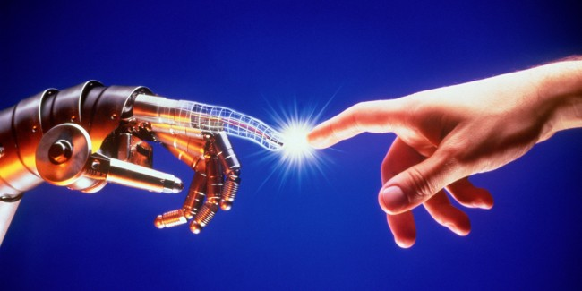

Scientific Truth vs Religious Truth
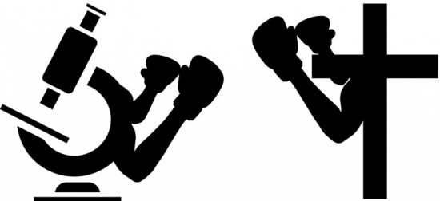
Scientific truth comes from making a hypothesis, then testing it to see if it is true. Seeing something happen again and again is important, this is called repeated observation. Your tests confirm or disprove an idea.
Science answers what and how questions; function and process. Scientific truth is always open to being developed and added to, as we find out more information, or find out new circumstances. It can be challenged and tested by other theories, so it not absolute. It is always conditional, that is, true when based on the conditions in which the testing /observation took place.
Religious truth comes from religions and holy books. We read it, or we get taught it, or some people think they were told by God. Many religions, or versions of a religion, are based on a person’s experience of God.
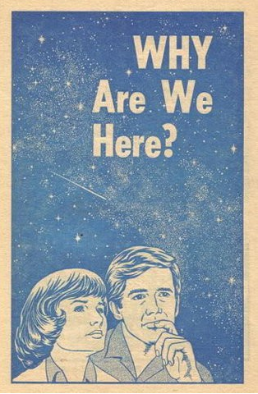
Religion tries to explain things like ‘why are we here?’, ‘who is God?’, ‘how should we behave?’ and, ‘what will happen after we die?’ In other words, it gives us answers to ultimate questions; the questions no one else has an answer for, and which are really important to humans.
Religion answers the why questions; purpose and meaning. Religion and holy books can be open to interpretation, but their words to not change. The truth of religion is considered to be absolute, that is, unchanging and relevant for all times.
The Origins of the Universe and Life
How the universe began is one of the areas in which it seems that science and religion disagree.
Tasks:
- What does scientific truth come from?
…………………………………………………………………………………………………………
…………………………………………………………………………………………………………
- What sort of questions does science answer?
…………………………………………………………………………………………………………
…………………………………………………………………………………………………………

- Where do religious truths come from?
…………………………………………………………………………………………………………
…………………………………………………………………………………………………………

- What sort of questions does religion answer?
…………………………………………………………………………………………………………
…………………………………………………………………………………………………………
- What is the truth of religion considered to be?
……………………………………………………………………………………………………………………………………………………………………………………………………………………
- What is one of the areas where science and religion disagree?
…………………………………………………………………………………………………………
…………………………………………………………………………………………………………

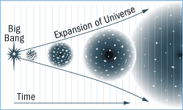
The Big Bang Theory
The Big Bang Theory is a description of how scientists believe the world began. Scientists say the universe began about 20 billion years ago. There was nothing. Then there was a huge explosion. The explosion made a cloud of dust and gas. It took a long time for the universe to form into what we know of it today; the sun, stars, planets and the universe itself. The earliest signs of life appeared millions of years ago, before the land and sea settled. The earth was very hot, and covered in a primordial soup (a mix of liquids, chemicals, minerals, proteins and amino acids). These fused to give the first life forms, which were simple-celled beings. From these, all other life developed, including humans.
An explosion causes everything to be flung outwards. Scientists know that the universe is still expanding and that the movement can all be tracked back to a single point. This supports the idea of an explosion; it is as if the explosion is still being felt.
Another bit of evidence is what we call background microwave radiation. Explosions cause radiation and this can still be detected in space.
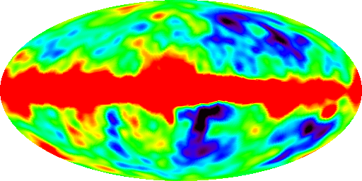
This was not the first theory of how the universe came to be. As scientists find new evidence, they reshape their ideas. In the case of the Big Bang, it replaced the Steady State Theory as the accepted view of the origins of the universe. There might be another theory waiting in the wings for that extra bit of persuasive evidence. Science, therefore, is open to change, development and revision. We could say that science is an evolving, changing description of the world and its workings. It is the truth for the time we are in with the knowledge we have.
Tasks:
- When do scientists say the world began?
…………………………………………………………………………………………………………
…………………………………………………………………………………………………………
- What started off the process of life?
…………………………………………………………………………………………………………
…………………………………………………………………………………………………………

- Describe the events in the Big Bang.
…………………………………………………………………………………………………………
…………………………………………………………………………………………………………
…………………………………………………………………………………………………………
…………………………………………………………………………………………………………
…………………………………………………………………………………………………………
…………………………………………………………………………………………………………

- What other form of evidence is there for the Big Bang Theory?
…………………………………………………………………………………………………………
…………………………………………………………………………………………………………
- What happens when scientists find new evidence?
……………………………………………………………………………………………………………………………………………………………………………………………………………………
- What is current science the truth for?
…………………………………………………………………………………………………………
…………………………………………………………………………………………………………

Charles Darwin and Evolution
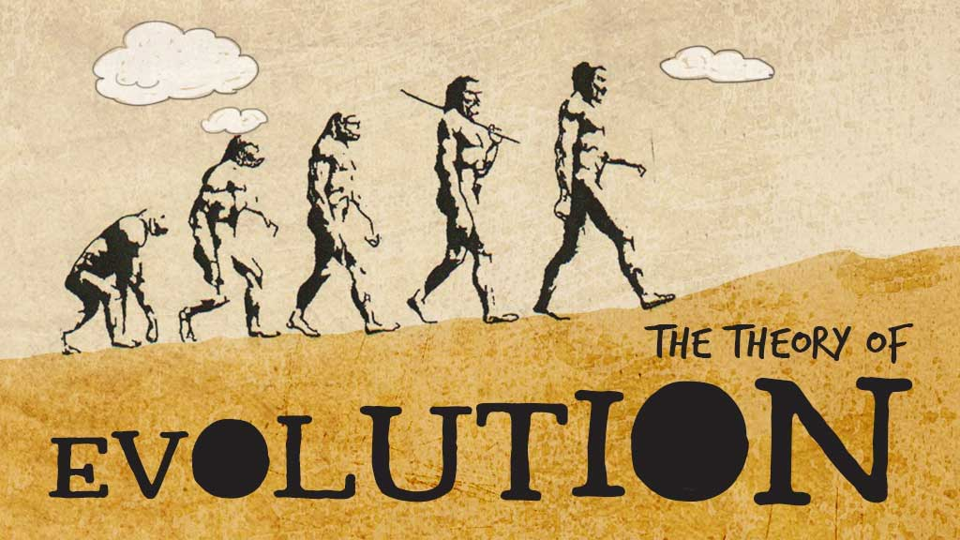
Darwin was a natural scientist. He wrote a book called ‘Origin of the Species’ in 1859, in which, he suggested that the world is a place of change, and that the huge variety of creatures and species is the result of thousands of years of change and adaptation (evolution). He said that there is a struggle for survival between species because of competing demands and limits on resources, like food, space, etc. Where species failed to adapt, they became extinct, so that only the fittest (best-suited) could survive. He called this ‘natural selection’. Darwin also realised that different places caused different varieties of the same creature to develop, because the places made different demands on the creatures.
In the environment, for example, some places have a hotter climate than others. In these areas, the creatures are suited to that particular area. For example, a polar bear has special fur, making it possible to live in cold temperatures.
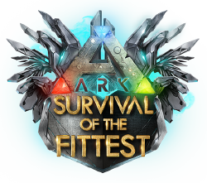
Environments are always changing, for example, volcanoes may erupt covering the surrounding area with ask, altering the shape of the landscape. Many scientists believe that the world has always been changing. Creatures have had to get used to the change and adapt to it, or they have died. Where a whole species could not adapt, it has become extinct. Where a species did adapt, its biology has changed so that the species survived.
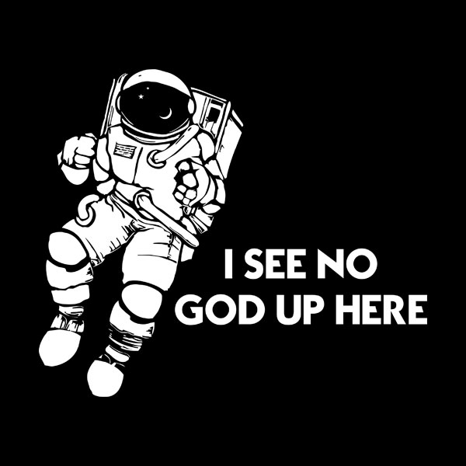
This theory suggests that nothing was designed to look like it does today, or to work in the way it does today. Things have changed so that they could survive, which means it is wrong to believe some power designed things as they are, or to believe the world has always been the same. Many religious people believe that God created the world, so they are at odds with accepted scientific theory.
No God?
You would think that scientific theories completely discarded God. The idea of the seven-day creation was challenged – so is it time to forget about God?
Darwin still claimed that God was involved in all this. In the final chapter of his book, he asks where all the intelligence within nature, and the complexity and interdependence came from. He finds it difficult to believe that without some sort of guidance, there is not just total chaos. He puts it down to God. God created the original lifeforms with the ability to adapt and change. It is not design down to the fine detail, it is design via intelligence and adaptability. Many Christians find this something they can agree with – after all, it just adds to the wonder and awe felt towards God.
Tasks:
- What was the name of Darwin’s book?
…………………………………………………………………………………………………………
…………………………………………………………………………………………………………
- What is the theory of evolution?
…………………………………………………………………………………………………………
…………………………………………………………………………………………………………

- What happens to species who fail to adapt?
…………………………………………………………………………………………………………
…………………………………………………………………………………………………………
- Describe an example of the process of evolution.
…………………………………………………………………………………………………………
…………………………………………………………………………………………………………
……………………………………………………………………………………………………………………………………………………………………………………………………………………
- What does the theory of evolution suggest about design?
……………………………………………………………………………………………………………………………………………………………………………………………………………………
- Even with his theory of Evolution, what did Darwin believe about God?
…………………………………………………………………………………………………………
…………………………………………………………………………………………………………
…………………………………………………………………………………………………………
…………………………………………………………………………………………………………
Genesis Creation Story
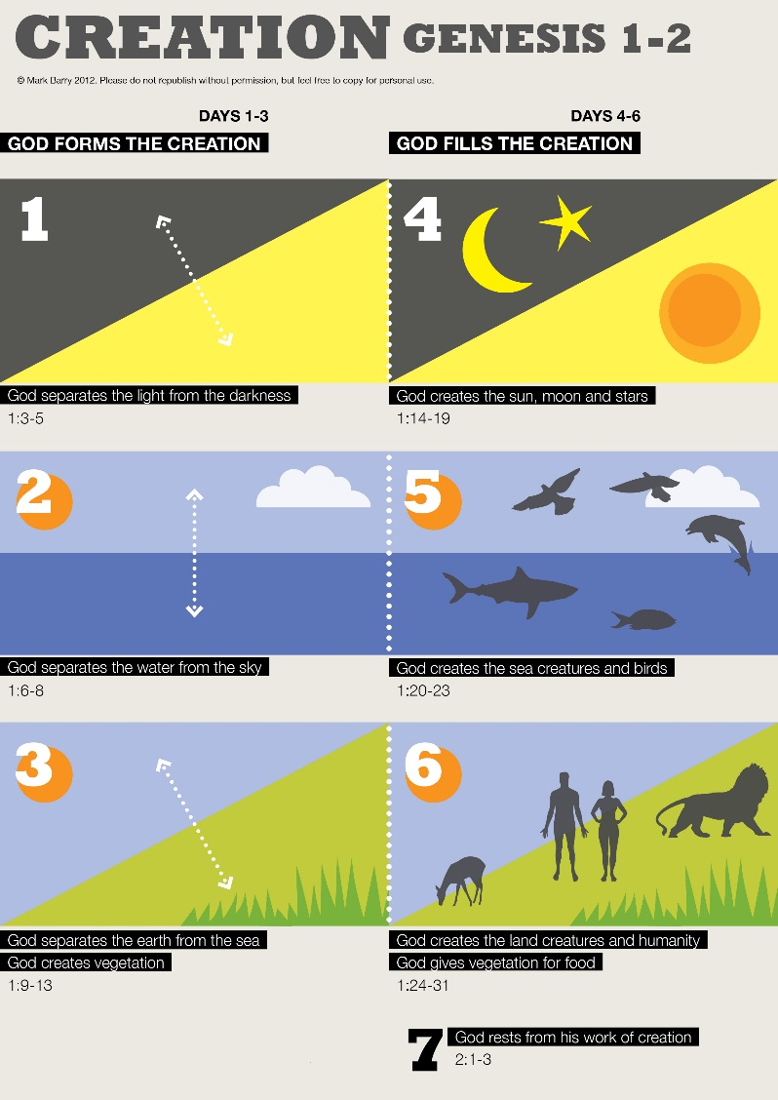
A creation story is a story telling us how God created the world and the universe. The Christian creation story is written in the Bible. The first book of the Bible is called Genesis, which means ‘beginning’, and it begins with God’s creation of the world. This version is known as the Genesis creation story, or the Christian creation story, or the seven days of creation story. It is also believed by the Jewish and Islamic faith.
In Genesis, it says that there was nothing in the beginning. God decided to create a world. On each day of creation he made a new thing:
- Day 1: Light and Dark
- Day 2: Heavens and the earth
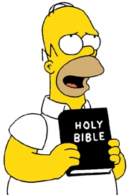
- Day 3: Water and Land
- Day 4: Sun, Moon and Stars
- Day 5: Fish and Birds
- Day 6: Animals and humans
- Day 7: God rested (creation was good)
The creation story is understood in different ways. However it is interpreted or understood, it is what we call a religious truth. Religious truth does not change, it is a truth for all time. Religious people believe this is so because it is a truth which came from God. God is eternal, and without fault, so it must be true.
For some, the creation story is literally true – word for word. They believe in an all-powerful, all-loving, all-knowing God, so it is easy to believe that God really could do this in the way described. This is a fundamentalist view of the Bible, and hence creation.
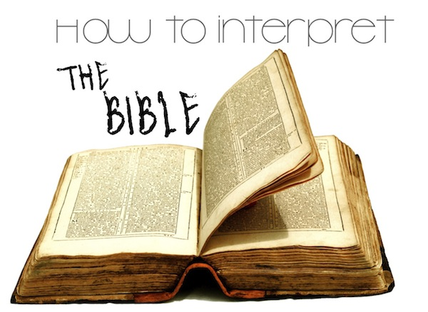
The order of the creation makes sense: the planet, then vegetation, then fish and birds, then animals and finally, man. Genesis perhaps seems a little quick in comparison to what science says, but it was a story first told thousands of years ago. It is told in the only way it could be told, using the language and knowledge of the time, so many believe that the order of the story is correct but the timing is out.
There are some key messages in the story. It is telling us that humans have a purpose; they were deliberately made by the Creator. This was a designed and considered creation – not just an accidental, chaotic happening.
Tasks:
- What is a creation story?
…………………………………………………………………………………………………………
…………………………………………………………………………………………………………
- What is the first book of the Bible called?
…………………………………………………………………………………………………………
…………………………………………………………………………………………………………

- Explain the creation story.
…………………………………………………………………………………………………………
…………………………………………………………………………………………………………
…………………………………………………………………………………………………………
…………………………………………………………………………………………………………
……………………………………………………………………………………………………………………………………………………………………………………………………………………
- What is a ‘religious truth’?
…………………………………………………………………………………………………………
…………………………………………………………………………………………………………
- Explain the different interpretations of the Bible.
……………………………………………………………………………………………………………………………………………………………………………………………………………………
…………………………………………………………………………………………………………
…………………………………………………………………………………………………………
- What are the key messages in the Genesis creation story?
…………………………………………………………………………………………………………
…………………………………………………………………………………………………………
…………………………………………………………………………………………………………
…………………………………………………………………………………………………………

Science, religion or both?
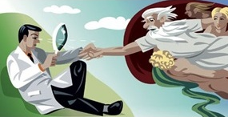
Some Christians believe that the Bible is the Word of God. Everything written in it is word for word, true. God told people exactly what to write. This includes Genesis, so these Christians believe that every word of Genesis is true. We cannot understand how God created the world like this – because we are mere humans – but it is undeniably God’s Word.
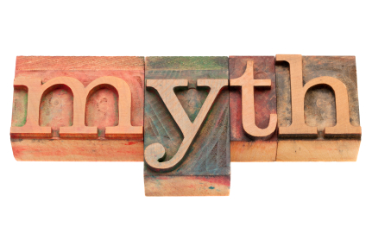
Other Christians believe that the Bible is true, but not word for word. The Bible could contain mistakes as it was written by humans. When God told or inspired the authors, there is room for ‘poetic licence’. Genesis, therefore, is right, but not exactly. For example, the Genesis story uses the word ‘days’, but the original language uses a word which means ‘period of time’. So perhaps the story is saying that over many periods of time, God made the world change and develop. Overall, Genesis is more or less what happened.
Some other Christians believe that Genesis is not word for word true, it can be understood as a story or a myth. However, God created the world. Science did not exist when the story was first told. People had to tell the story in the way that made sense. Genesis made sense, and it matches the way that scientists now say the universe was formed and life developed.
The Big Bang Theory and the religious creation story obviously say different things, so a literal understanding of Genesis would make believing in both a problem. However, the less literally we take Genesis, the easier it is to see it as a non-scientific way of understanding the world around us. If we think of Genesis as having a message for us, then it is not even answering the same question as science. Science is telling us how, whilst religion is telling us why.
It is the same with science – the more completely you believe that theory, the less room there is to believe in anything else.
Tasks:
- What do some Christians believe about the Bible?
…………………………………………………………………………………………………………
…………………………………………………………………………………………………………
- Why could the Bible contain mistakes?
…………………………………………………………………………………………………………
…………………………………………………………………………………………………………

- What phrase could be used to describe the ‘days’ in Genesis?
…………………………………………………………………………………………………………
…………………………………………………………………………………………………………
- How can the creation story be understood as a myth?
…………………………………………………………………………………………………………
…………………………………………………………………………………………………………
- Can scientific theories like the Big Bang be compatible with religious views, like the Genesis creation story?
……………………………………………………………………………………………………………………………………………………………………………………………………………………
…………………………………………………………………………………………………………
…………………………………………………………………………………………………………
- What does science tell us? What does religion tell us?
…………………………………………………………………………………………………………
…………………………………………………………………………………………………………

Comparing These Truths
Science is about hypothesis and testing. It describes observed regularities in the world around us; it helps us make sense of how the world works. Religion is about giving a sense of purpose and meaning to our lives; it can act as a control on behaviour, because of its rules and the promise of an afterlife; it gives people a sense of well-being and comfort. Are those things the same?
Science and religion are different kinds of truth, telling us different things. So maybe they do not even contradict each other. Many people dismiss religion because it tells us things without scientific proof. However, science works on theories, like the Big Bang – there is evidence for the theory, but not absolute proof. Is there a difference?
Why does religion still prove strong in the world?
Religion answers the questions that nothing else can. It can make us feel special. It is traditional. Or it may just be right.
In our society, science holds a high place. It is very important to society’s development and improvement right now, and it seems to have overtaken religion for many people. Science does challenge religious beliefs, and this course wants you to explore two of the biggest challenges science made.
Tasks:
- What does science help us to do?
…………………………………………………………………………………………………………
…………………………………………………………………………………………………………
- What can religion give people a sense of?
…………………………………………………………………………………………………………
…………………………………………………………………………………………………………

- How are religious and scientific belief similar?
…………………………………………………………………………………………………………
…………………………………………………………………………………………………………
- Why does religion still prove strong in the world?
…………………………………………………………………………………………………………
…………………………………………………………………………………………………………
…………………………………………………………………………………………………………
…………………………………………………………………………………………………………

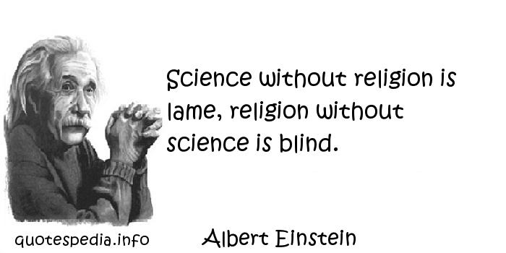

The Value of the World
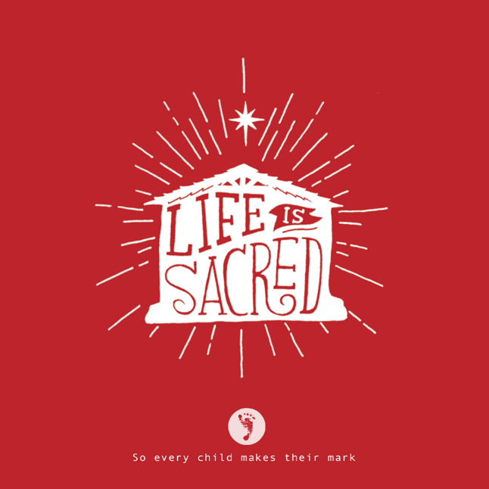
All religious believers believe that life is sacred, or special. This must extend to all life and so the world becomes sacred as it is the home to all. It should be treated with respect.
The idea that God created the world means it has to be looked after. In fact, religious people believe they were given a responsibility or duty by God to look after the world (stewardship).
As the prime species, religious believers think that God gave them the right to decide what happens to the world and all the species in it. This is called dominion. Humans have power over nature by God’s permission.
When people look at the beautiful things in nature, they are struck by a sense of wonderment. They are amazed and ‘wowed’ by beautiful sunsets, landscapes, waterfalls and the power of nature. This is called awe. For religious people, that sense of awe makes them praise God even more because they believe that God created the world. He is responsible for the things that make them feel this way. They want to worship Him more as a result.
Abuse of the Environment
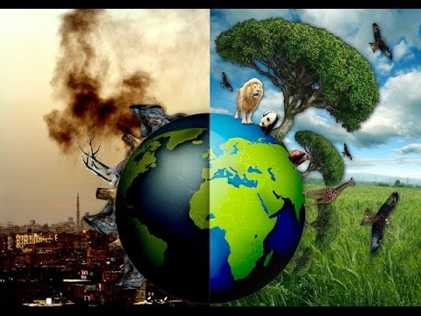
Pollution
Pollution is when there is too much of something that is toxic and causes damage to the environment. It can affect air, water or land. We now even talk about light or noise pollution. Usually, it is a result of human actions.
Busy roads and factories cause air pollution. That affects our health and drives some wildlife away. It also produces acid rain, where chemicals dissolve in water droplets in the atmosphere so that when rain falls it poisons the land and water, and damages buildings and structures.
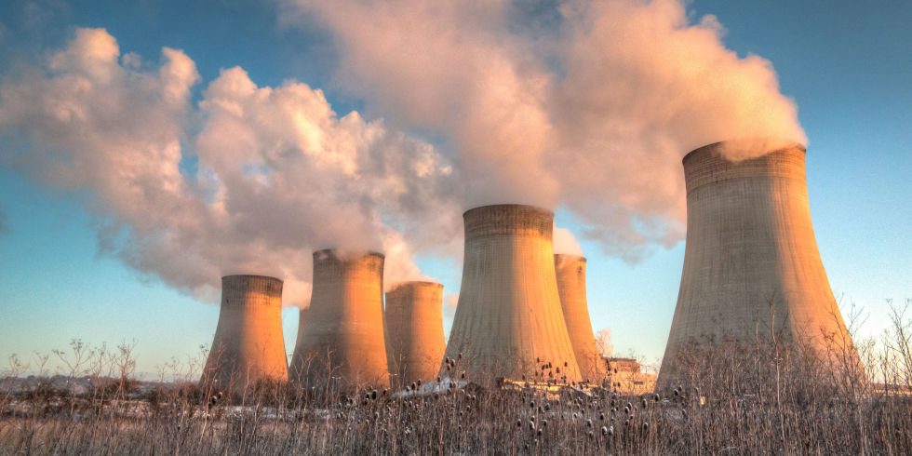
Factories can cause water pollution by emptying waste into rivers, poisoning it. Fertiliser running off farmers’ fields can kill off all the fish, as it makes the algae grow too fast, taking the oxygen from the water. This is just one form of toxic chemical. Too much pesticide does more damage to the ecosystem than intended and can change its whole balance.
Humans add to land pollution because of litter. This does not just look bad, it also kills lots of wild animals who eat it or get trapped in it.
In towns and cities, you see fewer stars than when you are in the countryside. The lights at ground level block out the stars, causing light pollution.
People living near airports, for example, suffer from noise pollution because of the sound of planes taking off and landing. Even if it does not affect their hearing, it makes life more unpleasant, and affects the value of their homes.
Pollution is a big part of the reason for global warming and climate change. Our waste produces greenhouse gases which heat the earth.
Tasks:
- What do all religious believers believe?
…………………………………………………………………………………………………………
…………………………………………………………………………………………………………
- What does the idea that God created the world mean?
…………………………………………………………………………………………………………
…………………………………………………………………………………………………………

- What is dominion?
…………………………………………………………………………………………………………
…………………………………………………………………………………………………………
- What is awe?
…………………………………………………………………………………………………………
…………………………………………………………………………………………………………
- Explain how pollution is abusing the environment.
……………………………………………………………………………………………………………………………………………………………………………………………………………………
…………………………………………………………………………………………………………
…………………………………………………………………………………………………………
……………………………………………………………………………………………………………………………………………………………………………………………………………………
…………………………………………………………………………………………………………
………………………………………………………………………………………………………………………………………………………………………………………………………………………………………………………………………………………………………………………………
…………………………………………………………………………………………………………
…………………………………………………………………………………………………………
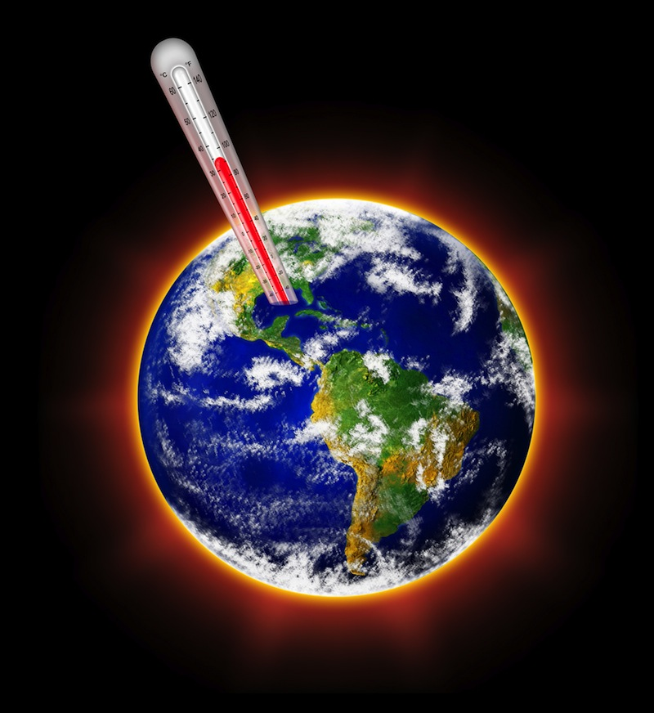
Global Warming and Climate Change
Climate change is the idea that the earth’s temperature is increasing and therefore causing more extreme weather, such as flooding and more storms. This will lead to temperatures everywhere getting higher and this is what is meant by global warming. The questions are: why is this happening; what are the consequences; how can we try to stop it?
Why it is happening?
The earth’s cycle is to get hotter and cooler over time. For example, the ice ages, when the earth froze over; global warming is the opposite. So climate change and global warming is all part of the earth’s life. However, scientists know that the activities of humans over the last 250 years, and especially the last 100 years, have speeded up temperature change. They estimate that the surface temperature of the earth will increase between 1.4 and 5.8 degrees Celsius before 2100. This is mainly because of greenhouse gases, particularly CO2 released by burning fossil fuels for energy, transport and industry. Following the precautionary principle, scientists are telling us that we need to act now.
What are the consequences?
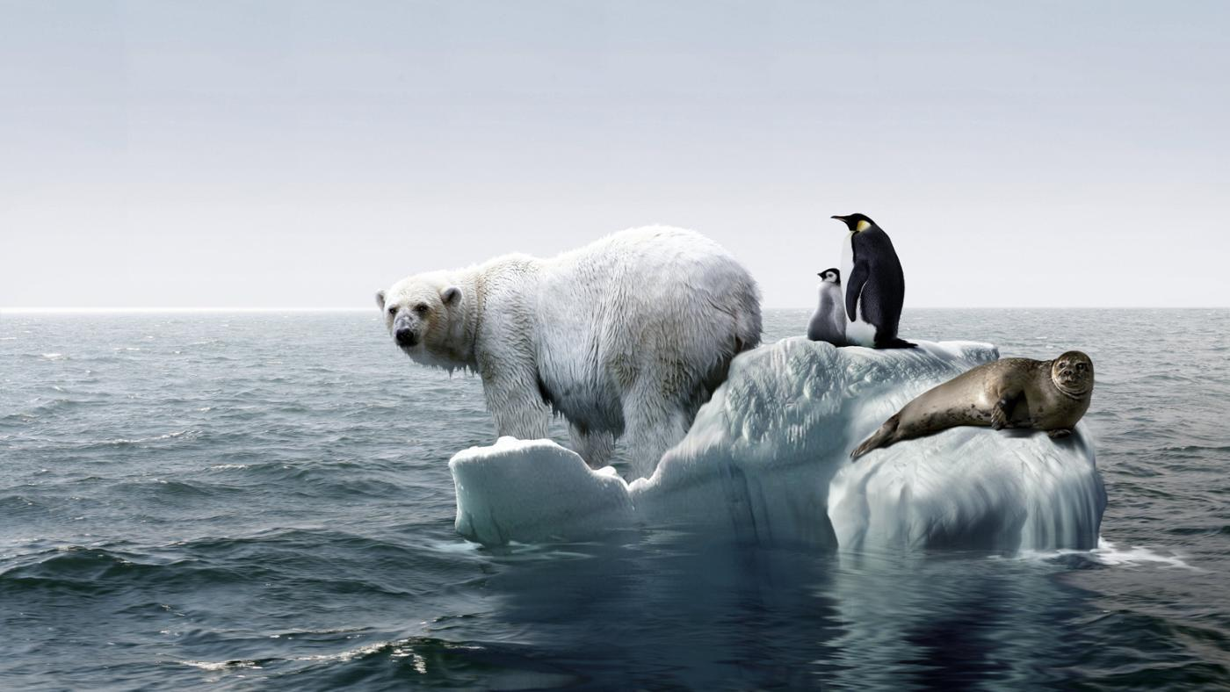
Hotter weather usually means dryer and so plants and animals have to adapt or die. Hotter everywhere means some places become just too hot to exist in. The ice caps melt, so the seas rise and lands flood (this will probably include Britain as we are not much higher than sea level). If it gets too hot, the diseases found in hot countries come too, for example, malaria, dengue fever, and so on. Everyone will need air conditioning which will cost money and resources.
Solutions?
Scientists say the key solution is to change our energy use. We need to find alternatives to fossil fuels (coal, gas and oil) so that the fuels we use do not add to the problem. This is called sustainable energy – in other words, we can keep using it without doing more harm. It is energy which meets the needs of the present without harming the ability or future generations to meet their own needs.
Tasks:
- What is climate change?
…………………………………………………………………………………………………………
…………………………………………………………………………………………………………
……………………………………………………………………………………………………………………………………………………………………………………………………………………
…………………………………………………………………………………………………………
…………………………………………………………………………………………………………
- Why is climate change happening?
…………………………………………………………………………………………………………
…………………………………………………………………………………………………………
……………………………………………………………………………………………………………………………………………………………………………………………………………………
…………………………………………………………………………………………………………
…………………………………………………………………………………………………………

- What are the consequences of climate change?
…………………………………………………………………………………………………………
…………………………………………………………………………………………………………
……………………………………………………………………………………………………………………………………………………………………………………………………………………
…………………………………………………………………………………………………………
…………………………………………………………………………………………………………
- What are the solutions to climate change?
…………………………………………………………………………………………………………
…………………………………………………………………………………………………………
……………………………………………………………………………………………………………………………………………………………………………………………………………………
…………………………………………………………………………………………………………
…………………………………………………………………………………………………………
Destruction of Natural Habitats (Deforestation)
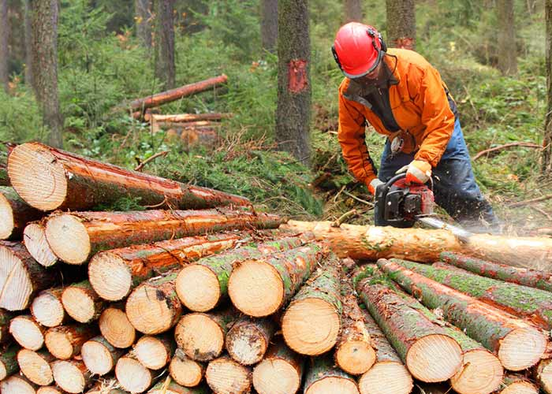
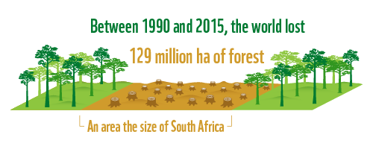
Pollution is one reason why natural habitats are being destroyed. For example, if a tanker spills oil into the sea, it wipes out life in that area, and degrades the land for many years. Another reason for the destruction of natural habitats is deforestation, where huge areas of forest are cut down, for example, to create grazing land for cattle, or to create areas for buildings, mining and roads. The trees are the habitat for many species and so these species are affected, some are even dying out. Also, the trees take in carbon dioxide and release oxygen that we breathe, so they help the fight against global warming.
The rainforests also contain many plants which can be used as medicines, which are lost with deforestation. There are thought to be many species of animals and plants which we have not even recorded yet in the rainforests; they could become extinct before we have even studied them. Even without causing extinction, natural habitats are destroyed and species endangered.
Use and Abuse of Natural Resources
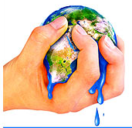
Natural resources include vegetation, minerals and fossil fuels. Humans are using these in greater quantities and at a faster rate now than at any other time in our history. This is because of how technologically advanced we are. We can take materials out of the ground faster and in greater quantities than ever before. Modern technology, for example, often needs more resources to run. More people use more technology more often.
Some of the fossil fuels, for example, coal, are already running out. These fuels are limited in quantity and take millions of years to be formed. We have to find different sources of energy, which is renewable. If we do not stop using them, they will run out, and we will have to find a new source anyway.
Tasks:
- What is deforestation?
…………………………………………………………………………………………………………
…………………………………………………………………………………………………………
- What are the problems with cutting down trees?
…………………………………………………………………………………………………………
…………………………………………………………………………………………………………

- How are humans using natural resources?
…………………………………………………………………………………………………………
…………………………………………………………………………………………………………
- Why do we need to find different sources of energy?
……………………………………………………………………………………………………………………………………………………………………………………………………………………
Caring for the World
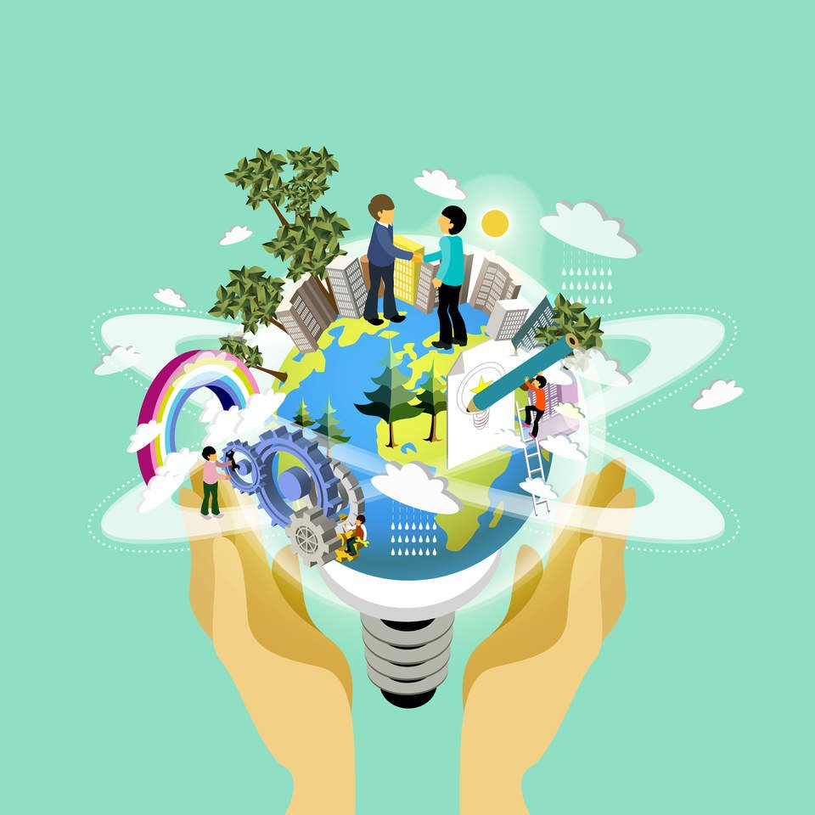
Sustainable Development
This is the idea that new technological developments should all be infinite, or very long-lasting, as well as within the reach of all nations. Developments should support, not damage the environment. It would be no use swapping coal as a fuel for something else which will quickly run out. Similarly, it would be no good finding a new technology which was simply too expensive for anyone to use.
Conservation
Conservation means when we try to protect an area or species. Sometimes it involved repairing damage that has already been done, for example, to maintain the environment for an endangered species. it might include planting trees to protect and area from landslides. It might be declaring an area a nature reserve in order to protect wildlife and the environment there. This has happened in Borneo to protect orang-utans.
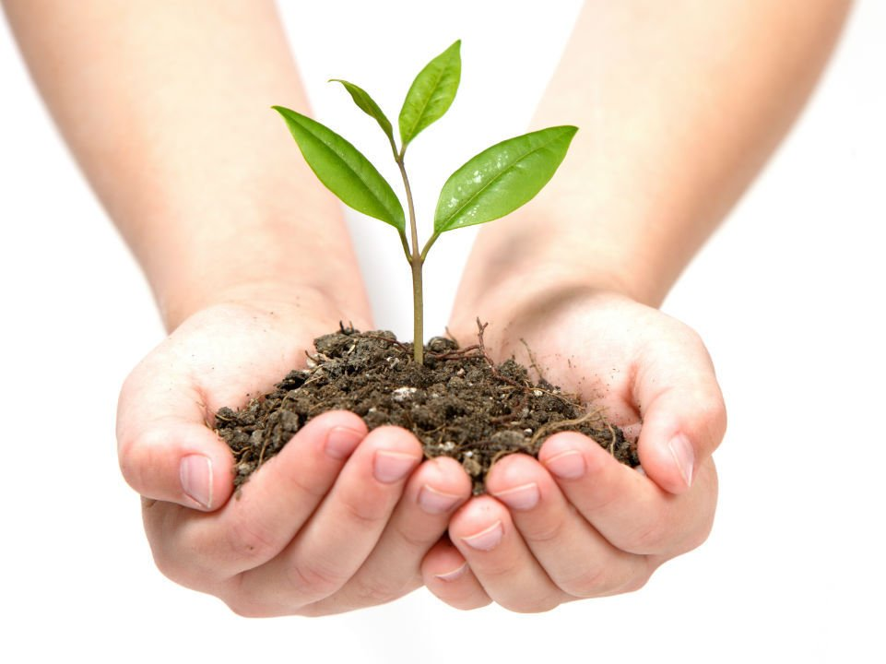
It is becoming more common for people to take holidays which are based around conservation, either of animals, like working on a lion reserve for a few weeks in Kenya, or environmental, like rebuilding dry stone walls in Scotland to protect vegetation in fields beyond the pathways.

What can individuals do?
Religious believers are like every other person on the planet and so can do what any other person can do. They can start from their own personal practice, for example, recycling, reusing and not wasting. They can join in local efforts, for example, clean-ups, not buying certain goods, buying local produce. They can join in with campaigns and donate to charities which try to resolve environmental problems. They might also work within their local communities, encouraging others to also help or focusing worship on the issue.
The difference between religious and non-religious actions is that religious people have a religious motivation to look after the environment.
Tasks:
- What is ‘sustainable development’?
…………………………………………………………………………………………………………
…………………………………………………………………………………………………………
- What does conservation involve?
…………………………………………………………………………………………………………
…………………………………………………………………………………………………………

- What is becoming more common?
…………………………………………………………………………………………………………
…………………………………………………………………………………………………………
- What can individuals do to help the planet?
……………………………………………………………………………………………………………………………………………………………………………………………………………………
……………………………………………………………………………………………………………………………………………………………………………………………………………………

Animal Rights
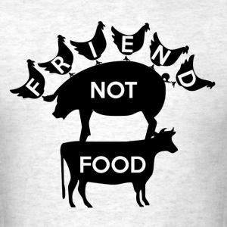
Religious people believe that animals are part of God’s creation. All life, including hat of animals, is sacred. Most religious believers think that they were given dominion over animals, so can make use of them for food, clothing and as working animals. However, animals should always be treated with respect, fairness and kindness.
Many of the ways we use animals can be justified. The problem comes with how some people treat animals, even in a use we find acceptable. So, for example, farming is fine, but battery farming may be thought of as cruel, given that the animals get very little space and a completely unnatural life. A religious person might choose never to buy produce which has come from a battery farm, choosing always free range.
Animal Experimentation
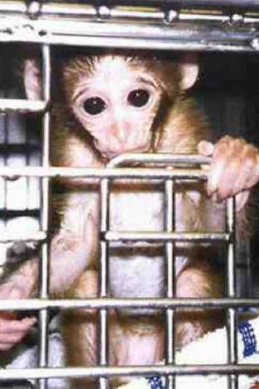
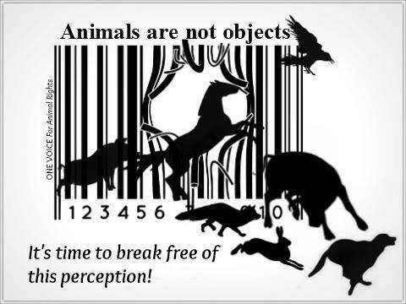
People often immediately think that animal experimentation is cruel, however some animal experiments should be for the good of human beings, which is why many people, including religious believers, support them. Animal experiments further our medical knowledge so that surgical procedures are improved. They are used to test new drugs for effectiveness and so that they do not cause harm. They are also used to test new products, for example, cosmetics for harmfulness (toxicity). Medical science has always used animals. Many surgical procedures, such as transplantation surgery, were perfected on animals. Some experiments just mean a change in diet; others cause injury or death. At the end of the experimentation any live animals left are humanely destroyed. Since 1896, in the UK, there have been specific laws to control animal experimentation.
What are some of the issues?
- It is cruel. Even scientists accept the animals suffer, though they believe it is for the greater good.
- Modern science has now developed some other alternatives, like using human tissue cultures to test for toxicity
- Animal genetics and human genetics are different, and often reactions are not the same. So some animal experimentation is pointless and tells us nothing helpful
Animals for Food
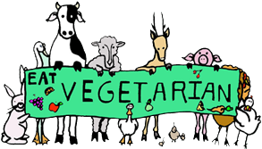
Why be vegetarian?
There are many reasons why people are vegetarian. They are usually to do with health, upbringing, religion and concerns about farming methods. Some people eat no meat or dairy products at all (vegans); some choose to eat no meat or meat products (vegetarians).
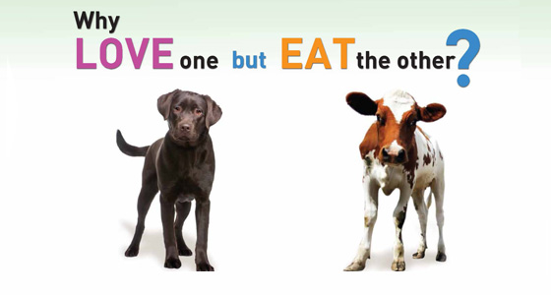
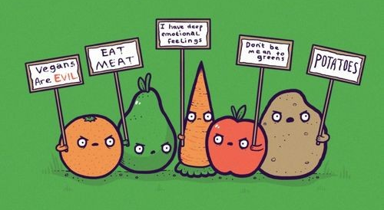
The Christian, Jewish and Muslim faiths all allow meat in their diets. Some Christians fast at certain times of year, for example, not eating certain foods during Lent. Many Christians do not eat red meat on Fridays out of respect for Jesus’ sacrifice on Good Friday. Muslims and Jews may not eat certain meats, for example, the meat of a pig, or shellfish, and birds of prey. They may only eat ritually slaughtered meal (halal for Muslims, kosher for Jews). This reflects the idea that God/Allah/G-d gave man dominion over animals, and so they could be used by man, including as food. Hindus and Buddhists, on the whole are vegetarian, reflecting two important beliefs: ahisma (non-violence) and respect for all life. However, for Buddhists, it very much depends on culture in the country and on available diet. For example, in Tibet a healthy diet is only possible if it includes meat. Many Sikhs are vegetarian to show respect for God’s creation and the Sikh langar is always a vegetarian meal.
Tasks:
- What does the belief in having dominion over animals mean for religious believers?
…………………………………………………………………………………………………………
…………………………………………………………………………………………………………
- What are the positives of animal experimentation?
…………………………………………………………………………………………………………
…………………………………………………………………………………………………………
…………………………………………………………………………………………………………
…………………………………………………………………………………………………………

- What are the negatives of animal experimentation?
…………………………………………………………………………………………………………
…………………………………………………………………………………………………………
…………………………………………………………………………………………………………
…………………………………………………………………………………………………………
- Why might someone choose to be a vegetarian?
……………………………………………………………………………………………………………………………………………………………………………………………………………………
……………………………………………………………………………………………………………………………………………………………………………………………………………………
- Explain religious reasons for eating meat.
……………………………………………………………………………………………………………………………………………………………………………………………………………………
……………………………………………………………………………………………………………………………………………………………………………………………………………………
- Why are many Sikhs vegetarian?
…………………………………………………………………………………………………………
…………………………………………………………………………………………………………

Christian Teachings about the World and the Environment
Christians believe God created the world and gave humankind stewardship – the responsibility to look after the world. Christians, in modern times especially, have seen the need to work to heal the world and look after the environment.
The Bible teaches:
- God made the world and gave the duty of stewardship to humans (Genesis 1:28)
- The earth is the Lord’s, and everything in it (Psalms 23:1)
- Respect for life extends to the rest of creation (Pope John Paul II)
- More than ever – individually and collectively – people are responsible for the future of the planet (Pope John Paul II)
- I want to awake in you a deep admiration for creation, until anywhere thinking of plants and flowers, are overcome by thoughts of the Creator (St. Basil)
Clearly, humans have a special role on earth, which is to look after the earth and animals. Since humans must face God on the Day of Judgement, all must carry out their given duties. If humans did not look after the world, or did nothing to stop its destruction, they should expect to be punished by God. Many Christians are motivated to do environmental work because of this belief.
Tasks:
- What does Christianity teach about the world and the environment?
…………………………………………………………………………………………………………
…………………………………………………………………………………………………………
…………………………………………………………………………………………………………
…………………………………………………………………………………………………………
…………………………………………………………………………………………………………
…………………………………………………………………………………………………………

- What does the Bible teach?
…………………………………………………………………………………………………………
…………………………………………………………………………………………………………
…………………………………………………………………………………………………………
…………………………………………………………………………………………………………
- What will happen to Christians who do not look after the world?
……………………………………………………………………………………………………………………………………………………………………………………………………………………
Muslim Teachings about the World and the Environment
Islam sees the creation in its entirely as the world of Allah. Humans are khalifa (stewards) of the world. Looking after the world shows respect to Allah.
Islam teaches:
- The world is green and beautiful, and Allah has appointed you His stewards over it (Qur’an)
- The whole earth has been created as a place of worship (Qur’an)
- When Doomsday comes, if someone has a palm shoot in his hand, he should still plant it (Hadith)
- Prophet Muhammad (PBUH) gave the example of not wasting. He only ever washed in water from a container, not the river or other running water
Humans are the trustees of Allah’s creation. Trustees look after things, rather than destroy them.
The whole creation reflects Allah, and Allah knows everything that happens in it. Allah known who damages and who looks after His creation. So it is a good idea to look after the world, because those who do not follow their duty will be punished on Judgement Day by Allah.
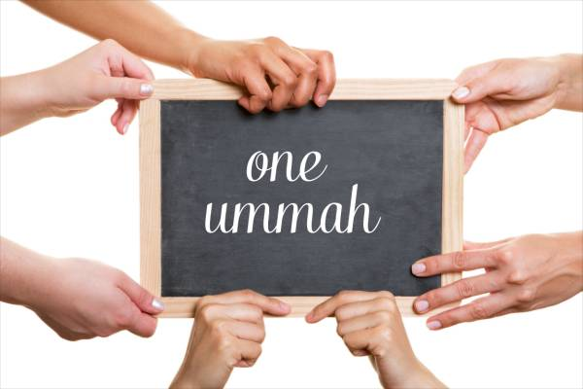
The Muslim community is ummah, a brotherhood, including those in the past and future. Everyone has a duty to their family and fellow humans to make sure they pass on to them a world fit to live in, not one damaged beyond repair because humans were so selfish as to think they could do what they wanted with it.
Tasks:
- What does Islam teach about the world and the environment?
…………………………………………………………………………………………………………
…………………………………………………………………………………………………………
…………………………………………………………………………………………………………
…………………………………………………………………………………………………………
…………………………………………………………………………………………………………
…………………………………………………………………………………………………………

- Why is it a good idea to look after the world?
…………………………………………………………………………………………………………
…………………………………………………………………………………………………………
…………………………………………………………………………………………………………
…………………………………………………………………………………………………………
- Explain the idea of ummah and how it relates to the environment.
………………………………………………………………………………………………………………………………………………………………………………………………………………………………………………………………………………………………………………………………………………………………………………………………………………………………………………………………………………………………………………………………………………………………………………………………………………………………………………………………

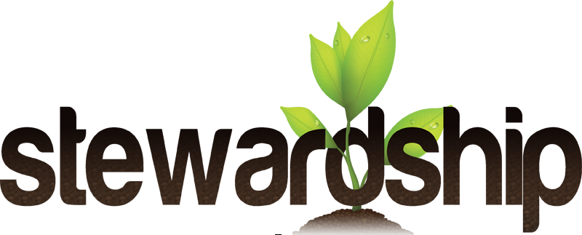

The Value of Human Life
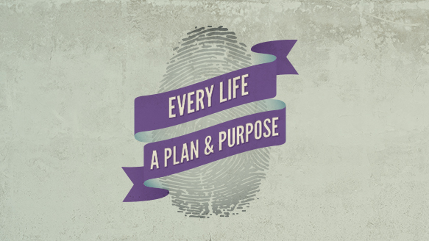
Religions say that human life is the most important and special of all kinds of life. There are two key concepts: quality of life and sanctity of life.
Sanctity of Life
This is the idea that all life is special. Many religions believe that life is sacred because God created it (Christianity, Hinduism, Islam, Judaism and Sikhism). Some religions believe life is special because it is the way we can achieve enlightenment (Buddhism and Hinduism). No one in the world believes that life is worth nothing. All the legal systems put murder as the worst crime you could commit, with the toughest punishments. All religions believe that life is special and deserves to be protected and cherished. Religions extend this belief to plant and animal life.
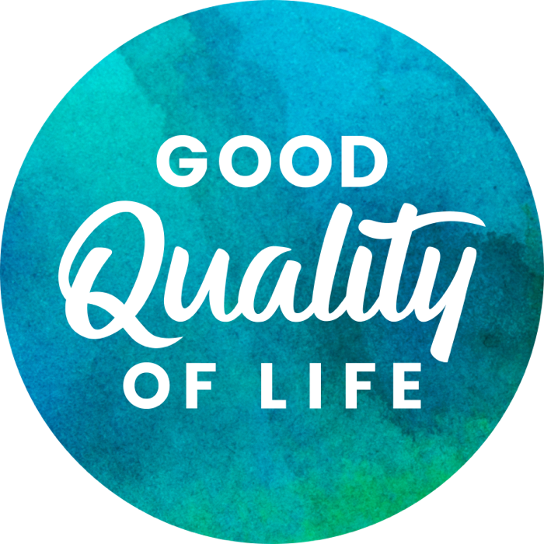
The Status of Human Life
Religious believers think that humans are the highest form of creation, or that they are within the highest levels of spiritual development. This means that the value of human life is beyond measure, and as such it should be protected and cared for. Most religious believers are ‘pro-life’ in many questions of life and death.
Quality of Life
This is a description of how good someone’s life is. It includes how comfortable they feel, how easy it is for them to live through each day, perhaps how much they have in terms of money and possessions. For this unit, it is about whether or not life is worth living because of the medical situation a person finds themselves in. Giving someone a good quality of life is part of the most basic teaching of all religions; we should treat others as we wish to be treated.
Tasks:
- What do religions say about human life?
…………………………………………………………………………………………………………
…………………………………………………………………………………………………………
- What is the sanctity of life?
…………………………………………………………………………………………………………
…………………………………………………………………………………………………………
…………………………………………………………………………………………………………
…………………………………………………………………………………………………………

- What is the status of human life?
…………………………………………………………………………………………………………
…………………………………………………………………………………………………………
…………………………………………………………………………………………………………
…………………………………………………………………………………………………………
- What is the quality of life?
……………………………………………………………………………………………………………………………………………………………………………………………………………………
……………………………………………………………………………………………………………………………………………………………………………………………………………………
Abortion
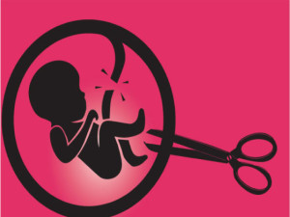
The question of when life begins is key because many people see abortion as murder or killing and there has to be a life before there can be a murder. It does affect whether or not we see abortion as wrong.
By law, the life begins when the baby is born, but given the Abortion Act (1967) will not allow abortions beyond 24 weeks; is that when life begins? Many people think that when the foetus looks like a baby, it should be treated as such, whether it is fully formed or not.
What we can say is that at every stage the foetus is a potential life.

The Law on Abortion in the UK
The law defines abortion as: “The deliberate expulsion of a foetus from the womb, with the intention of destroying it.” It is different from a miscarriage, which has the same result (the pregnancy ends without a living baby), because miscarriage is accidental, a turn of nature.
The law in the UK (except in Northern Ireland) begins by stating that abortion is illegal. It then goes on to say that there are some exceptions. Abortion can only be carried out is two registered doctors agree that at least one of the following is true:
- There is a danger to the woman’s mental and/or physical health
- The foetus will be born with physical and/or mental disabilities
- The mental and/or physical health of existing children will be put at risk
The abortion has to be carried out at a registered place, by a registered doctor, before the 24th week of pregnancy.
A registered doctor is a doctor who has passed medical exams and is recognised by the Medical Council. So a doctor who has been struck off the official list can neither give advice, nor carry out an abortion. A registered place is a hospital or a clinic that has registration with the government, and can perform such medical procedures as abortion because of that registration. Any other place is not legal. Breaking the law carries great penalties for all those involved.

Reasons For and Against Abortion
Pro-Life
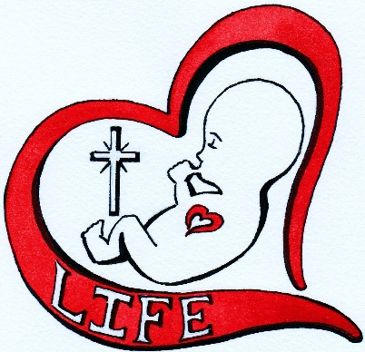
Pro-life is the term we use for those arguments against abortion, usually in any circumstances. Pro-life pressure groups include PROLIFE and SPUC. Since they support the foetus’ right to life, their arguments are all in favour of protecting the foetus to ensure it is born. Pro-life arguments include:
- All life is sacred and must be protected
- The foetus cannot defend itself – someone has to
- God created life, and as stewards of this world, humans have to protect life
- Abortion is the murder of another human being. Murder is wrong
- When a foetus will be born with disabilities, we cannot say what the quality of its life would be, so should not decide to forbid it that life
- The foetus has a right to life and not to be discarded as if it is just waste
Pro-Choice
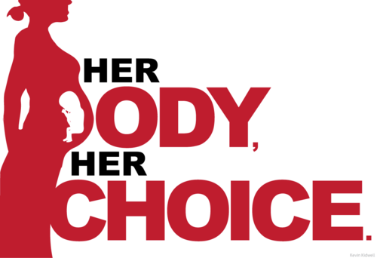
Pro-choice is usually associated with supporting the use of abortion, but it actually means the arguments which defend a woman’s right to choose what happens to her body. Since they support the woman’s right to choose, the arguments are about the woman, rather than the foetus. Pro-choice arguments include:
- A woman should have the right to decide what happens to her body
- If having a child is going to put a woman’s life at risk, or is going to make her postpone medical treatment which she needs, then she should have the right to an abortion
- Where a woman is pregnant as a result of rape or incest, it would be wrong not to allow her an abortion
- Up to a certain point, the foetus cannot survive outside the womb, so it should not be thought of as a life in its own right
- Some foetuses are so damaged that it would be cruel to allow them to be born
- If we banned abortions, women would still have them – but not in a safe way. We need to protect women
Tasks:
- What question does abortion debate?
…………………………………………………………………………………………………………
…………………………………………………………………………………………………………
- How many weeks is abortion legal until?
…………………………………………………………………………………………………………
…………………………………………………………………………………………………………

- What does law in the UK say about abortion?
…………………………………………………………………………………………………………
…………………………………………………………………………………………………………
…………………………………………………………………………………………………………
…………………………………………………………………………………………………………
- When might an abortion be allowed?
……………………………………………………………………………………………………………………………………………………………………………………………………………………
……………………………………………………………………………………………………………………………………………………………………………………………………………………
- Explain reasons for abortions (pro-choice).
……………………………………………………………………………………………………………………………………………………………………………………………………………………
……………………………………………………………………………………………………………………………………………………………………………………………………………………
……………………………………………………………………………………………………………………………………………………………………………………………………………………
- Explain reasons against abortions (pro-life).
…………………………………………………………………………………………………………
…………………………………………………………………………………………………………
……………………………………………………………………………………………………………………………………………………………………………………………………………………
……………………………………………………………………………………………………………………………………………………………………………………………………………………

Thinking About the Lives Involved
When we consider abortion, we are immediately thinking about the foetus involved. However, the law considers the women first not the foetus. Her life and well-being take precedence in law. For example, if a woman has a cancerous uterus, the only option is to remove her womb. This will result in the death of the foetus, but without treatment, the cancer will kill the woman.
How would religions view the argument that a woman’s life is at risk unless she has the abortion?
- All religions believe in the sanctity of life and that life should be preserved/protected. Without the woman’s life, the foetus has no chance of life
- In Islam, the life of the mother takes precedence – she is a fully developed human with responsibilities, whereas the foetus is not even born and will need everything doing for it
- The Roman Catholic Church sees abortion as wrong, but where it is the ‘side effect’ of a procedure to save a woman’s life, it can be accepted
- The Church of England has said that abortion is a great moral evil, but that where the continuance of a pregnancy threatens a woman’s life, then it is justifiable
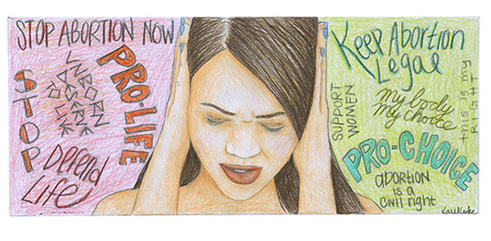
Other Questions About Abortion
The woman is usually the first to contribute to the debate about whether an abortion is the correct course of action – it is her body after all. You would expect it to be discussed with the father. She might also discuss it with parents and siblings. She will have to talk to a doctor – and under UK law, doctors are the ones who sanction and carry out abortions (without their say-so, she cannot have an abortion legally). The question is, who gets the bigger say and the final decision?
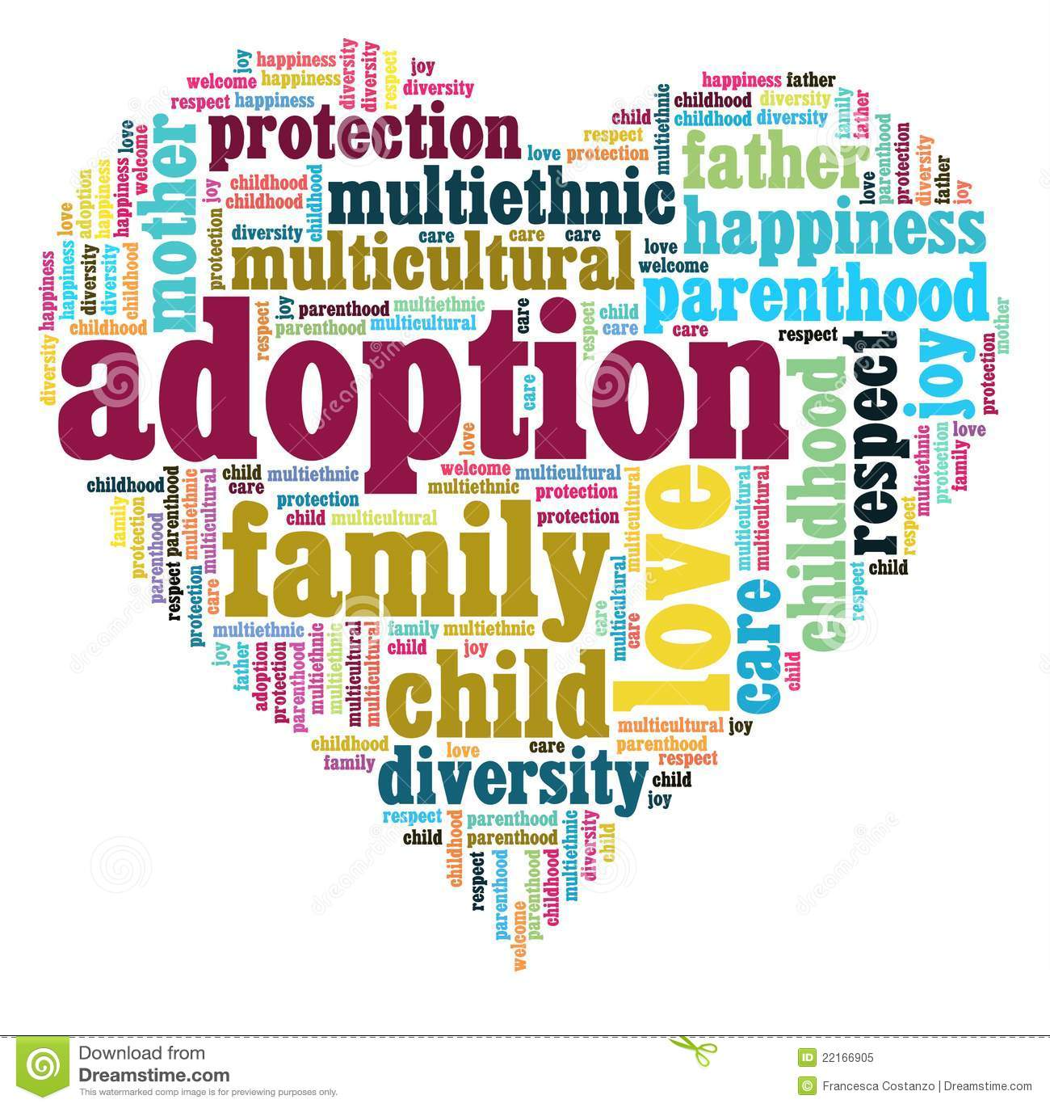
What other options are available?
IF the woman has a medical condition, she may have no choice but to have the abortion or she forfeits her own life. That seems quite straightforward, but it is still difficult because it involves taking a life.
A woman could decide against abortion, complete the pregnancy and have the baby fostered or adopted. At some point, by law, that child would be able to find out about their birth circumstances and might come back to the mother to ask questions.
Or, she could decide against an abortion and continue the pregnancy. She would be choosing to work through or in spite of the problems, which made her consider abortion. If there had been a risk to her mental or physical health, this is even more difficult.
Tasks:
- Who does the law consider first?
…………………………………………………………………………………………………………
…………………………………………………………………………………………………………
- How would religions respond if the woman’s life was in danger?
…………………………………………………………………………………………………………
…………………………………………………………………………………………………………
…………………………………………………………………………………………………………
…………………………………………………………………………………………………………
…………………………………………………………………………………………………………
…………………………………………………………………………………………………………

- Who might the woman discuss the issue of abortion with?
…………………………………………………………………………………………………………
…………………………………………………………………………………………………………
…………………………………………………………………………………………………………
…………………………………………………………………………………………………………
- What other options are available?
……………………………………………………………………………………………………………………………………………………………………………………………………………………
……………………………………………………………………………………………………………………………………………………………………………………………………………………
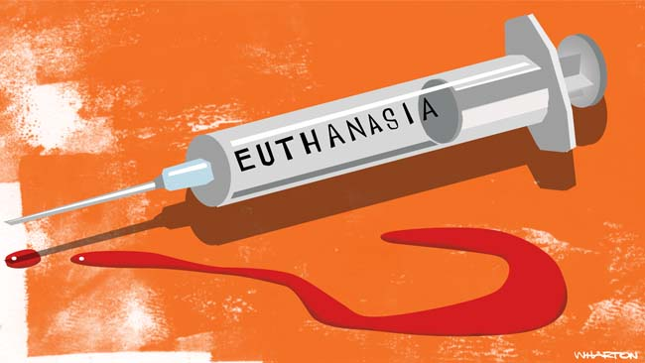
Euthanasia
Euthanasia is mercy-killing. It is helping someone to die, who is suffering from a terminal illness or whose quality of life is less than they can bear, usually because of a degenerative disease. Euthanasia is done because of compassion or loving kindness.
The debates surrounding euthanasia have a long history. Hippocrates, a doctor from ancient Greece, openly stated he would not prescribe drugs to help someone end their life. His stance has become the basis for the Hippocratic Oath, sworn by doctors in the UK, which says, “I will give no deadly medicine to anyone if asked, nor suggest such counsel…” In 1516CE Thomas More defended euthanasia as the last treatment option for doctors to give, if the patient wanted it.
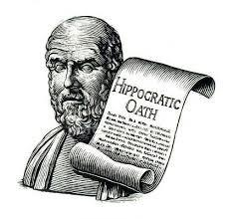
In the 21st Century, in most Western countries, groups exist to try to make euthanasia legal. In some countries, e.g. the Netherlands, it is legal.
Voluntary euthanasia is when the person who is suffering asks for euthanasia to end their suffering. This could be active euthanasia, for example, being given lethal drugs to end their life so that their illness does not kill them. However, it could also be a choice to stop taking medication, so that their illness kills them. This is passive euthanasia.
Involuntary euthanasia is when the patient is unable to say what they want to happen, and their family has to decide. It is usually that the person is on life support and will not recover. This is usually acceptable to most people, because actually the person is being allowed to die rather than being killed.
The Law on Euthanasia
Euthanasia is illegal in the UK. It can be seen as assisted suicide, so breaking the Suicide Act of 1961, which forbids anyone from helping someone else to die and carries a 14-year jail sentence. It can also be viewed as manslaughter or, at worst, murder, which carries a life sentence.
Doctors do switch off life-support machines when patients have no sign of brain activity, and they do administer drugs to ease pain, which also shorten life. Neither of there is seen as euthanasia in the UK.
Tasks:
- What is euthanasia?
…………………………………………………………………………………………………………
…………………………………………………………………………………………………………
- What is the Hippocratic Oath?
…………………………………………………………………………………………………………
…………………………………………………………………………………………………………

- What is the difference between voluntary euthanasia and involuntary euthanasia?
…………………………………………………………………………………………………………
…………………………………………………………………………………………………………
…………………………………………………………………………………………………………
…………………………………………………………………………………………………………
- What does UK law state about euthanasia?
…………………………………………………………………………………………………………………………………………………………………………………………………………………………………………………………………………………………………………………………………………………………………………………………………………………………………………
The Right to Die
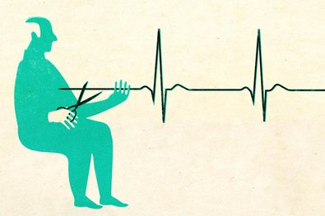
In society, arguments about euthanasia focus around the right of a person to choose their own death. On the whole, religious believers do not believe humans have the right to make this decision.
Arguing for the right to die:
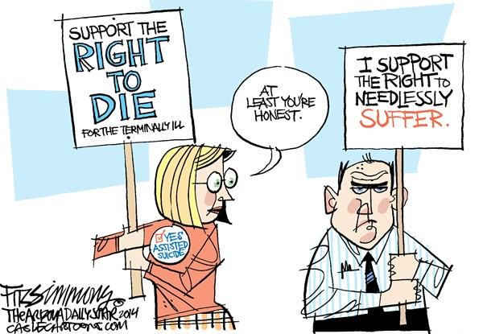
- It is my body, so should be my right to make decisions about it, after all I can elect for surgery, have tattoos, and make every other major decision
- When you consider all human rights, the right to die naturally follows on from them
- I am the only one who can really say when my life is no longer worth living
- We see it as compassionate to put animals in pain to sleep, so should allow the same compassion to humans
Arguing against the right to die:
- to allow euthanasia would be to encourage it, so that people would force it on others for their own advantage, for example, making an elderly relative feel a burden
- Life does not belong to us, it belongs to God – euthanasia is playing God
- We should care for people in their last days, showing love, not kill them
- Doctors and nurses take oaths to protect lives, not to end lives
Quality versus the Sanctity of Life
Many people say that euthanasia is all about the quality of life and that for those who want euthanasia, they are suffering too much, and they no longer have a good quality of life. Others say that, regardless of quality, life must be maintained because it is too special to end.
Tasks:
- Why do people believe they have the right to choose their own death?
…………………………………………………………………………………………………………
……………………………………………………………………………………………………………………………………………………………………………………………………………………
…………………………………………………………………………………………………………
- Why shouldn’t people be able to choose their own deaths?
…………………………………………………………………………………………………………
…………………………………………………………………………………………………………
…………………………………………………………………………………………………………
…………………………………………………………………………………………………………

- Explain the significance of the quality versus the sanctity of life.
…………………………………………………………………………………………………………
…………………………………………………………………………………………………………
…………………………………………………………………………………………………………
…………………………………………………………………………………………………………

Care for the Dying – The Hospice Movement
Hospices are the preferred Christian response to the issue of euthanasia. A hospice is a home for those who are terminally ill (dying). They are for both children and adults of all ages, for example, those with cancer. People may go there until they die or to give their families respite from looking after them for a while. On average, people stay there for two weeks.
Originally, hospices were places for travellers, the sick and the needy to stay. They were set up by Christians. Over time, some of them began to specialise in looking after those who were dying.
When someone is dying, they cannot be cured – only cared for. Hospices try to provide care for all aspects of a person’s illness and suffering. Many religious people believe that if the care is good enough, then euthanasia would not even be considered.
The aims of hospices:
- To relieve the physical symptoms of illness. In other words, to get rid of as much pain as is possible. This includes whatever it takes, for example, massage, meditation and relaxation. Often, medical treatment for the dying is very specialised. It is called palliative care.
- To care for the emotional and spiritual well-being of the patient. Many dying people have unfinished business, which is a worry to them. The hospices help them to sort things out. Many patients are angry, for example, asking questions like ‘why me?’ – Hospices help them to come to terms with dying. Many patients need to be listened to and often relatives cannot cope with this, but the hospices do
- To support families of patients who also suffer. Hospices provide many support networks and education services for them, even after the death of the patient
- To educate others caring for the dying and to work out new, better ways to care for the dying which will be invaluable in the future. The experience built up in hospices can be used in other places.
Religious groups see hospices as the way forward for terminally ill people. God wants us to care for these people, to look out for them, to express God’s love for them, not to kill them.
St. Ann’s Hospice
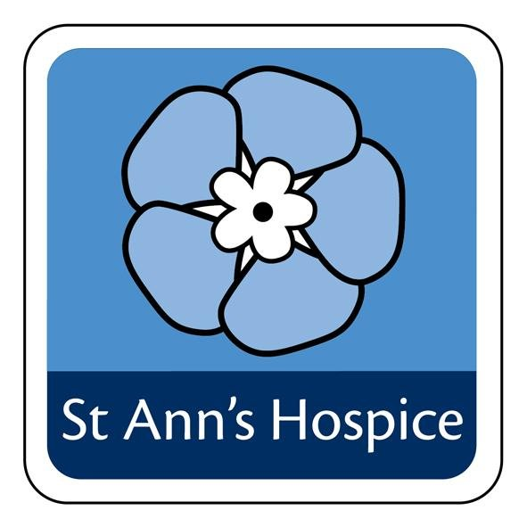
This hospice was opened in 1971 and serves the Greater Manchester community. Its aim is to improve the quality of life of people with life-threatening illnesses. It aims to do this whilst supporting families and carers. In a year, the hospice treats over 3000 patients, 40% of whom return home after their stay. This costs almost £9milion, meaning that the hospice has to raise over £16,000 a day, which it does through voluntary contributions.
95% of patients are suffering from a cancer-related illness. Each patient is given a personal care plan, which is tailored to meet their individual needs. This is what makes the support so unique and effective.
Tasks:
- What is the Hospice movement?
…………………………………………………………………………………………………………
……………………………………………………………………………………………………………………………………………………………………………………………………………………
…………………………………………………………………………………………………………
- How did the Hospice movement begin?
…………………………………………………………………………………………………………
…………………………………………………………………………………………………………
…………………………………………………………………………………………………………
…………………………………………………………………………………………………………

- What are the aims of hospices?
…………………………………………………………………………………………………………
…………………………………………………………………………………………………………
……………………………………………………………………………………………………………………………………………………………………………………………………………………
- Explain the work of St. Ann’s Hospice, Manchester.
…………………………………………………………………………………………………………
…………………………………………………………………………………………………………
……………………………………………………………………………………………………………………………………………………………………………………………………………………

Christian Attitudes to Life
Christianity tells us:
- God created life in his own image (Genesis)
- Do not kill (Ten commandments)
- I, your God, give life, and I take it away (Old Testament)
- The Catholic Church teaches that life must be respected from conception until natural death
- Doctors do not have an overriding obligation to prolong life by all means possible (Church of England)
It is clear that on most occasions, Christians will not agree with either abortion or euthanasia. All life is sacred as it was created and belongs to God. Whilst death might mean going to heaven to be with God, it should not be hastened. Life should always be protected. For most Christians, abortion is always morally wrong. Some accept it rarely as a necessary evil.
in the case of abortion, where the mother’s life is at risk it is difficult because her life is also sacred. Most Christians would accept procedures which save her life, even if they lead to the ending of the pregnancy. Many would also point to the fact that in many cases, there are options other than abortion, for example, adoption.
In the case of euthanasia, few support active euthanasia, regardless of what a person might themselves wish for. This is seen as killing, so is wrong. However, in countries where euthanasia is legal, there are Christian groups who also agree with it, for example, the Dutch Protestant Church in the Netherlands, who see it as an act of love and compassion and a good use of the medical knowledge God has granted us.
Tasks:
- What does Christianity teach about life?
…………………………………………………………………………………………………………
…………………………………………………………………………………………………………
…………………………………………………………………………………………………………
…………………………………………………………………………………………………………
…………………………………………………………………………………………………………
…………………………………………………………………………………………………………

- Would Christians support abortion? Why/why not?
…………………………………………………………………………………………………………
…………………………………………………………………………………………………………
…………………………………………………………………………………………………………
…………………………………………………………………………………………………………
…………………………………………………………………………………………………………
…………………………………………………………………………………………………………
- Would Christians support euthanasia? Why/why not?
………………………………………………………………………………………………………………………………………………………………………………………………………………………………………………………………………………………………………………………………………………………………………………………………………………………………………………………………………………………………………………………………………………………………………………………………………………………………………………………………

Muslim Attitudes to Life
Islam tells us:
- Neither kill nor destroy yourself (Qur’an)
- No one can die except by Allah’s leave, that is decree with a fixed term (Qur’an)
- Each person is created individually by Allah from a single clot of blood (Qur’an)
- Do not take life – which Allah has made sacred – except for a just cause (Qur’an)
- Euthanasia is zulum – wrongdoing against Allah (Shari’ah Law)
All life is specially created by Allah, and Allah has a plan for each life; both abortion and euthanasia, go against these plans. Hence, for most Muslims, abortion is always wrong, as it any form of self-harm or self-killing.
There is a debate within Islam as to when ensoulment takes place (when the soul becomes part of the growing foetus). It is varyingly said to be at conception, at 40 days or at 120 days. Before this time, technically an abortion is acceptable because no life is being taken. Where a mother’s life is at risk, most Muslims defend the woman’s right to life.
Prophet Muhammad (PBUH) told the story of a man who helped a friend die because he was in so much pain. The man and his friend were both denied paradise as a result. No one knows the plans of Allah, this is called al-Qadr or the predestination of Allah’s will. Life will end when Allah wills it, so euthanasia is not acceptable. This does not mean that passive euthanasia is wrong, this would be accepted where there was no hope.
Tasks:
- What does Islam teach about life?
…………………………………………………………………………………………………………
…………………………………………………………………………………………………………
…………………………………………………………………………………………………………
…………………………………………………………………………………………………………
…………………………………………………………………………………………………………
…………………………………………………………………………………………………………

- Would Muslims support abortion? Why/why not?
…………………………………………………………………………………………………………
…………………………………………………………………………………………………………
…………………………………………………………………………………………………………
…………………………………………………………………………………………………………
…………………………………………………………………………………………………………
…………………………………………………………………………………………………………
- Would Muslims support euthanasia? Why/why not?
………………………………………………………………………………………………………………………………………………………………………………………………………………………………………………………………………………………………………………………………………………………………………………………………………………………………………………………………………………………………………………………………………………………………………………………………………………………………………………………………

Religious Beliefs about Death and the Afterlife
Christianity
Christians believe in the physical resurrection of the body. At death, the body waits until Judgement Day. Catholics call this Purgatory. At judgement, each person faces God and Jesus to evaluate their deeds. If there were good in life, they go to heaven, which is paradise and wonderful forever. If they were bad, they go to hell for eternal punishment.

Islam
Muslims believe in resurrection. At death, the body waits in the grave (barzakh) and sees the events of its life. This can be quick or very slow and painful. On Judgement Day, people are sorted according to their beliefs and actions. The wicked are cast into hell; the truly good go straight to paradise. All others cross As-Sirat Bridge, carrying the book of their deeds (sins make it heavier). The bridge is sharp and so they are purified from sin before going to paradise.
Tasks:

- What does Christianity teach about death and the afterlife?
…………………………………………………………………………………………………………
…………………………………………………………………………………………………………
…………………………………………………………………………………………………………
…………………………………………………………………………………………………………
…………………………………………………………………………………………………………
…………………………………………………………………………………………………………

- What does Islam teach about death and the afterlife?
…………………………………………………………………………………………………………
…………………………………………………………………………………………………………
…………………………………………………………………………………………………………
…………………………………………………………………………………………………………
…………………………………………………………………………………………………………
…………………………………………………………………………………………………………

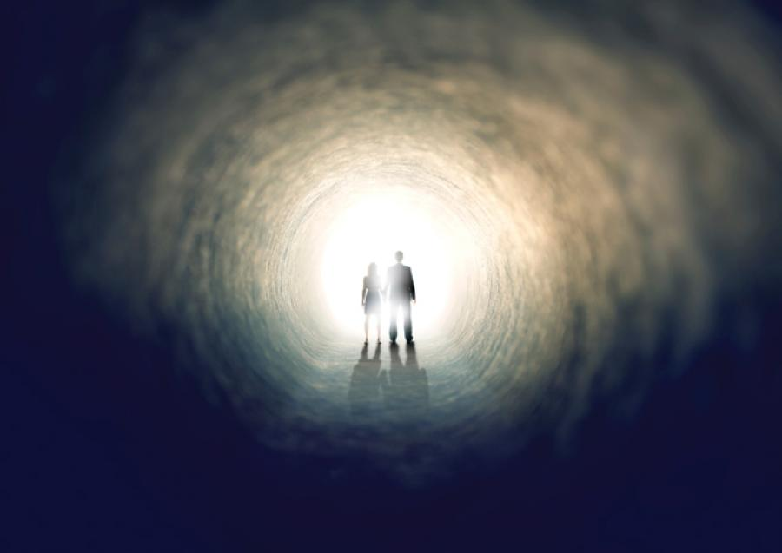

Exam-style questions
- What is meant by the term sanctity of life? (1 mark)
………………………………………………………………………………………………………………………………………………………………………………………………………………………………………………
- What is meant by the term quality of life? (1 mark)
………………………………………………………………………………………………………………………………………………………………………………………………………………………………………………
- Which word describes terminating a pregnancy so that it does not result in the birth of a baby? (1 mark)
………………………………………………………………………………………………………………………………………………………………………………………………………………………………………………
- What is meant by the term euthanasia? (1 mark)
………………………………………………………………………………………………………………………………………………………………………………………………………………………………………………
- What is the Hippocratic Oath? (1 mark)
………………………………………………………………………………………………………………………………………………………………………………………………………………………………………………
- What is meant by the term environmental sustainability? (1 mark)
………………………………………………………………………………………………………………………………………………………………………………………………………………………………………………
- What is meant by the term afterlife? (1 mark)
………………………………………………………………………………………………………………………………………………………………………………………………………………………………………………
- What is meant by the term conservation? (1 mark)
………………………………………………………………………………………………………………………………………………………………………………………………………………………………………………

- Can you explain what global warming is? (2 marks)
………………………………………………………………………………………………………………………………………………………………………………………………………………………………………………
- Can you explain what a creation story is? (2 marks)
………………………………………………………………………………………………………………………………………………………………………………………………………………………………………………
- Can you explain what is meant by a scientific truth? (2 marks)
………………………………………………………………………………………………………………………………………………………………………………………………………………………………………………
- Give two religious beliefs about the use of natural resources. (2 marks)
………………………………………………………………………………………………………………………………………………………………………………………………………………………………………………
- Give two religious beliefs about animal rights. (2 marks)
………………………………………………………………………………………………………………………………………………………………………………………………………………………………………………
- Give two reasons why a religious believer might be a vegetarian. (2 marks)
………………………………………………………………………………………………………………………………………………………………………………………………………………………………………………
- Give two effects of legalising euthanasia. (2 marks)
………………………………………………………………………………………………………………………………………………………………………………………………………………………………………………

- Explain two contrasting religious beliefs about the environment. (4 marks)
………………………………………………………………………………………………………………………………………………………………………………………………………………………………………………………………………………………………………………………………………………………………………………………………………………………………………………………………………………………………
- Explain two contrasting religious beliefs about animal rights. (4 marks)
………………………………………………………………………………………………………………………………………………………………………………………………………………………………………………………………………………………………………………………………………………………………………………………………………………………………………………………………………………………………
- Explain two contrasting religious beliefs about abortion. (4 marks)
………………………………………………………………………………………………………………………………………………………………………………………………………………………………………………………………………………………………………………………………………………………………………………………………………………………………………………………………………………………………
- Explain two contrasting religious beliefs about creation. (4 marks)
………………………………………………………………………………………………………………………………………………………………………………………………………………………………………………………………………………………………………………………………………………………………………………………………………………………………………………………………………………………………
- Explain two contrasting religious beliefs about euthanasia. (4 marks)
………………………………………………………………………………………………………………………………………………………………………………………………………………………………………………………………………………………………………………………………………………………………………………………………………………………………………………………………………………………………
- Explain two contrasting religious beliefs about death and the afterlife. (4 marks)
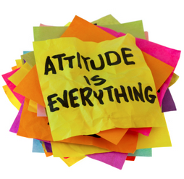
………………………………………………………………………………………………………………………………………………………………………………………………………………………………………………………………………………………………………………………………………………………………………………………………………………………………………………………………………………………………

- Explain two religious beliefs about use of natural resources. Refer to scripture or sacred writings in your answer. (5 marks)
………………………………………………………………………………………………………………………………………………………………………………………………………………………………………………………………………………………………………………………………………………………………………………………………………………………………………………………………………………………………………………………………………………………………………………………………………………………………………………………………………………………………………………………………………………………………………………………………………………………………………………………………………………………………………………………………………………………………………………………………
- Explain two religious beliefs about the sanctity of life. Refer to scripture or sacred writings in your answer. (5 marks)
………………………………………………………………………………………………………………………………………………………………………………………………………………………………………………………………………………………………………………………………………………………………………………………………………………………………………………………………………………………………………………………………………………………………………………………………………………………………………………………………………………………………………………………………………………………………………………………………………………………………………………………………………………………………………………………………………………………………………………………………
- Explain two religious beliefs about the afterlife. Refer to scripture or sacred writings in your answer. (5 marks)
………………………………………………………………………………………………………………………………………………………………………………………………………………………………………………………………………………………………………………………………………………………………………………………………………………………………………………………………………………………………………………………………………………………………………………………………………………………………………………………………………………………………………………………………………………………………………………………………………………………………………………………………………………………………………………………………………………………………………………………………
- Explain two religious beliefs about abortion. Refer to scripture or sacred writings in your answer. (5 marks)
………………………………………………………………………………………………………………………………………………………………………………………………………………………………………………………………………………………………………………………………………………………………………………………………………………………………………………………………………………………………………………………………………………………………………………………………………………………………………………………………………………………………………………………………………………………………………………………………………………………………………………………………………………………………………………………………………………………………………………………………
- Explain two religious beliefs about euthanasia. Refer to scripture or sacred writings in your answer. (5 marks)
………………………………………………………………………………………………………………………………………………………………………………………………………………………………………………………………………………………………………………………………………………………………………………………………………………………………………………………………………………………………………………………………………………………………………………………………………………………………………………………………………………………………………………………………………………………………………………………………………………………………………………………………………………………………………………………………………………………………………………………………
- Explain two religious beliefs about sustainable development. Refer to scripture or sacred writings in your answer. (5 marks)
………………………………………………………………………………………………………………………………………………………………………………………………………………………………………………………………………………………………………………………………………………………………………………………………………………………………………………………………………………………………………………………………………………………………………………………………………………………………………………………………………………………………………………………………………………………………………………………………………………………………………………………………………………………………………………………………………………………………………………………………
- Explain two religious beliefs about scientific creation theories. Refer to scripture or sacred writings in your answer. (5 marks)
………………………………………………………………………………………………………………………………………………………………………………………………………………………………………………………………………………………………………………………………………………………………………………………………………………………………………………………………………………………………
- Explain two religious beliefs about the value of the world. Refer to scripture or sacred writings in your answer. (5 marks)
………………………………………………………………………………………………………………………………………………………………………………………………………………………………………………………………………………………………………………………………………………………………………………………………………………………………………………………………………………………………………………………………………………………………………………………………………………………………………………………………………………………………………………………………………………………………………………………………………………………………………………………………………………………………………………………………………………………………………………………………

- “Science and religion contradict each other.”
Evaluate this statement. You should:

  - Refer to Christian teaching
  - Give developed arguments to support this statement
  - Give developed arguments to support a different point of view
  - Reach a justified conclusion
……………………………………………………………………………………………………………………………………………………………………………………………………………………………………………………………………………………………………………………………………………………………………………………………………………………………………………………………………………………………………………………………………………………………………………………………………………………………………………………………………………………………………………………………………………………………………………………………………………………………………………………………………………………………………………………………………………………………………………………………………………………………………………………………………………………………………………………………………………………………………………………………………………………………………………………………………………………………………………………………………………………………………………………………………………………………………………………………………………………………………………………………………………………………………………………………………………………………………………………………………………………………………………………………………………………………………………………………………………………………………………………………………………………………………………………………………………………………………………………………………………………………………………………………………………………………………………………………………………………………………………………………………………………………………………………………………………………………………………………………………………………………………………………………………………………………………………………………………………………………………………………………………………………………………………………………………………………………………………………………………………………………………………………………………………………………………………………………………………………………………………………………………………………………………………………………………………………………………………………………………………………………………………………………………………………………………………………………………………………………………………………………………………………………………………………………………………………………………………………………………………………………………………………………………………………………………………………………………………………………………………………………………………………………………………………………………………………………………………………………………………………………………………………………………………………………………………………………………………………………………………………………………………………………………………………………………………………………………………………………………………………………………………………………………………………………………………………………………………………………………………………………………………………………………………………………………………………………………………………………………………………………………………………………………………………………………………………………………………………………………………………………………………………………………………………………………………………………………………………………………………………………………………………………………………………………………………………………………………………………
- “The earth is ours to do with what we want.”
Evaluate this statement. You should:

  - Refer to Christian teaching
  - Give developed arguments to support this statement
  - Give developed arguments to support a different point of view
  - Reach a justified conclusion
……………………………………………………………………………………………………………………………………………………………………………………………………………………………………………………………………………………………………………………………………………………………………………………………………………………………………………………………………………………………………………………………………………………………………………………………………………………………………………………………………………………………………………………………………………………………………………………………………………………………………………………………………………………………………………………………………………………………………………………………………………………………………………………………………………………………………………………………………………………………………………………………………………………………………………………………………………………………………………………………………………………………………………………………………………………………………………………………………………………………………………………………………………………………………………………………………………………………………………………………………………………………………………………………………………………………………………………………………………………………………………………………………………………………………………………………………………………………………………………………………………………………………………………………………………………………………………………………………………………………………………………………………………………………………………………………………………………………………………………………………………………………………………………………………………………………………………………………………………………………………………………………………………………………………………………………………………………………………………………………………………………………………………………………………………………………………………………………………………………………………………………………………………………………………………………………………………………………………………………………………………………………………………………………………………………………………………………………………………………………………………………………………………………………………………………………………………………………………………………………………………………………………………………………………………………………………………………………………………………………………………………………………………………………………………………………………………………………………………………………………………………………………………………………………………………………………………………………………………………………………………………………………………………………………………………………………………………………………………………………………………………………………………………………………………………………………………………………………………………………………………………………………………………………………………………………………………………………………………………………………………………………………………………………………………………………………………………………………………………………………………………………………………………………………………………………………………………………………………………………………………………………………………………………………………………………………………………………………………………………
- “Only God can give and take life.”
Evaluate this statement. You should:

  - Refer to Christian teaching
  - Give developed arguments to support this statement
  - Give developed arguments to support a different point of view
  - Reach a justified conclusion
……………………………………………………………………………………………………………………………………………………………………………………………………………………………………………………………………………………………………………………………………………………………………………………………………………………………………………………………………………………………………………………………………………………………………………………………………………………………………………………………………………………………………………………………………………………………………………………………………………………………………………………………………………………………………………………………………………………………………………………………………………………………………………………………………………………………………………………………………………………………………………………………………………………………………………………………………………………………………………………………………………………………………………………………………………………………………………………………………………………………………………………………………………………………………………………………………………………………………………………………………………………………………………………………………………………………………………………………………………………………………………………………………………………………………………………………………………………………………………………………………………………………………………………………………………………………………………………………………………………………………………………………………………………………………………………………………………………………………………………………………………………………………………………………………………………………………………………………………………………………………………………………………………………………………………………………………………………………………………………………………………………………………………………………………………………………………………………………………………………………………………………………………………………………………………………………………………………………………………………………………………………………………………………………………………………………………………………………………………………………………………………………………………………………………………………………………………………………………………………………………………………………………………………………………………………………………………………………………………………………………………………………………………………………………………………………………………………………………………………………………………………………………………………………………………………………………………………………………………………………………………………………………………………………………………………………………………………………………………………………………………………………………………………………………………………………………………………………………………………………………………………………………………………………………………………………………………………………………………………………………………………………………………………………………………………………………………………………………………………………………………………………………………………………………………………………………………………………………………………………………………………………………………………………………………………………………………………………………………………………
- “Life begins at conception.”
Evaluate this statement. You should:

  - Refer to Christian teaching
  - Give developed arguments to support this statement
  - Give developed arguments to support a different point of view
  - Reach a justified conclusion
………………………………………………………………………………………………………………………………………………………………………………………………………………………………………………………………………………………………………………………………………………………………………………………………………………………………………………………………………………………………………………………………………………………………………………………………………………………………………………………………………………………………………………………………………………………………………………………………………………………………………………………………………………………………………………………………………………………………………………………………………………………………………………………………………………………………………………………………………………………………………………………………………………………………………………………………………………………………………………………………………………………………………………………………………………………………………………………………………………………………………………………………………………………………………………………………………………………………………………………………………………………………………………………………………………………………………………………………………………………………………………………………………………………………………………………………………………………………………………………………………………………………………………………………………………………………………………………………………………………………………………………………………………………………………………………………………………………………………………………………………………………………………………………………………………………………………………………………………………………………………………………………………………………………………………………………………………………………………………………………………………………………………………………………………………………………………………………………………………………………………………………………………………………………………………………………………………………………………………………………………………………………………………………………………………………………………………………………………………………………………………………………………………………………………………………………………………………………………………………………………………………………………………………………………………………………………………………………………………………………………………………………………………………………………………………………………………………………………………………………………………………………………………………………………………………………………………………………………………………………………………………………………………………………………………………………………………………………………………………………………………………………………………………………………………………………………………………………………………………………………………………………………………………………………………………………………………………………………………………………………………………………………………………………………………………………………………………………………………………………………………………………………………………………………………………………………………………………………………………………………………………………
- “Animals have rights.”
Evaluate this statement. You should:

  - Refer to Christian teaching
  - Give developed arguments to support this statement
  - Give developed arguments to support a different point of view
  - Reach a justified conclusion
……………………………………………………………………………………………………………………………………………………………………………………………………………………………………………………………………………………………………………………………………………………………………………………………………………………………………………………………………………………………………………………………………………………………………………………………………………………………………………………………………………………………………………………………………………………………………………………………………………………………………………………………………………………………………………………………………………………………………………………………………………………………………………………………………………………………………………………………………………………………………………………………………………………………………………………………………………………………………………………………………………………………………………………………………………………………………………………………………………………………………………………………………………………………………………………………………………………………………………………………………………………………………………………………………………………………………………………………………………………………………………………………………………………………………………………………………………………………………………………………………………………………………………………………………………………………………………………………………………………………………………………………………………………………………………………………………………………………………………………………………………………………………………………………………………………………………………………………………………………………………………………………………………………………………………………………………………………………………………………………………………………………………………………………………………………………………………………………………………………………………………………………………………………………………………………………………………………………………………………………………………………………………………………………………………………………………………………………………………………………………………………………………………………………………………………………………………………………………………………………………………………………………………………………………………………………………………………………………………………………………………………………………………………………………………………………………………………………………………………………………………………………………………………………………………………………………………………………………………………………………………………………………………………………………………………………………………………………………………………………………………………………………………………………………………………………………………………………………………………………………………………………………………………………………………………………………………………………………………………………………………………………………………………………………………………………………………………………………………………………………………………………………………………………………………………………………………………………………………………………………………………………………………………………………………………………………………………………………………………………

- “Humans should be stewards of the environment.”
Evaluate this statement. You should:

  - Refer to Christian teaching
  - Give developed arguments to support this statement
  - Give developed arguments to support a different point of view
  - Reach a justified conclusion
……………………………………………………………………………………………………………………………………………………………………………………………………………………………………………………………………………………………………………………………………………………………………………………………………………………………………………………………………………………………………………………………………………………………………………………………………………………………………………………………………………………………………………………………………………………………………………………………………………………………………………………………………………………………………………………………………………………………………………………………………………………………………………………………………………………………………………………………………………………………………………………………………………………………………………………………………………………………………………………………………………………………………………………………………………………………………………………………………………………………………………………………………………………………………………………………………………………………………………………………………………………………………………………………………………………………………………………………………………………………………………………………………………………………………………………………………………………………………………………………………………………………………………………………………………………………………………………………………………………………………………………………………………………………………………………………………………………………………………………………………………………………………………………………………………………………………………………………………………………………………………………………………………………………………………………………………………………………………………………………………………………………………………………………………………………………………………………………………………………………………………………………………………………………………………………………………………………………………………………………………………………………………………………………………………………………………………………………………………………………………………………………………………………………………………………………………………………………………………………………………………………………………………………………………………………………………………………………………………………………………………………………………………………………………………………………………………………………………………………………………………………………………………………………………………………………………………………………………………………………………………………………………………………………………………………………………………………………………………………………………………………………………………………………………………………………………………………………………………………………………………………………………………………………………………………………………………………………………………………………………………………………………………………………………………………………………………………………………………………………………………………………………………………………………………………………………………………………………………………………………………………………………………………………………………………………………………………………………………………………

