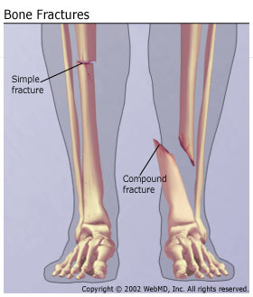
INJURY
Fractures - broken bone.
Sorted into two major classes: simple and compound fractures.

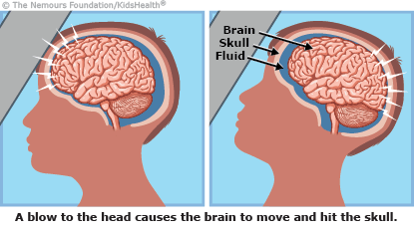

Concussion - a temporary injury to the brain caused by a bump, blow or jolt to the head. An impact to the head causes the brain to hit the inside of the cranium.
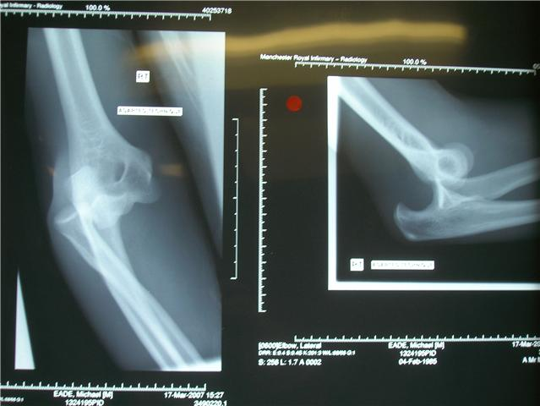

Dislocation - where the bones of a joint come apart from their normal position.
Caused by an awkward twist or fall which forces the bones of a joint to separate.

Sprain – a joint injury
A sprain is an injury that occurs when you twist or turn your joint in an awkward way. This can stretch or tear the ligaments that help hold the bones of the joint together.
A sprained ankle is the most common.

Strain – a muscle injury (pulled muscle)
A pulled muscle usually caused by overstretching a muscle or an inadequate warm-up

Torn cartilage
Cartilage is the soft, spongey substance that covers the end of the bones. It acts as a shock absorber and prevents the bones rubbing directly against each other.
Torn cartilage usually occurs during an awkward twist or movement. This can cause a piece of the cartilage to come lose or brake away.

Injury prevention
- correct application of the principles of training to avoid overuse injuries;
- correct use and enforcement of the rules of the game (e.g. with referee)
- use of appropriate protective clothing and equipment;
- checking of equipment and facilities before use
- Effective warm-up – cool down does NOT prevent injury as done AFTER training
Performance Enhancing Drugs:
Anabolic steroids POWER | Benefits  - Training drug (train harder for longer)  - Increase muscle mass  - Leading to muscle hypertrophy  - Therefore increase in power | Negative Side-effects  - Testicular atrophy (fertility problems)  - Acne  - Aggression  - “Male” features e.g. facial hair  - Heart Attack  - Infection e.g. HIV
Peptide Hormones (EPO)  ENDURANCE | Benefits  - Red blood cells, increase oxygen transportation, improved endurance | Negative Side-effects  - Increased thickness of blood  - Therefore thrombosis/blood clots  - stroke/heart attack
Peptide Hormones  (GH) –  GROWTH & REPAIR OF MUSCLE | Benefits  - Improved growth/repair of muscle  - Used to shred/burn fat (unlikely to be asked this) | Negative Side-effects  - Abnormal growth of hands/feet
Blood doping – ENDURANCE (MIMICS THE EFFECTS OF EPO) | Benefits  - Mimics the effects of EPO but avoids drug testers  - Increases number of red blood cells to aid oxygen delivery | Negative Side-effects  - Blood clots/thrombosis  - stroke/heart attack  - Blood therefore risk of infection e.g. HIV
Beta Blockers - Calm/reduce anxiety | Benefits  - Slows heart rate  - Blocks adrenaline  - Increases concentration  - Target sports e.g. archery | Negative Side-effects  - Not beneficial in most sports (only those requiring concentration)
Diuretics  Weight loss, mask traces of other drugs | Benefits  - Increases urination to dehydrate body  - Leading to temporary weight loss to “make weight” | Negative Side-effects  - Dehydration - therefore nausea/sickness, kidney damage, reduced thermoregulation
Narcotic Analgesics Mask pain | Benefits  - Mask pain of an injury  - Allows athletes to “play hurt” | Negative Side-effects  - Addictive, loss of coordination  - Risk permanent injury  - Moral/ethical arguments appropriate here (e.g. is it morally right to ask a player to risk health?)
Stimulants -  alertness | Benefits  - increase alertness, reduce fatigue | Negative Side-effects  - Insomnia  - Heart palpitations
Moral & Ethical Arguments
- Risks to athletes health
- Risk shame in the media
- Against the “spirit of the game”
- Because athletes want to compete on a “level playing field”
- But cheating gives an “unfair advantage”
- Pressure on others to take drugs to keep up

